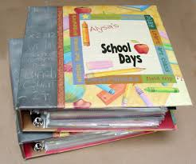
Communication about
Student Learning

- Parent Portal/Class Dojo
- Updates on the school’s website
- Parent-teacher conferences
- Connect –Ed messages
- Parent Meetings
- Monthly Parent Newsletters
Principal,
Philip Bush

Assistant Principal,
Janet Whitley

516 Heath Drive
706-748-3072

Access our school’s website at www.muscogee.k12.ga.us
River Road Elementary
School-Parent Compact

What is a
School-Parent Compact?
A Home-School Compact is an agreement that parents, students, and teachers develop together. It explains how they will work together to make sure all students reach grade-level standards. Meetings are held each year to review and revise the compact based on the school’s academic achievement goals and student’s needs. For all students that reside in residential facilities served by the Muscogee County School District, parental involvement correspondence and activities will be mailed to each facility where students reside.

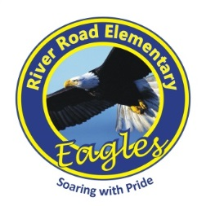


Our Goals for Student Achievement

District Goals
The Muscogee County School District will create an environment that focuses on Tier I Instruction while targeting individual student needs, leadership development, and customer service.
-------------------------------------------------------------

School’s SMART Goals

Goal 1 By May 2018, all ten Tier 1 critical elements of the School-Wide Positive Behavioral Intervention (PBIS) Program will be partially implemented.

Goal 2 By May 2018, 100% of teachers will implement guided instruction to create an academically challenging environment and promote students to be self-directed learners.

to establish effective grade level teams which will aid in increasing standardized test scores in all subject areas.

2017-2018
Revised 9-5-2017

Revised 9-14-2016

Our Students:
Our Students:
Students are encouraged to participate in the educational process. A successful student takes ownership of his/her learning and sets high educational goals.
As Parents, we will…..

As Parents, we will….

- Communicate with our child’s teacher regarding any questions or concerns about my child’s performance.
- Check our child’s homework folder or agenda book daily.
- Make sure my child is at school and arrives on time prepared for the day.
- Reinforce skills obtained at school.




As a School, we will…..
- Help parents stay connected through multiple ways of communication.
- We will monitor student progress to ensure student success.
- We will model and teach wanted behaviors with positive rewards.

As Students, we will…..
- Ask questions if we don’t understand our class room or homework assignments.
- Follow the rules.
- Read for 20 minutes every day.
- Study and do our very best on tests.
- Practice writing each night.


[Grab your reader’s attention with a great quote from the document or use this space to emphasize a key point. To place this text box anywhere on the page, just drag it.]
[Grab your reader’s attention with a great quote from the document or use this space to emphasize a key point. To place this text box anywhere on the page, just drag it.]
[Cite your source here.]

