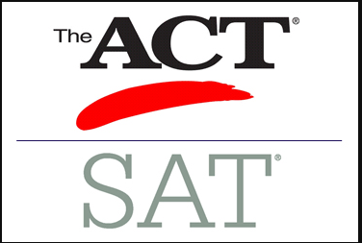

### Important things to know

### Q&A

Should I guess or skip questions?

* (Applies to both ACT and SAT) You get one point for every right answer since there is no wrong answer penalty, so you should bubble something in for every question.

What are Rigor Requirements?

* Rigor courses: Advanced Math, Advanced Science, Advanced Foreign Language, Advanced Placement (AP) in core subjects, International Baccalaureate (IB) in core subjects, Dual Credit Enrollment courses in core subjects taken at an eligible postsecondary institution.
* Students graduating on or after May 1, 2017 must earn four full credits from the above list.

ACT

Why take it?

* Colleges use ACT scores for admissions and merit-based scholarships.

Test Structure:

* English
* Math
* Reading
* Science Reasoning
* Essay (Optional)

Length:

* 2 hours, 55 minutes (without essay)
* 3 hours, 40 minutes (with essay)

Reading:

* 4 reading passages

Science:

* 1 science section testing your critical thinking skills (not your specific science knowledge)

Math:

* Covers:
* Arithmetic
* Algebra I & II
* Geometry & Trigonometry

Calculator Policy:

* You can use a calculator on all math questions
* Essays:
* Optional. The essay will test how well you evaluate and analyze complex issues.

How it’s scored:

* Scored on a scale of 1-36

*Content-Based*

SAT

Why take it?

* Colleges use SAT scores for admissions and merit-based scholarships.

Test Structure:

* Reading
* Writing & Language
* Math
* Essay (Optional)

Length:

* 3 hours (without essay)
* 3 hours, 50 minutes (with essay)

Reading:

* 5 reading passages

Science:

* None

Math:

* Covers:
* Arithmetic
* Algebra I & II
* Geometry, Trigonometry and Data Analysis

Calculator Policy:

* Some math questions don’t allow you to use a calculator.

Essays:

* Optional. The essay will test your comprehension of a source text.

How it’s scored:

* Scored on a scale of 400-1600

*Critical Thinking and Problem-Solving*

“Outside the box thinkers”

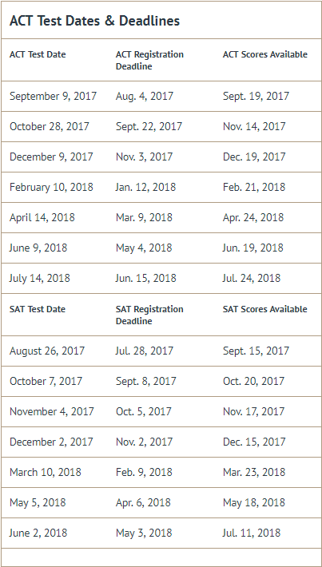

**ACT Test Dates & Deadlines**

**Test Date Deadline Late Deadline**

September 9 August 4 August 18

October 28 September 22 October 6

December 9 November 3 November 17

February 10 January 5 January 19

April 13 March 8 March 22

June 8 May 3 May 17

July 13 June 7 June 21

**SAT Test Dates & Deadlines**

**Test Date Deadline Late Deadline**

August 26 July 28 August 15

October 7 September 7 September 26

November 4 October 5 October 24

December 2 November 2 November 21

March 9 February 23 February 27

May 4 April 19 April 23

June 1 May 17 May 21

GPA Scale:

A= 4.0

B= 3.0

C= 2.0

F= 0.0

Check your HOPE average today at:

GaFutures.org

### Hope vs. Zell miller

Hope Scholarship

* 3.0 GPA in all academics
* 4 Rigorous course minimum

Zell Miller

* 3.7 GPA
* ACT= 26 composite or
* SAT= 1200 (CR+ Math)
* 4 Rigorous course minimum

Hope Grant

* Technical Colleges

Hope Scholarship: 90% tuition paid

Zell Miller Scholarship: 100% tuition paid

IF YOU DO NOT RECEIVE HOPE AT THE END OF THE YOUR SENIOR YEAR, YOU WILL ONLY BE ELIGIBLE TO REGAIN IT ONCE

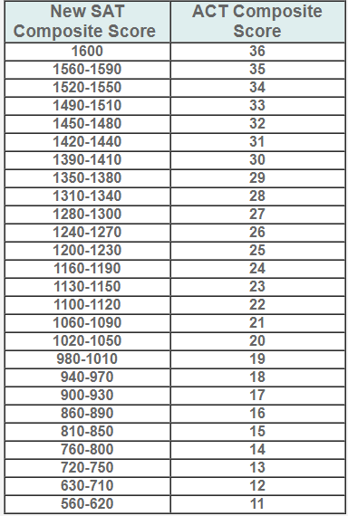

For SAT: Register online at www.collegeboard.org

Registration fee: $60.00

Late fee: $30.00

For ACT: Register online at www.actstudent.org

Registration fee: $68.00 | w/writing: $93.00

Late fee: $36.00

Free Waiver Available for Students on Free or Reduced Lunch. See Mrs. Rolison in the counseling office or email her at rolison.nicole.h@muscogee.12.ga.us

SCHOOL CODE: 110838

How do Sat and ACT scores compare?