Two Methods To Post Scores for Standard Base Grades

* **Post Grades:** May be used to enter grades for all standards except upper/ lower cases letters and identify numbers.
* **Grade Book:** Must be used to enter grades for upper/lower case letters and identify numbers standards.

**Post Grades Method**

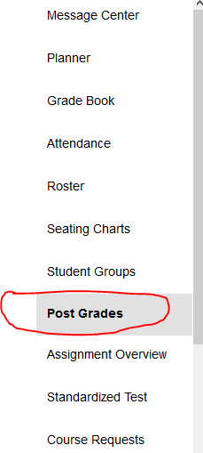

Select The Course

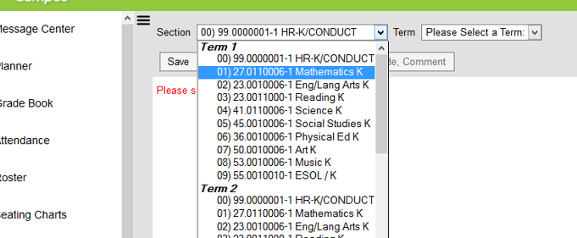

Select The Term and Standard

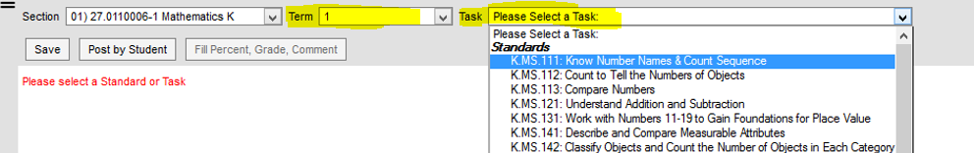

To Fill All Grades with the same score, click on Fill Percent, Grade Comment

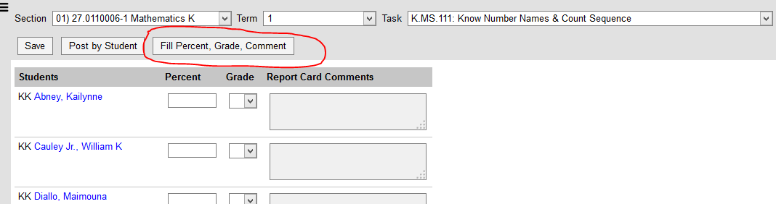

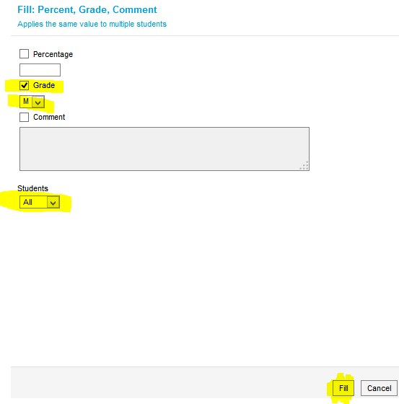



Click “Save” after editing all scores.

**Grade Book Method**

This method **must** be use for upper/lower case letters and identify numbers standards.



Select The Course

**Select The Term and Standard**

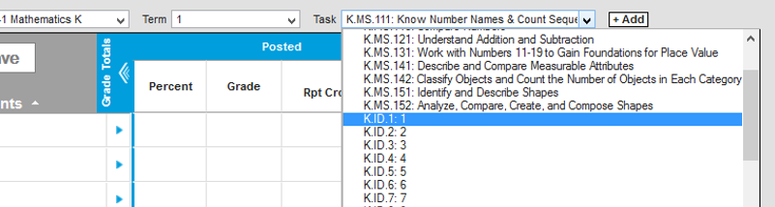

**Select the Score. Click Save after entering all scores.**

