**How to Set the Grade Book as the Default**

1. 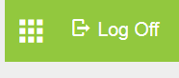

Click on the Icon by Log Off

1. 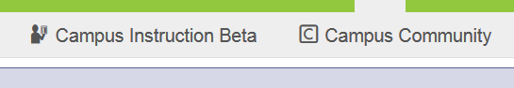

Click on Campus Instruction Beta

1. 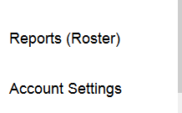

Click on the Account Setting in the bottom left hand corner

1. 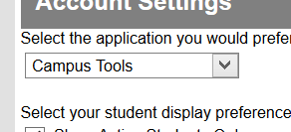
2. 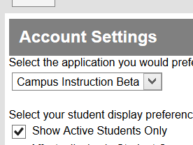

Click on the Drop Down and Choosing Campus Instruction Beta. (4 and 5) and then Save.