**Transferring Students from one MCSD School to Another**

Using the Admin login, select the tab ‘School Data’. Select ‘Manage People’.

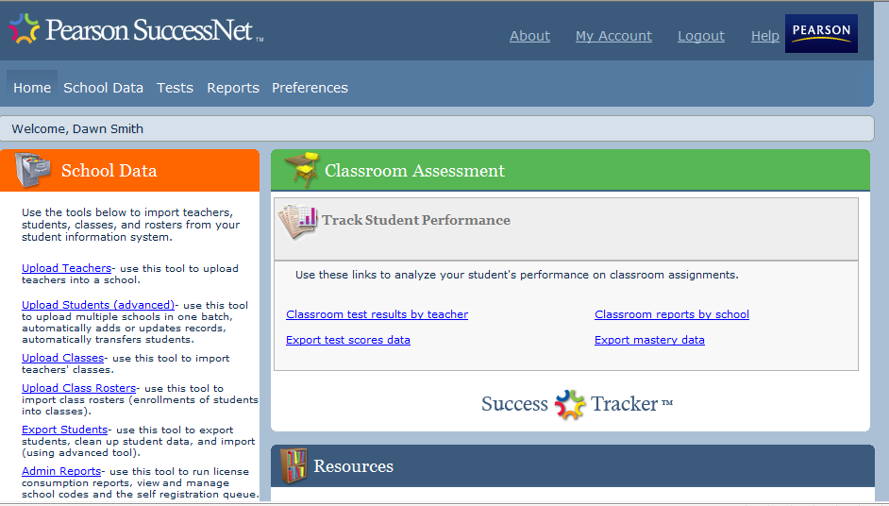

Your school name should be listed as ‘School’. From the ‘Role” drop down select ‘Student’. Your search can be narrowed by grade level. Click on ‘Search’.

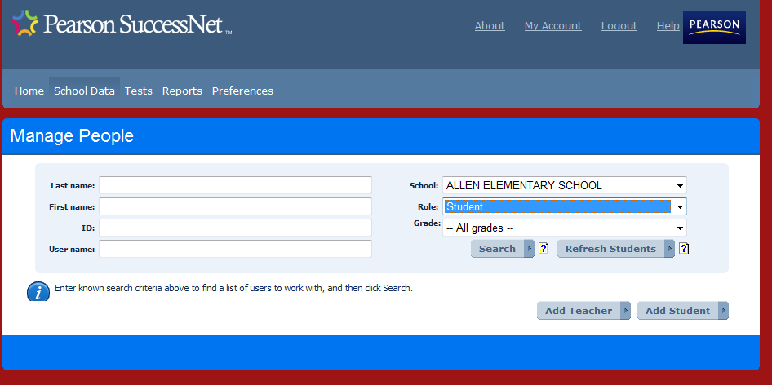

The next screen (not pictured) will list all students in the search. Click on the ‘School Name’ for the student you wish to transfer.

The screen below will pop up. Select the school that the student is transferring to. This removed them from your school and adds them to their new school.

The teacher at the new school will add them to their class and the student will be ready to go. Student data will follow the student to the new school.

