**Directions for setting up enVisionMATH**

**Product Selection and Calendar**

Log in to Pearsonsuccessnet.com

User Name: E# Password: mc+ 6 digit birthdate (mcmmddyy)

**PRODUCT SELECTION:**

Before you can begin to use PearsonSuccessNet you will be prompted to ‘Manage Products’. You will select six (6) products: Mathematics 2012 CC Grade K-5 Access Packs. Save your selections,

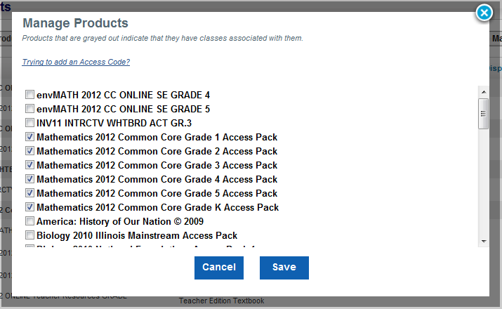

After selecting and saving, you can ‘Hide’ the grades that you do not need. They will not show up on the HOME page, however you will be able to access them from the CONTENT and PLANNING pages for differentiation.

**CALENDAR:** Use the Grade Level Curriculum Map and the Calendar Template to help.

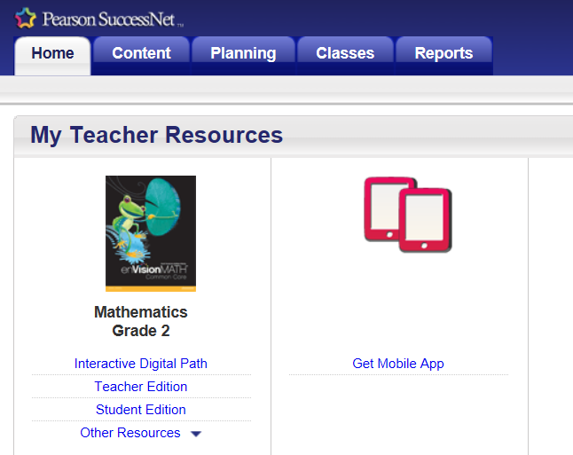

**Select**

Planning



Select

Lesson Planner

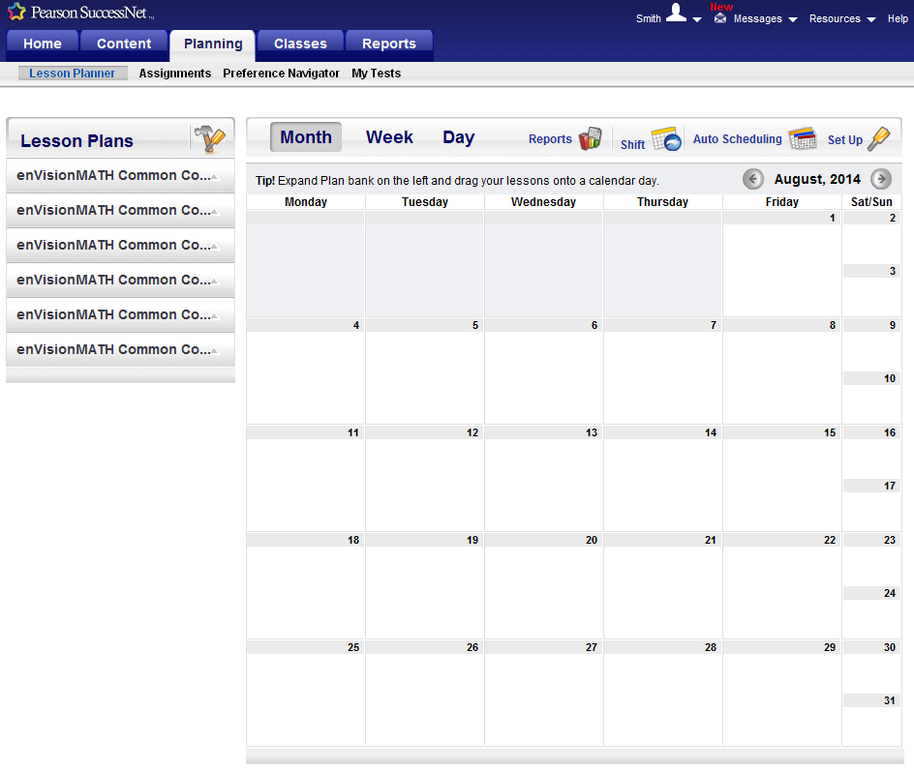Your Screen Should Look Like This

Select

Set Up

This screen will pop up on top of the existing screen.

Add a Period by selecting the ‘ +’. The Period establishes that you teach math sometime Monday – Friday.

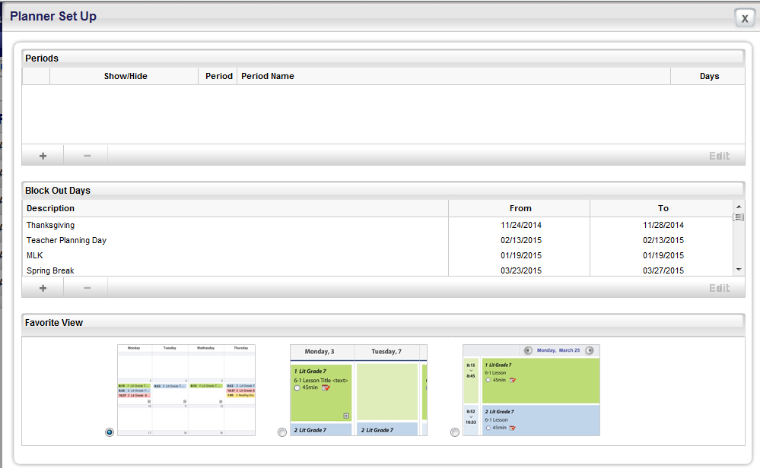

First, complete the Period, Period Name, and check M-F. Then select ‘set’

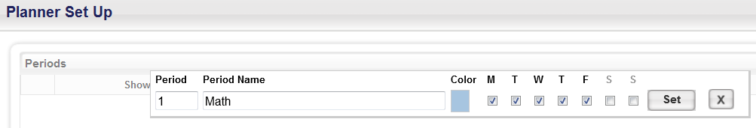

Next, you will add all Block Out Days by selecting ‘+’ **(*Follow the calendar template for holidays, review days, and assessment days*)**



You will enter each Block Out Day (holiday, inservice, spring break, assessment date, etc.) by title, start and end dates, and then select ‘set’



After all dates have been selected, go back to the calendar by clicking the X

Your Screen Should Look Like This

Select the drop down arrow to open the Lesson Plans

(You will see all lessons 1-5 and K. Select your grade level.)

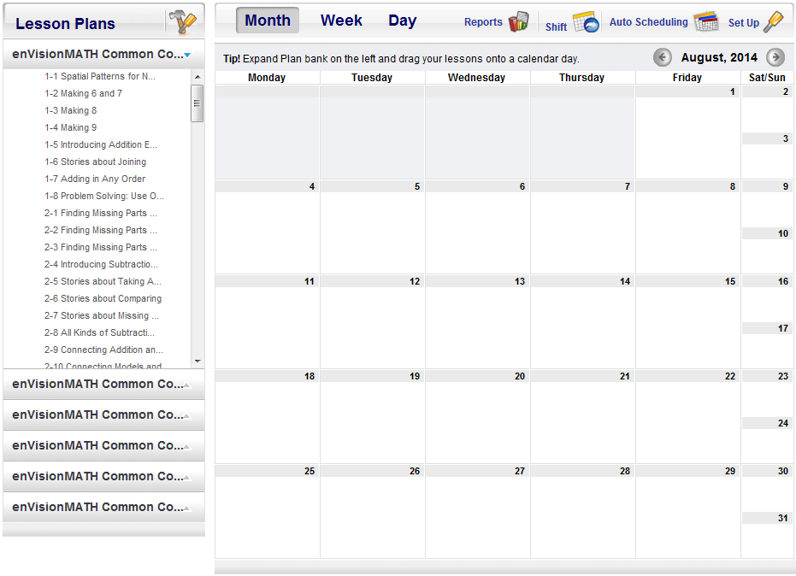

Click and drag the lesson to the day on the calendar

This screen will pop up on top of the existing screen.

Check ‘Math’ and ‘Save’.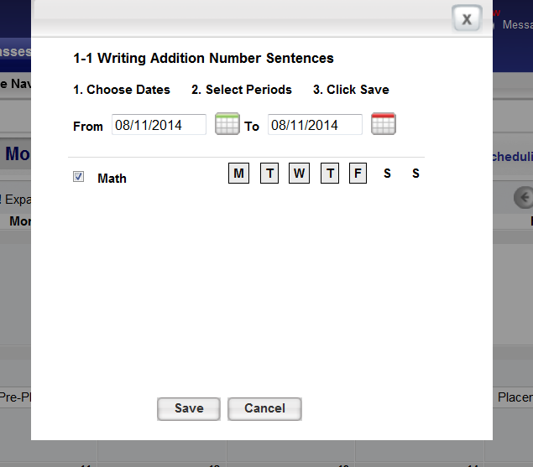

You will drag each lesson from the 16 topics to the calendar.