**HOW TO SET UP YOUR CLASS in enVISION MATH**

**After you have set up your Calendar**, you will need to setup your class. Students that are enrolled in Infinite Campus have been uploaded into EnVision math online.

Select the **Classes** tab from the options at the top. Click on the **Manage Classes** under the HOME button.

You will want to name your class:

Teacher Name Math 14 15

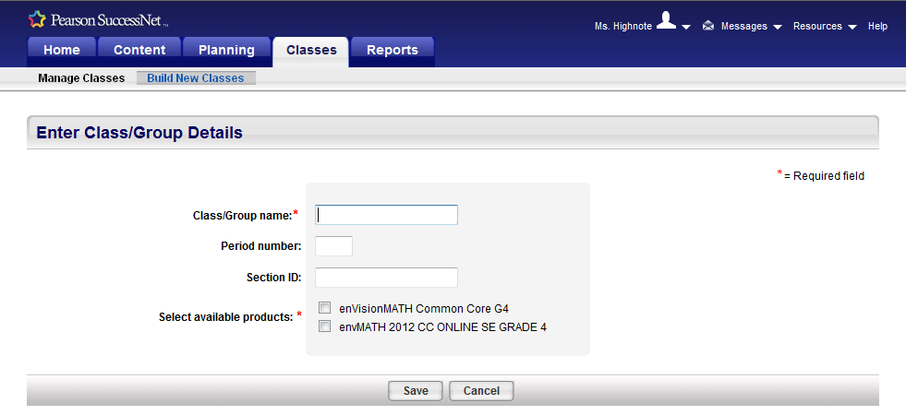

**Save**

A new window will load. This new window will look like this. Next click **view** under the blue Roster button.

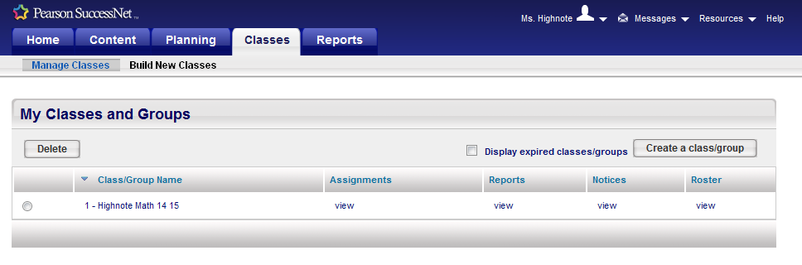

A new screen pops us. enVision wants to know how you want to identify students. You will use **Select from a school roster.**

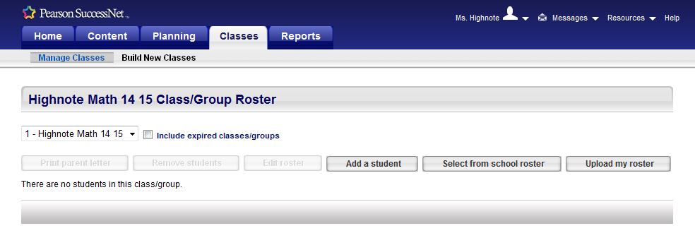

Select the grade you teach then click on search. You should see all students in the selected grade from the drop down menu.

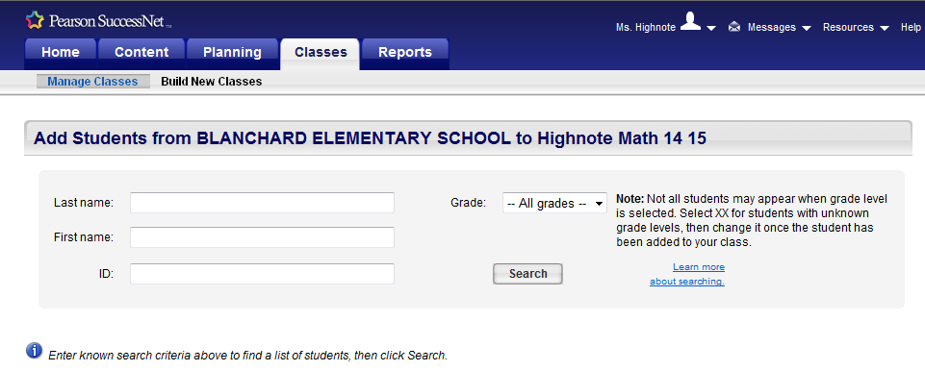

Next click the box next to each student for your class. When you get to the bottom of the page **Save**. You can add more students from the next page and **Save** again.

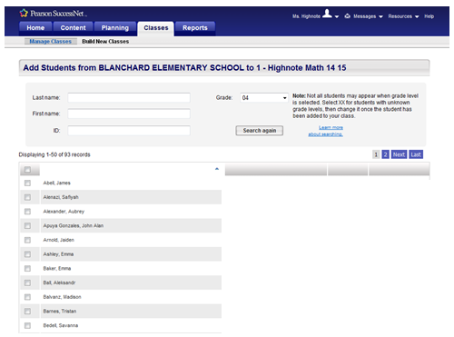

Once all students have been added, check to see that the total numbers you have added (in green) match the numbers on your roster.

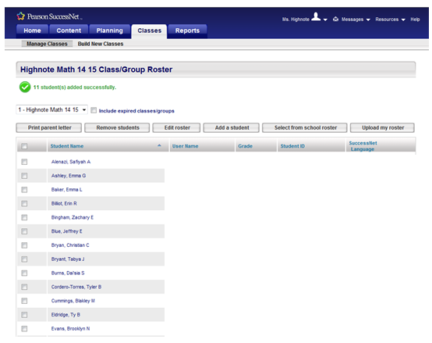

Here you can select the option to print a letter to send home. If you’d like to send it to your entire class click the first box at the top of the boxes next to the student names. This will select all the students and you can print it out with the personalized letter for each child. These letters explain how to access and log in to SuccessNet.