**Adding Students New to MCSD**

Using the Admin login, select the tab ‘School Data’. Select ‘Manage People’.

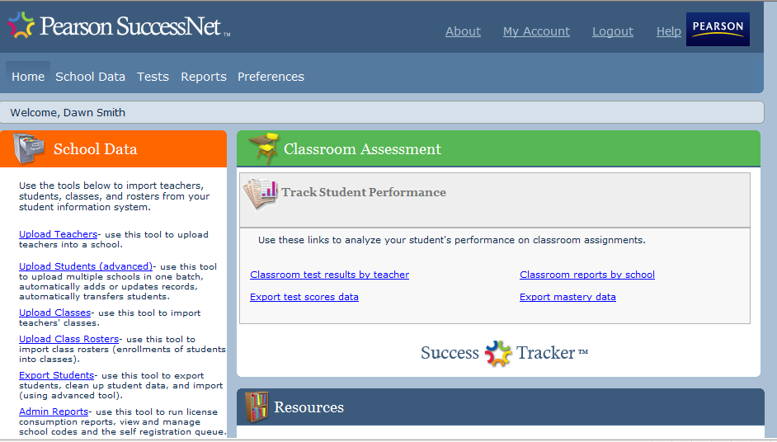

Your school name should be listed as ‘School’. Click on ‘Add Student’.

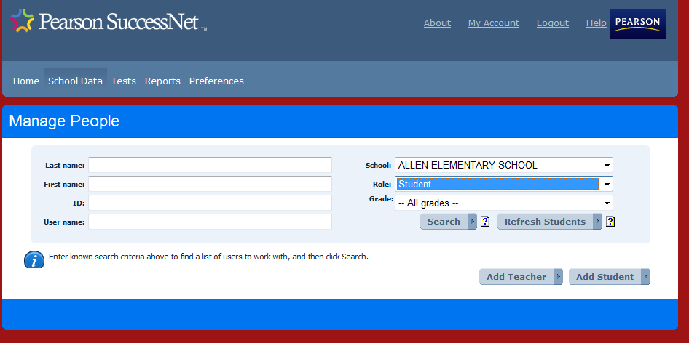

The screen below will pop up. Put 319 in the ‘Enter Zip Code’ box and all MCSD schools will populate. Select your school. Fill in:

First Name

Last Name

User Name (GTID)

Password (initpass1)

Confirm Password

Save

