n  Feedback  Visit Our Parent Resource Center/Area  All Stakeholders at Forrest Road Elementary School are invited to give suggestions, comments, and feedback. For any part of the Parent and Family Engagement Policy and School-Parent Compact that you feel is not satisfactory with the students’ and the school’s goals for academic achievement, please provide suggestions and feedback. Please send those suggestions and/or feedback to the school office and/or Parent Contact Representative. Thank you for your continued support!  Thank you for your continued support!  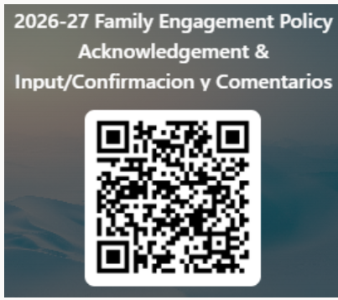   |  | Parent Resource Center | Our Parent Resource Center/Area has learning games, books, workbooks, and many other resources available for families to check out or keep for use at home. Let us know if we can help you find resources, navigate the Parent Portal, connect with teachers, and learn about ways you can help your children at home.  Our Parent Center/Area is located in Room #21.  Please contact the school for additional information about our Parent Resource Center, resources available for checkout, and volunteer opportunities.  School Phone Number: (706) 565-3061  Website: http://sites.muscogee.k12.ga.us/  forrestroad/  Muscogee County School District Mission  Our mission is to inspire and equip all students to achieve unlimited potential.  Muscogee County School District Vision  MCSD is a beacon of educational excellence where all are known, valued, and inspired.   |  |  | 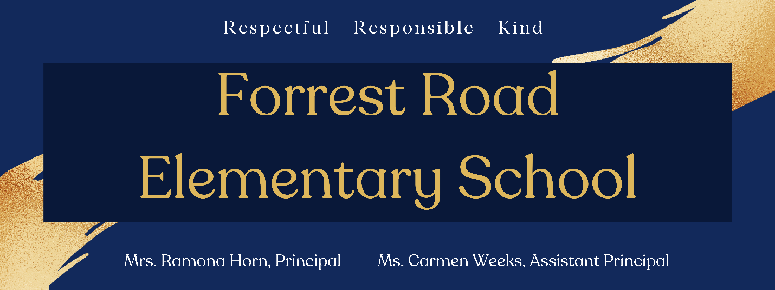  Parent and Family Engagement Policy & School-Parent Compact 2026-2027    Revised: August 17, 2026  Principal, Ramona Horn  Asst. Principal, Carmen Weeks  6400 Forrest Road  Columbus, GA 31907  706-565-3061  http://sites.muscogee.k12.ga.us/forrestroad/

Our School Goals  Forrest Road Elementary School will provide all students with high-quality curriculum and instruction in a supportive and effective learning environment to meet high academic standards.  School’s SMART Goals:  - SIP Goal(s): By May 2027, Forrest Road Elementary School will implement a Tier 1 teaching and learning framework, resulting in 5% growth in ELA and Math from the BOY to EOY, as measured by STAR data.  - SIP Goal(s): By May 2027, as part of a Multi-Tiered System of Support (MTSS), FRE will decrease the number of Office Discipline Referrals (ODRs) by 5% from the 2025-2026 school year as measured by comparative data.  Parent and Family Engagement Standards  Forrest Road Elementary School and our parents have adopted the National PTA Standards for Family-School Partnership as the school’s model in engaging parents, students, and the community.  The National PTA Standards are:  - Welcoming All Families  - Communicating Effectively  - Supporting Student Success  - Speaking Up for Every Child  - Sharing Power  - Collaborating with Community |  |  | Working Together to Ensure Success    Forrest Road Elementary will work with students and their families to promote and support students’ academic success. Some of our key connections with families will be:  - Coordinate activities and share strategies with families on how to help students at home.  - Monitor student progress in reading and math and update parents frequently.  - Establish open lines of communication with parents concerning their child’s school performance.  - Increase personalized learning for all students.  Ramona Horn, Principal   |  |  |   As Students, we will…  - Work hard in all subjects to be successful in school.  - Ask for help and understanding as soon as it is needed in any subject.  - Practice the different strategies learned in the classroom to help me academically.  - Increase Lexile scores for reading.    As Families, we will…  - Stay engaged and communicate with the teachers to help with the success of my child  - Practice writing and math frequently with my child at home.  - Attend Parent and Family Engagement Workshops.  - Monitor my child’s academic progress.

Our District Goals
ENGAGING AND EMPOWERING FAMILIES WITH…

- By June 2031, Muscogee County School District will increase the percentage of students performing at or above grade-level readiness by 20 percentage points through the implementation of evidence-based instructional  practices, targeted interventions, and ongoing progress monitoring across all schools  - By July June 2031, Muscogee County School District will reduce districtwide chronic absenteeism by a minimum of 20% from the established baseline  year (2025–2026), as measured by official student attendance data reported through the state  accountability system.  How is the Parent and Family Engagement Policy and School-Compact developed and revised? |  |  | School Measures to Provide Required Assistance: Forrest Road Elementary will take the following measures to promote and support parents:  Curriculum Information: Inform parents throughout the year about what their child is learning by providing parent and family engagement meetings and workshops, parent-teacher conferences, information on Canvas, and on our school website.  Student Progress Monitoring: Ensure families are familiar with the online resource Infinite Campus (Parent Portal) that allows families to view grades, attendance, schedules, assessments, course history, and much more. Monitoring student progress in school is an important way to be involved in their education.  Parent Resources: Create and maintain a Parent Resource Area/Room to allow parents opportunities to check out materials to assist them with helping their child at home. Resources are available in English and Spanish.  Staff Trainings: Conduct staff development quarterly on parent involvement practices and effective strategies for staff to communicate and build partnerships with parents.  Communication: Ensure all information related to school workshops, programs, meetings, and activities are published in both English and Spanish and communicated on a regular basis.  Transition Support: Partner with early childhood programs, elementary schools, middle schools, high schools, college and career organizations, parent resource centers, or other programs (as applicable) to help prepare families and their children for successful school transitioning. |  | Communication | Forrest Road is committed to keeping open lines of  communication with families. We have several ways to communicate. We utilize two-way communication through the school website, email, phone calls, parent conferences, social media, Infinite Campus and Canvas to reach our students and families.  Forrest Road will also provide materials at conferences and workshops to help parents work with their children at home. Parents can request additional conferences by contacting the school or their child’s teacher. Transportation and childcare may also be offered for parents to prevent barriers to family engagement. For all students who reside in residential facilities served by the Muscogee County School District, parental involvement correspondence and activities will be mailed to each facility where students reside. If you need interpretation and/or translation services, please contact the school at (706) 565-3061.  Some of the ways you can expect us to reach you are:  - Class Dojo  - Weekly homework folders  - Connect-Ed phone calls and/or text messages  - Updates on the school’s website  - Parent Emails  - Parent-teacher conferences  - Canvas  - Student agendas  - Informational flyers and permission forms
Each Title I school will conduct a yearly family meeting to review and revise the Parent and Family Engagement Policy and School-Parent Compact. Invitations will be sent to all families to provide input on revisions to the policy/compact. Families are welcome to provide input throughout the year via feedback forms, emails, comments, or telephone. The revised policy/compact will be available throughout the year in our parent resource area and on our school website.  Where is the Parent and Family Engagement Policy and School-Compact available and who is it for?  The Family Engagement Policy/School-Parent Compact and all other Title I information is designated for all families and is available on our school’s website under the Title I Parent Section. Families can also find paper copies of the Parent and Family Engagement Policy/School-Parent Compact in our Parent Center/Area and at Parent and Family Engagement meetings. All families at Forrest Road are encouraged and invited to fully participate in the opportunities as described in our Parent and Family Engagement Policy/School-Parent Compact. Forrest Road will provide full opportunities for the participation of families with limited English, parents with disabilities, and parents of migratory children. |  |  | What is a Parent and Family Engagement Policy?  The Parent and Family Engagement Policy describes how Forrest Road Elementary School will provide opportunities to improve parent and family engagement to support student learning. Forrest Road Elementary School values the contributions and involvement of families in order to establish partnership for the common goal of improving student achievement. The Parent and Family Engagement Policy describes the different ways the school will support parent and family engagement and how families are encouraged to be full partners in the decision-making of their child’s education.  What is a School-Parent Compact?  The School-Parent Compact is a written agreement that outlines how our school, our students, and our families will work together to ensure the academic success of all students. An effective School-Parent Compact contains the following elements:  - Jointly developed by families, school staff, students, community business partners, and other stakeholders during our review meeting  - Clear learning goals that are linked to the school’s improvement plan  - Specific skills students will learn during the year  - Strategies that staff, families, and students will use to improve student learning  - Ways to extend learning at home  - Methods teachers and family members will use to communicate about student progress  - Opportunities for family members to observe and participate in the classroom  - Review and revise the School-Parent Compact at meetings and workshops throughout the year to assure we are diligent in our efforts to support academic success for all students. |  |  | What is Title I?  Forrest Road Elementary is identified as a Title I school as part of the Every Student Succeeds Act (ESSA). Title I is a federal grant that was designed to ensure that all children receive a high-quality education and reach grade level proficiency. Title I programs must be based on effective means of improving student achievement and include strategies to support parent and family engagement. Parents and family members of children receiving services shall be involved in the decisions regarding how funds reserved are allotted for parent and family engagement activities and resources.  Building Partnerships  Forrest Road Elementary collaborates with families and community partners to provide multiple workshops and trainings at various times that meet the needs of the parents and support Parent and Family Engagement at the school. We will offer the following activities to build our partnership with families:  - Annual Title I Parent Meeting - To inform parents of the requirements of Title I and the school’s participation as well as the parents’ rights under Title I.  - Parent and Family Engagement/School-Parent Compact Review Meeting  - Literacy and Technology Meeting  - Math Night Meeting  - Georgia Milestones Meeting  - Transition Meetings  - Additional Activities to Build Parent Capacity  Please visit our website regularly and check emails/notifications to learn about dates, times and other details about upcoming events.  http://sites.muscogee.k12.ga.us/forrestroad/

