
Magnet Academy
Encouragement • Commitment • Motivation Achievement


Student Handbook 2019 – 2020

Ms. Tamura Magwood, Principal
Dr. Michael Seckinger, Assistant Principal

6100 Georgetown Drive
Columbus, Ga 31907 (706) 565-3026
East Columbus Magnet Academy
Mission, Vision, and Values of School District

Mission: To inspire and equip all students to achieve unlimited potential.
Vision: The MCSD is a beacon of educational excellence where all are known, valued and inspired.
Values: MCSD fosters a healthy organization where…
WE embrace equity and diversity
WE hold ourselves and others to the same high standards
WE commit to continuous learning and improvement
WE treat everyone with dignity and respect
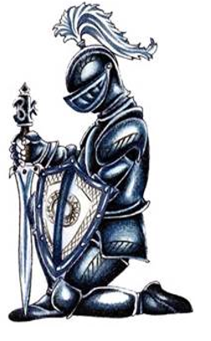
… as WE serve the needs of others
I am an ECMA Knight!
I Encourage Everyone
I am Committed to Excellence
I am Motivated for Academic Achievement
I begin to achieve when I begin to believe.

Go Knights!

Table of Contents

Arrival to School ………………………………………………............. 3
Attendance and Absences …………………………………............ 3-8
Breakfast and Lunch Program ………………………………………… 8
Care and Use of School Property ………………………………… 9-10
Conferences, Guidance, Clinic & Media Center …………… 10-13
School Uniform and Dress Code ……………………………….. 13-17
Academic Courses, Grading, Report Cards …………………. 17-23
School Safety ……………………………………………………….. 23-25
Student Behavior and Discipline ……………………………… 26-33
ECMA Bell Schedule ……………………………………………………. 34
MCSD 2019-20 Calendar ……………………………………………… 35



Arrival to School

Students may enter ECMA no earlier than 8:00 am. Students arriving between 8:00 am and 8:15 am must report to the gym upon arrival. At 8:15 a.m. students will have the option to stay in the gym or attend breakfast. Whichever place a student decides to be will be where he/she will need to stay until the bell rings for 1st period. When the first bell rings at 8:40 a.m., students will report directly to Homeroom. After 1st period begins, they should not be in the halls without a hall pass. Students should not be on school property other than at supervised times.

Attendance and Absences

ECMA is committed to the philosophy that every student should attend every class, every period, every day. Daily attendance and promptness are expected in all classes and are essential for success in school.

1. Daily Absence Reporting:
a. Parents/guardians should notify the school each day a student is absent.
b. Students who are absent without a parent or guardian’s excuse may be considered truant.
c. All absences, including those approved in advance by parents or guardians or school administration, except those for school-sponsored activities, will count against a student’s attendance.
d. ECMA encourages parents to schedule doctor and dental appointments after school hours.
e. Excessive absences will affect a student’s academic achievement.
f. Parents/guardians may be required to submit supporting documentation in order to excuse the absence of their student if student absenteeism is excessive. For example, in order for the absence to be excused, parents/guardians may be asked to submit written notification from a licensed physician stating the reasons why a student is unable to attend school.
g. Students who are absent (excused or unexcused) the day of an extracurricular activity (dance, sporting event, trip, etc.) are not allowed to attend the extracurricular activity.
h. Students who have unexcused absences because of suspension, who miss class because of discipline referrals, or who are excessively tardy to school (5 or more tardies) will be prohibited from participation in after school activities (dances, ball games, club meetings, etc.) for a period of nine weeks.
i. Students who are excessively tardy (5 times) to school will not qualify for recognition for perfect attendance.

2. Tardiness
Students arriving after 8:50 A.M. are counted tardy. Students must be checked in with a parent/guardian if the student arrives after 9:00 A.M. In order to be counted present, a student must attend at least half of the school day (12:20 P.M.). If a student must leave the building for an appointment during physical education class, he/she may secure a pass from the front office before school begins to make check-out easier.

Students who are frequently tardy, either at the beginning of the day or to classes during the day, may be subject to the below disciplinary measures:

* Three unexcused tardy days, school contacts parent/guardian.
* Five unexcused tardy days, referral to School Administrator (Principal) or designee and a mandatory parent conference and counselor referral.
* Ten unexcused tardy days, referral to School Social Worker and to support agencies outside of the district, as Principal deems appropriate (DFCS, Juvenile, et al).
3. Excused/unexcused Absences

In the case of a necessary absence from school, a student must bring a written note from the parent/guardian, doctor, court, or dentist. The note should state the student’s name, date(s) of absence(s), reason for the absence(s), date of excuse, appropriate signature and phone number so parent, physician, agency can be reached to verify the note. The note must be given to the ILT teacher on the day the student returns to school. The absence shall remain unexcused if no note is brought within three days.

State law recognizes the following reasons as excused absences:

- Personal illness
- Death in immediate family
- State recognized religious holidays
- Principal’s approval of attendance at school related experiences
- Absences mandated by governmental agencies
- Instances where attendance would be hazardous
- Serving as a page in the General Assembly of Georgia
Unexcused absences include, but are not limited to, the following:
- Oversleeping (student or family)
- Missing the bus
- Babysitting
- Joining the family on vacation
- Skipping school
- Cutting class
- Out of school suspension
- Car trouble
- Out of class for discipline referral
- Failing to bring a note from parent about absence
Potential consequences for repeated unexcused absences
5th Absence: Social worker referral
10th Absence: Social worker referral and Attendance Agreement
15th Absence: Social worker referral and Court referral

4. Make-Up Work

When a student is absent, it is the student’s responsibility to ask for missed assignments within 3 school days of returning to school. The student must return all make-up work to each teacher within the time limit decided upon by the teacher. It is the student’s responsibility to turn in make-up work without having to be given reminders. This includes students returning from suspension.
5. Extended Illness or Injury
In case of an extended illness or injury, parents should contact the counselors to determine if the services of a visiting teacher are required. A hospital/ homebound teacher may be assigned to a student who will be absent for ten or more days due to illness or injury.
6. Check In / Check Out
When a student arrives late to school (after 8:50 A.M.), he/she must come to the tardy table before going to class. It is not necessary for parents to accompany students to the office; however to be excused, the school must have a note indicating why he/she is late. The note should be given to the office receptionist who will pass it on to the homeroom teacher. The student will be given a pass to class.
If a student is to be dismissed early, parents must come to the office and ask the office receptionist to call for the student. The parent must sign the student out before the student can leave the building. Proper identification is required and person must be in IC or on student information sheet. It is helpful for the parent to know which class the student is in at the time the parent wants the student dismissed.
NOTE: If it is necessary for an older brother, sister, or friend to pick up a student, the student must bring a note to the office by 9:05 a.m. The office receptionist will call the parent to verify the note. All special request notes must be brought to the office at the beginning of the day in order to be verified by office personnel.
All parents, guardians, and visitors to the school that wish to visit any area of the school other than the front office must be entered into the ECMA Raptor system. After proper government-issued identification is provided, the visitor will receive a badge that must be visible the duration of the school visit.
Students will not be checked out after 3:00 PM unless an appointment card/printout from the doctor’s office can be presented or faxed. Due to safety issues, it is not possible to get messages to students. Transportation arrangements or changes in transportation arrangements should be made prior to the student coming to school.
7. Dismissal Procedures
School is dismissed at 3:55 p.m. Halls should be cleared within 10 minutes after the bell has rung (4:02).
a. All bus students should be at the bus loading area or in a classroom.
b. All students attending an “After School Program” should be in the designated area.
c. All students attending detention should be in the appropriate room.
d. All students attending other after school activities should be in the appropriate room or area.
e. Car riders must be picked up no later than 4:30 pm.

8. After School Activities: Athletic events, dances, concerts, club meetings, etc.
Students are supervised after school hours only for school-sponsored meetings and activities. Parents should be prompt in picking up their children from activities. Parents assume full responsibility for supervision of the students beyond a 15 minute period after the closing of any school event. Parents and students should not depend upon the school telephone being available so that a student may call when the school event is over.
NOTE: Students who are not picked up within the given time after the ending of an event will not be allowed to attend extracurricular activities.

Breakfast and Lunch Program
ECMA is a Free Breakfast and Lunch location.
Menus
Monthly menus can be found on the MCSD website. Menus may change on a very short notice due to market conditions, deliveries, or special school activities.
Special Dietary Needs
School Nutrition will accommodate food allergies and special dietary needs when documentation from a doctor is provided. MCSD SNP will make modifications and substitutions to the regular school meals for a student with a disability that restricts their diet. Special Dietary Needs Prescription Form must be completed and signed by a physician for a student with a disability before the school cafeteria can provide any modifications or substitutions.
The completed form must be provided to the school cafeteria Manager, the clinic worker, and the special needs dietitian. A form and instructions can be found on the School Nutrition page of the MCSD web site, or at the school clinic or cafeteria. Nutrition analysis chart for menu items is available on the website.

Care and Use of School Property
Chromebooks, Textbooks and Media Center Checkouts
ECMA students will be held responsible for the proper care of all books, supplies, Chromebooks, accessories or equipment furnished to them by the school. Students who deface, damage or lose (including theft) school property shall be required to pay for the damage or loss.
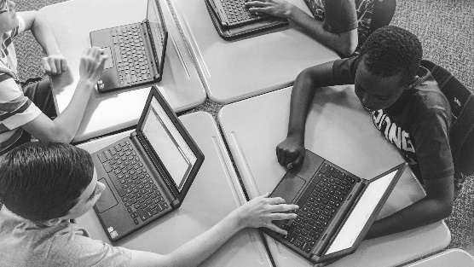

Book Bags

To help ensure that Chromebook computers assigned to each student remain undamaged, students are encouraged to use clear book bags. The use of clear book bags is permitted during the school day, including in classrooms, class changes, and travel to and from the dining room and the gym area.
If a student carries a non-clear book bag, it must be placed in the hall locker before the morning tardy bell. Non-clear book bags must stay in the locker throughout the day and are not permitted in classrooms at any time and in hallways during class changes. Non-clear book bags are not to be carried to the dining room or to the gym area. Any bag large enough to accommodate a book will be considered a book bag.
Lockers
Homeroom teacher will issue hall lockers to students. A rental fee of $7.00 will be charged for each locker. This fee covers the expense of changing combinations and replacing worn hardware on each locker each year. Students who rent lockers are expected to cooperate with the following:
a. Use only the locker that has been assigned to the student.
b. Do not allow other students to learn the combination.
c. Each locker has a built in combination lock. No other locks are to be placed on hall lockers.
d. Keep lockers neat and do not attach pictures with any adhesive to the interior.
e. Realize that lockers are school property and that administration has the right to conduct locker inspections and/or searches when the need arises.
f. Students are not allowed to share a locker.
g. Lockers will also be available in the gym for $7 for those students that have been assigned a Physical Education class.
h. Lockers are not intended for the storage of valuable personal items, money, or jewelry. Students should only bring to school those personal items necessary for class. If brought, money and other personal items must be kept on the student at all times. ECMA cannot be responsible for personal belongings.

Conferences, Guidance, Clinic and Media Center
Parent/Teacher Conferences
ECMA teachers and administration encourages parents and guardians to schedule a conference if questions or concerns exists regarding a student’s academic achievement or classroom behavior.
a. Upon notification by note, email, or phone that a conference is requested, the teacher or administrator will schedule the earliest conference date and time that allows all of the students’ teachers to be in attendance. Note: parents should expect the meeting to be several days in advance, especially if student data must be collected prior to the meeting.

b. Because many ECMA teachers coach or have other extracurricular commitments, parents should not expect same day meetings.

Guidance and Counseling Services
ECMA is staffed with highly qualified counselors committed to providing responsive services to all students. Services include individual counseling, curriculum guidance, crisis support, and personal and social development.
Students desiring a visit to Guidance must first notify their teacher. In the cases of an emergency, the teacher will document the student’s location and send the student to Guidance with a signed pass. In nonemergency cases, the teacher will notify Guidance of the request and the student will be called to Guidance at an appropriate time.
Bullying

Bullying is defined as any willful attempt, or threat, to inflict pain/injury on another person or any intentional display of force which gives the victim reason to fear or expect immediate harm over a period of time. ECMA has no toleration for bullying in any of its forms and mandates students to inform a teacher, administrator, or guidance if they experience bullying or witness it occurring to another student.

Sexual Harassment
Sexual harassment is defined as the making of unwelcome, inappropriate, and hurtful sexual remarks or physical advances. This includes actions specifically targeting students identifying as lesbian, gay, bisexual, transgender and queer (LGBTQ). As with bullying, ECMA has no toleration for sexual harassment in any of its forms and mandates students to inform a teacher, administrator, or guidance if they experience it or witness it occurring to another student.
Clinic

There is a part-time nurse to supervise the clinic. Limited space allows only one student to be served. Students who are ill will report to the Clinic area where a parent will be called. The school does not supply any medication. Any medication whether over the counter or prescribed, must be supplied in the original container. Loose pills in a baggie or other container and liquid medicine in an unlabeled container cannot be dispensed. Prescription medicine, including inhalers, must have a copy of the pharmaceutical label attached to the container. Students cannot have medication, over the counter or prescribed, in their possession. All medications are to be delivered to the Clinic area and registered. The parent must complete a special form/ document before any medication can be administered at school. The student is responsible for reporting during the day to take his/her medication.
Media Center

The school Media Center contains many books, audiovisual items and technological equipment. A qualified media specialist is available to assist students.

The student will be charged a replacement value for lost and/or damaged library books. The student whose name appears as the checkout name will be held responsible for the book. The student is responsible for the book no matter where the book is left. A student must check out the book before it is taken home. Failure to pay for lost or damaged books/materials/ equipment may result in limiting the use of the Media Center resources to in-school use only.

Sign In: The student must sign in at the podium when they enter the Media Center without the teacher.
Checking Out a Book: All students will use their GTID to check out books. A book is due two weeks from the day it is checked out, excluding holidays.
Overdue Materials: If a student has overdue materials/books or has any outstanding fines from the previous year he/she may NOT check out any media center materials/books until the prior debt is paid.

School Uniform and Dress Code

Beginning the 2019-20 school year all ECMA students will wear the appropriate uniform that pertains to his/her grade level. Below details the uniform options for each grade level.

6th Grade
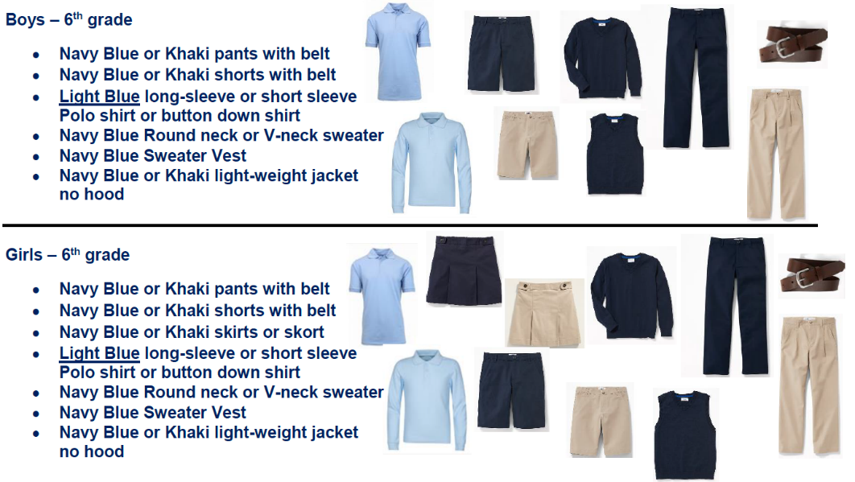

7th Grade
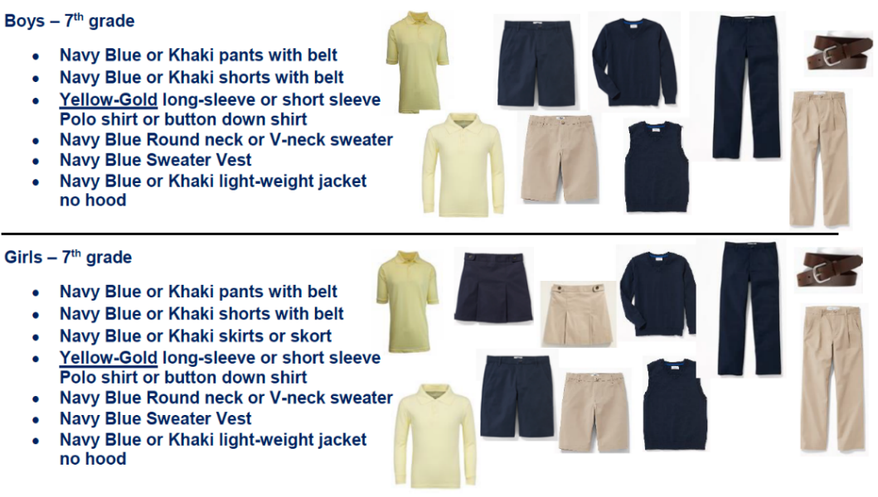

8th Grade
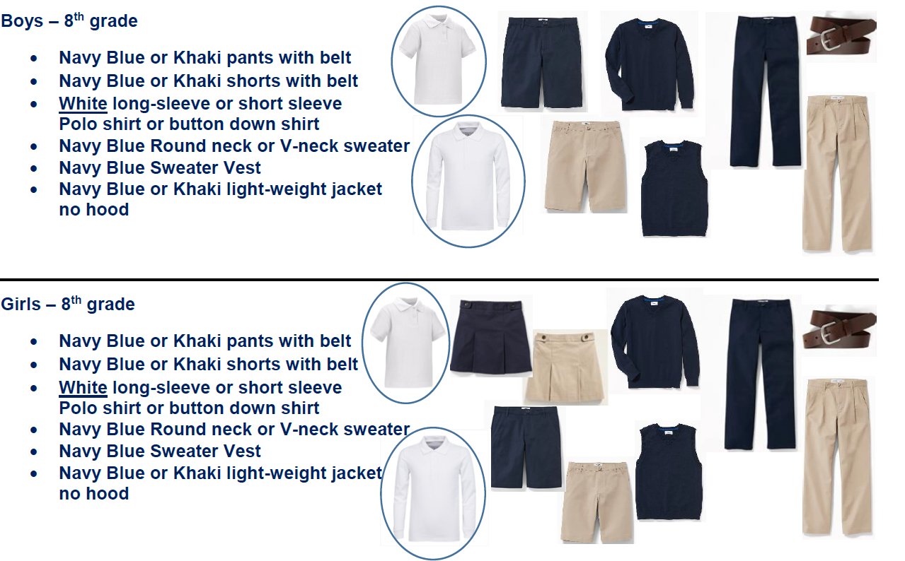

All Grades
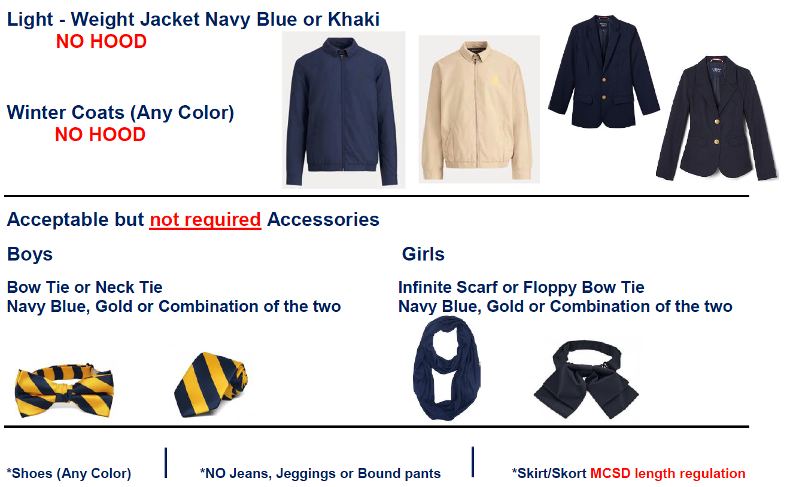

Knight Dress Down Days

At the discretion of school administration, students may be provided the opportunity to use PBIS points to purchase a one-day exemption to the uniform policy. During the school year, school administration will review and communicate to students the total PBIS points required and specific days they can be used. Below details the dress policy for those students participating in Dress Down days.

Shirts
ALL SHIRTS MUST BE TUCKED IN (Boys and Girls)
No undergarments are to be worn as outer garments (ex. plain, white t-shirts)
No midriffs should be exposed
No see-through shirts/blouses
No shirts that expose parts of undergarments
No tank tops, spaghetti straps, tube tops, or razor back tops
Nothing that advocates drugs, sex, alcohol, violence, gangs, hate, or profanity
Shirts that are made for females that cover the midriff but move when the student sits may not be worn
No jackets or shirts should be tied around the waist.
No oversized clothing is allowed.
Shoes
No shower shoes, flip flops, or bedroom shoes
No heels higher than two (2) inches

Pants
Pants are to be worn on or above the waist
No see-through pants
If pants can be worn properly on or above the waist, no belt is required Sweat pants and wind pants are not to be worn
No pants are to be worn bound at the ankle.
Pants cannot have rips, runs, holes, or tears that are more than 3 inches above the top of the knee.

Dresses, Skirts, Shorts
Dresses, skirts, or shorts may be worn with the length to be no higher than three (3) inches above the top of the knee cap.

Coats
Hooded garments (hoodies) may be worn to school, but the hood must be removed immediately upon entering the building. If wearing hoods in the building become a problem, hoodies will no longer be allowed to be worn in the school. All jackets with zippers or buttons must remain unzipped and unbuttoned at all times while inside the building as a safety precaution.

Hats
No head coverings i.e., bandanas, do rags, sweat bands.

Jewelry
No jewelry with reference to gangs, drugs, hate, violence, or sex is allowed. Items such as chains on a belt, wallet, etc. and items with spikes are not permitted. No metal picks or rat tail combs are allowed on campus.

Academic Courses, Grading, Report Cards, and Progress Reports
Traditional Academic Subjects

All ECMA students will take courses in the mathematics, sciences, language arts, and social studies each year in grades 6-8. Note: Select students will have the opportunity in 8th grade to earn high school credit in Physical Science and Algebra I.

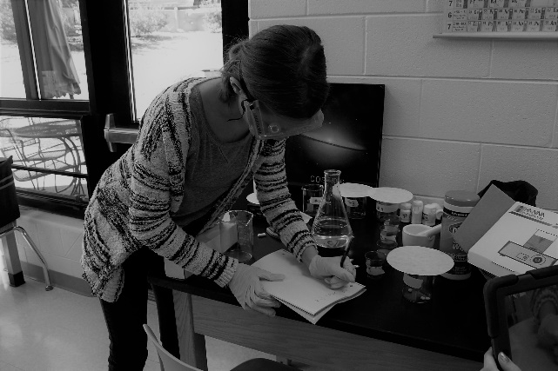

Special Education Services

ECMA’s highly qualified faculty and staff are trained to ensure that all students can achieve academic excellence. Students with special needs who meet the eligibility requirements are provided services in academic areas and emotional support as is warranted. The students receive help during all or part of the school day throughout the year. Information about these programs can be obtained from the classroom teacher, counselors or the administration.

Connections Courses
Connections classes provide students with a variety of interesting experiences that go beyond the traditional academic curriculum. These classes carry the same weight as academic classes. Students have a rotation of different connection classes each year, or take band, orchestra or chorus for the entire year.

Art

Art is taught to sixth, seventh, and eighth grade students. Students are taught visual awareness through the elements and principles of art by exploring drawing, painting, ceramics, printmaking, puppetry and sculpture. Student works are exhibited in the school, community, and several art exhibits.

Band

Band offers students in all grades the opportunity to learn to play musical instruments in the brass, woodwind and percussion families. Previous musical experience is not necessary. To help ensure student success, the band director counsels each student in selecting an instrument that is best suited for the student. Students have the opportunity to receive instruction in full band, small ensemble, and solo performance. A variety of musical styles are covered including symphonic, jazz, rock, Broadway, and pop.

Chorus

Choral music courses provide opportunities for students to develop their musical potential and aesthetic understanding through singing in a choral ensemble. These courses seek to give students in grades 6-8 experiences in the study and performance of a diverse repertoire of music. Study of vocal/choral music includes the cultivation of a beautiful singing tone, aesthetic understanding, and the ability to read music with fluency, the polishing of performance skills, responsible rehearsal habits, discipline, and the value of collaboration.
The chorus performs several times during the year and attends the district choral large group performance evaluation each year. Students in chorus have the opportunity to participate in the district honor choir and a chance to audition for the all-state chorus.
Computer Education/STEAM class (Robotics)

The purpose of the computer education program is to provide each student with an opportunity to understand both the capabilities of electronic information systems as well as an opportunity to know their applications and impact on society. Each student is provided hands-on experience using computer hardware and current types of applications software.
Computer education for sixth grade students is an introduction to microcomputers and keyboarding. Students learn to operate the computer. They work with prepared computer programs that support the middle school curriculum The seventh grade students will learn database and word processing skills. This computer utilization allows students to become more proficient with computers. Eighth grade computer courses combine keyboarding, computers, and technology of the business world to give students practical ideas of courses to take at high school as the course applies to careers. The utilization of word processing, database and spreadsheet helps students to create well designed, well-structured presentations for use in business and private life.
Health

Health is required for all students at each grade level. Units on human growth and development, human sexuality, drug abuse prevention, mental health, nutrition, safety and first aid are all part of the curriculum. Special emphasis is placed on skills such as responsible decision-making, refusal skills and conflict management. These life skills help students learn to appropriately meet the challenges of adolescence.

JLC (Junior Leadership Core)

Junior Leadership Corps is a three year Connections course offered to six, seventh, and eighth grade students. Lessons are designed to enhance students' leadership skills including: time and money management, goal setting, healthy relationships, working with groups, health and physical fitness, community service initiatives, and leadership in a diverse world. In addition to the JLC curriculum, students are required to wear the JLC uniform twice in a month and conduct dress for success once in a month, participate in drill and ceremony training, and perform ten hours of community service each nine weeks.

Orchestra

The orchestra program begins in sixth grade and offers sequential instruction to students through eighth grade. The program offers ensemble instruction in violin, viola, cello, and string bass. Previous musical training is not required Practice at home and concert performance are expected of students. Instruments are not available through the school.
Physical Education

All students take physical education. Physical education offers students instruction in team and individual sports. Students participate in activities such as volleyball, basketball, field hockey, soccer, softball, line dancing, and team handball.
Participation is an important part of the physical education grade. Students are required to dress out daily and must have a written note signed by the parent if they cannot participate. If the student cannot fully participate, the teacher will modify the program for up to three days. It should be used to cover colds, flu and short-term illnesses. When a student needs to be excused from physical education for more than three days, a doctor’s note is required Students are responsible for their personnel items during physical education. Lockers with combinations are provided in the locker room.

Spanish

HS Spanish is offered for eighth grade student for one HS credit.

Clubs and Organizations
Academic Bowl: General knowledge trivia, team competition against other middle schools.
Anime Club: Meets to discuss, show, and promote anime in a local community setting with a focus on broadening Japanese cultural understanding.
Art Club: Bringing together artists of the East Columbus area to share their interests and enrich their experiences in art, as well as making creative contributions to the community.
Book Club: Hosts student book discussions, book talk, book reviews and homework help.
Junior Marshal: The Junior Marshal Program aims to foster character development, service to community, and provide positive interaction between public safety personnel, students, and their parents.
Math Club: Math-talented students compete in competitions throughout the school year.
Science Club: Consists of 6th through 8th grade students - gifted to special education! Each month, members participate in an activity, project, or volunteer activity related to science. At the end of each year, a Science Festival is planned for all members who have participated in at least half of the events.
Science Olympiad: Team members compete in a variety of engineering, life science, earth science, and physics events to prepare for the regional competition at Columbus State University.
Spanish Club: A friendly organized group of people trying to partake in Spanish activities, learn more about Spanish-speaking countries, enhance your communication/speaking skills, expand your vocabulary and learn about foreign food.
Spelling Bee: A school-wide competition where contestants are asked to spell English words and the winners advance to district, state and national level competitions.
Student Council: The Student Government is an elected group of students who are responsible for promoting school spirit and awareness of others (through activities such as the canned food drive). Each 6th through 8th grade class has representation with officers elected from those grades.
Technology Club: A club that explores the World Wide Web and a variety of software such as graphic programs and word processing programs. The activities are designed to increase technological skills, extend student knowledge and complement school instruction.

Honor Society

The National Junior Honor Society is an organization that promotes appropriate recognition for students who reflect outstanding accomplishments in the areas of scholarship, leadership, citizenship, character, and service. National Junior Honor Society members participate in programs and activities that promote and support the five standards of the National Junior Honor Society so that they will become the leaders of tomorrow.
National Junior Honor Society is open to all seventh and eighth graders who choose to apply themselves and have met the established criteria. Students do not apply for membership; membership is granted only to those students selected by the East Columbus Magnet Academy’s Faculty Council (selection committee). This is not an election, nor is membership automatically conveyed simply because a student has achieved an honor roll in academic performance. A student’s demonstration of scholarship, leadership, citizenship, character, and service are carefully weighed and included in the selection process.
The scholarship requirement is based on a cumulative grade point average (GPA) of at least 86% on a 100 point scale. Academically eligible candidates will be evaluated on the basis of leadership, service, character and citizenship. A candidate must have been on the Honor Roll for each grading period.
Grading Periods
East Columbus Magnet Academy operates on a nine weeks academic grading period. At the midterm of a nine weeks period, any student with a grade of F will receive a midterm progress report. Report cards are issued to students at the end of each nine weeks. Students are to return the signed report card to the homeroom teacher. The grading scale approved by the Muscogee County School District is as follows:
- = 100-90 Excellent progress
- = 80-89 Good progress
- = 70-79 Needs improvement
F = 69 and below Not passing
Principal’s List and Honor Roll

Principal’s List honors outstanding ECMA students who have earned all A’s in a grading period while Honor Roll recognizes those ECMA students who have earned all B’s or better on their report cards. Principal’s List and Honor Roll students will receive school-wide recognition by participating in a “Walk of Fame” each nine weeks.

School Safety
ID Badge

In compliance with the request from School Security for the Muscogee County School District, student identification badges (ID badges) are made for all students. These badges must be worn at all times in school and at school activities/functions to identify the students attending East Columbus Magnet Academy. The following procedures are used.
- All students will be issued an ID badge and device to use for displaying the card.
- The ID card must be worn and visible on the student from above the waist to the neck.
- The ID card is QR-coded with the student information.
- If an ID card is lost, it must be replaced at a cost of $2.00 and $2.00 for lanyard replacement fee. A replacement ID can be purchased in the Media Center.
Riding the Bus

Students who live more than 1.5 miles from the school and whose addresses are within the school’s attendance zone are eligible to ride the school bus. Riding the bus is a privilege. Improper conduct on the bus will result in that privilege being denied. Students riding a bus will be expected to ride their designated bus. Each bus driver has complete charge of students riding the school bus. The Student Conduct Behavior Code applies. Students who refuse to obey the bus rules will be disciplined and may forfeit their right to ride the bus. Parents who have concerns about a bus driver should contact the school administration and transportation.
Emergency Drills
In order to maintain a safe environment for ECMA students to study and learn, it is necessary that we practice our emergency and crisis response plans by having drills designed to exercise our procedures. We will be conducting various drills throughout the school year. This letter is to promote awareness of the importance of this, as well as to understand each type of drill. The students and staff of your school will be practicing 3 primary emergency drills. They are “fire drills”; “lockdown drills and “severe weather drills”. Each type of drill is explained below:
a. Fire drills
The school will conduct a “fire drill” each month (except for two severe weather months) that school is in session. This is a Fire Code requirement as well as a requirement by Muscogee County Schools. We want each student to understand and be aware of the importance of this drill when the fire alarm is sounded.
b. Lockdown drills
The school will conduct periodic “Lockdown Drills”. This type of drill will secure the school building and safely shelter all students, staff and visitors inside the building. The purpose of this drill is to keep the students safe from any danger outside or inside the building. During a “lockdown drill” all of the perimeter doors to the classrooms and school building will be locked. They will remain locked until the danger or issue outside or inside the building is removed. To enable everyone to remain safe, no one will be allowed to enter or exit the building until the authorities authorize such a release.
c. Severe weather drills
The “Severe Weather” drill will be conducted twice a year. The purpose of this drill is to prepare students to move to a secure location within the building in case of severe weather or tornados.
If your student has a severe allergy, mobility, or any issue the would give you concern that they would not be able to follow basic instructions if there was a cause to relocate during an emergency, please see someone in the front office about an ECMA Emergency Sheet or contact Dr. Seckinger at 706-565-3026, to discuss any concerns.
Individual Money Making Projects

Students are not allowed to sell or trade items at school. The school should not be used as a place for distributing items sold outside the school. Any such items will be held at the school office for a parent to get.
Student Insurance

The Muscogee County School District offers student accident insurance to all students in the Muscogee County School District. This information is available to the parent at a nominal fee. Interested parents may contact the school office for information. If a parent does not wish to take out the Student Accident Insurance, then the student’s health insurance is the responsibility of the parent. The Muscogee County School District does not carry health coverage on students.
No student may participant in football, basketball, track, volleyball, soccer, cross country, dance team, or cheerleading until the above requirement has been met. All participants in the above named programs must have a current physical/ medical form on file in order to qualify for tryouts.

Student Behavior and Discipline

Positive Behavioral Interventions and Supports (PBIS)

PBIS is intended to create a positive school climate by focusing on teaching good behavior in the same way that we teach math or science. Although consequences for unexpected behaviors still occur, being proactive and preventative through the use of proven behavioral strategies is the focus and more energy and time is spent recognizing students who exhibit positive behaviors. PBIS is consistent with the core principles of Response to Intervention (RtI) including multiple levels or “tiers” of interventions and supports.

Every school has a unique “PBIS” framework, ECMA’s is discussed in the following section. Parents are encouraged to contact the school administrator or PBIS coach to learn more. The District PBIS Coordinator (Dr. Kenya Gilmore) may also be contacted at PBIS@muscogee.k12.ga.us, call 706-748-3292 or visit our webpage @ https://muscogee.k12.ga.us/p/Divisions/StudentServices/School-WidePBIS/Information.

ECMA has adopted the following PBIS Matrix:
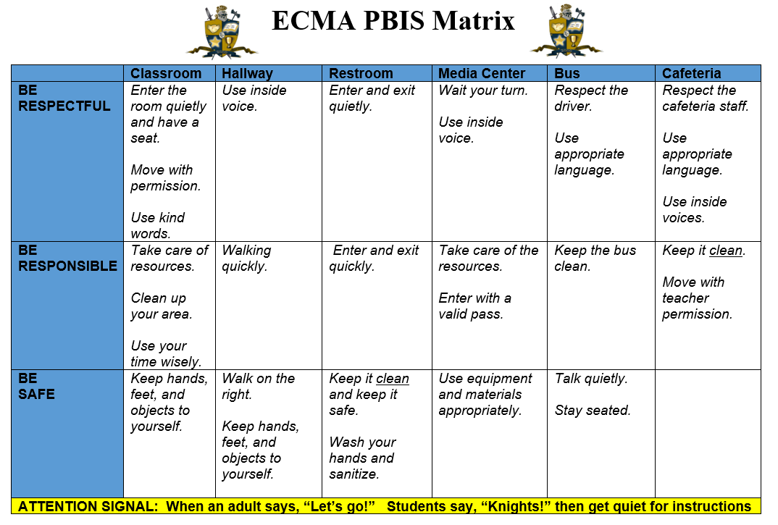

Students at ECMA will be provided an ID that can be scanned by all staff members for points. Students can receive points for a range of things from walking in the hall correctly to entering the class properly. There are behavior matrixes posted all around the school that explain the expectations for behavior in the hall, classroom, restroom, cafeteria, etc. Each month the school offers events or activities that can only be attended by students are wearing their badge, have enough points, and are willing to spend them. Several times throughout the school year we will open our KNIGHT STORE, which is a store that has items such as candy, supplies, puzzles, games, etc. that the students can purchase for a varying amount of PBIS points. To attend any event, receive points, or make purchases at the store students must be wearing their student ID.

Standards for Discipline and Behavior Limitations

No ECMA student, faculty, or staff member has the right to the following:
- Physically injure themselves or others or threaten injury.
- Discriminate against others (to treat others as though they are not as good as you).
- Damage or destroy materials.
- Steal from others.
- Impose on others (to force someone to see, do or hear something that they do not want).
- Interfere with others (to make a sound or movement that keeps others from hearing, seeing or concentrating or from participating in class).
- Misrepresent to others (to make a false report about yourself or others).

General Rules and Information

- Public display of affection is not allowed.
- Gum and candy are not allowed in school or on the school bus.
- Radios, MP3 players, video games i.e. any electronic device, are not to be brought to school.
- Students who wish to use the telephone must have a “phone” pass and check with the front office before using the telephone.
- Classes will not be interrupted to call students to the telephone or give them a message.
- All food is restricted to the dining room unless otherwise instructed.
- Fast food items (i.e. McDonald’s, Burger King, Taco Bell, etc.) may not be eaten in the dining room.
- The school accepts no responsibility for items that are lost, damaged or stolen.
- Aerosol cans, hair spray, cologne sprays, whiteout, inhalants, breath sprays or any other item that might be dangerous to the health of students are unacceptable at school.
Local Discipline Procedures
1. The classroom teacher is the first line of student management. The philosophy of the school is to provide an optimum learning environment for all students. If a student continues inappropriate behavior and after several different teacher interventions are tried, an administrative discipline referral will be the next step. Teachers will use a Tier 1 intervention form to track minor discipline in the classroom. Tier 1 discipline is cumulative.
2. Administrative Detention is assigned by administrators. Twenty-four hour notice is given for parents to provide transportation and prompt pick-up. Failure to report to an assigned detention will result in additional consequences. The purpose of detention is to put responsibility of behavior on the student so that self-discipline can be developed.
3. In-School Suspension (ISS) is another more serious form of discipline. Students may be placed in ISS for continuous disruptive behavior or serious infractions of rules. ISS is designed to allow students to remain in school so that their educational process is not interrupted.
Students in ISS are isolated from their peers and must remain in the ISS room for part of or the entire school day. Students are under the direct supervision of a classified employee of the school district during this period of time. Students are expected to complete their assignments in ISS. If a student fails to finish the assignments, he/she may receive additional time in ISS. If a student is disruptive while assigned to ISS, additional days of ISS or out of school suspension will be considered.
4. Out of School Suspension (OSS) from school is a disciplinary procedure used if the above procedures are ineffective. A student can be suspended for 10 days without appearing before the Muscogee County School District Discipline Tribunal. The principal may call a tribunal hearing, if he/she feels the situation warrants or suspension is beyond ten school days. A student may also be suspended from school for any serious infraction of rules and regulations. A suspended student must request make up school work. Work requested, by student, but not picked up, or incomplete upon return will receive a “0.”
5. If rules are broken on days before holidays or summer break, students will receive consequences upon returning to school.
Minor Offenses (Level 1)
Level 1 offenses are behaviors that are considered distracting to another student’s learning or to the teacher’s teaching. When these minor offenses occur the teacher will handle them in the classroom or in detention. Each teacher will be responsible for his/her own detention. Detention notices will be sent home to give parents 24 hour notice prior to detention. This condition can be waived if parents can be contacted and agree to detention on that day. In addition to these forms, parent contacts will be made when repeated minor offenses occur. Minor offenses include, but are not limited to, the following:
- Talking without permission
- Inappropriate volume level
- Disruptive actions – clowning, not keeping hands/feet to self, arguing, yelling out, teasing
- Eating food without permission
- Name calling, insulting
- Minor damage to school property, technology or resources.
- Not following instructions, refusal to work
- Not having necessary supplies
- Minor pushing or tripping

ECMA teachers and administrators will make every reasonable efforts to intervene before student misbehavior becomes serious. Reasonable efforts would include, but not be limited to, the following:
- Verbal reprimand
- Team meeting with student
- Referral to counselor
- Silent lunch
- Parent contact
- Parent conference
- Student behavior contract
- Detention
- Temporary removal (timeout) from classroom or school event.

When reasonable teacher and/or administrator efforts do not result in improved behavior, a referral to the office may result in, but not be limited to, the following:
- Detention (one or more days)
- Administrative conference with student and parents
- In School Suspension
- Out of School Suspension
- Banishment from after school activities (including athletics participation) for a specified period of time.
Cell Phones (or Other Electronic Devices) Used or Powered On During the School Day
Device taken up & sent to office to be held until parent picks up. Parent can pick up between 8:30 AM and 3:30 PM the following day.
Continuous issues with Cell Phone will result in parent conference, ISS, and OSS.
Students are expected to store their electronic devices in their locker upon arriving on campus. Devices must remain in the lockers until the last locker break. Phones and devices should remain off until school releases.
Refusal to turn over device to ECMA faculty/staff will result in 2 days of OSS.
If the parent/guardian is adamant that he or she cannot allow the phone to be held for the number of days listed in the procedures, then the parent/ guardian chooses for his or her son/daughter/ward to accept a two (2) day out of school suspension in lieu of the phone being held.
“Other Electronic Devices” includes hand-held game systems, iPods, mp3 players, cameras, PDAs, CD players, mini- computers, laser pointers, etc.
Major Offenses (Levels 2)
Students who exhibit level 2 discipline infractions will receive more intense consequences. Basic guidelines for each offense is listed in parenthesis in the following manner (1st offense, 2nd offense, 3rd offence, etc.). Discipline is always determined by administration and can be adjusted as needed.
Level 2 (Major Offenses): Any behaviors, which threaten the learning environment of other students, cannot and will not be tolerated. The following behaviors have no place at ECMA and will result in serious consequences: Major offenses include, but are not limited to, the following:
- Skipping class or detention
- Inappropriate displays of affection
- Blatant defiance / disrespect of adults
- Horseplay
- Misbehavior on bus
- Repeated dress code violations
- Hitting, roughing, and physical abuse with intent
- Destroying/stealing property
- Disruption, or attempt to disrupt, any mode of electronic communication or distribution (i.e. hacking, spamming, cyber bullying, etc.)
- Fighting, bullying, sexual harassment/sexual advances, threatening another student.
- Using profanity, disrespectful or abusive language, and/or gesture toward another student.
- Leaving class without permission.
- Rudeness to guests of the school or while on field trips.
- Forgery or cheating
- Continuous disruptive behavior
- Intimidation of peers or adults
- Theft (severity of threat will determine the need for police charges and/or referral to tribunal)
- Vandalism
- Throwing objects, shooting objects with rubber bands, or otherwise causing objects to fly through the air in a way that is potentially dangerous.

Extreme Offenses (Level 3)

Level 3 (Extreme/Critical Offenses): These offenses are behaviors that are considered serious enough to result in immediate referral to the office. Extreme offenses include, but are not limited to, the following:

- Excessive aggressiveness / Out of control fighting
- Leaving school property without permission
- Weapon possession or use
- Tampering with and/or setting off the fire alarm.
- Starting a fire
- Sexual activity on campus
- Threatening a teacher or other adult school personnel
- Hitting, biting, physical assault on a teacher or other adult school personnel.
- Profanity or gestures towards adults
- Constant defiance to persons of authority
- Possessing and/or using tobacco products, lighters, matches, etc…
- Skipping school
- Indecent exposure (referral to tribunal if genitals are exposed)

This is not an exhaustive list of offenses, only the most common ones. All consequences are subordinate to MCSD policies and subject to change at the discretion of the administration.
Severity of consequences may be altered during weeks leading up to long breaks (i.e. Christmas break, Spring break, end of school, etc.).

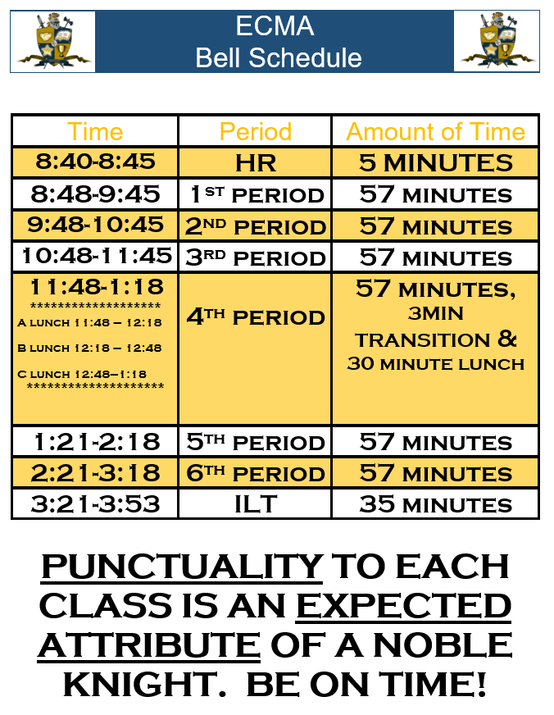

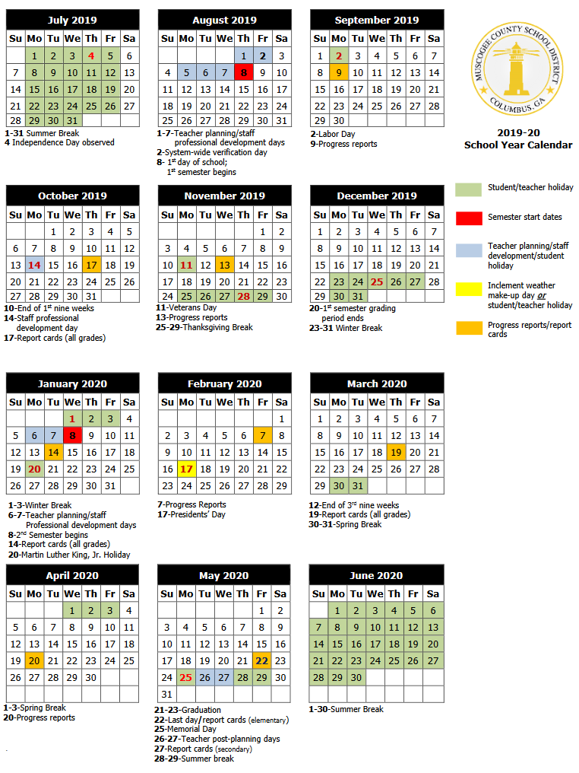
MCSD 2019-20 School Year Calendar

