Double Churches
Middle School
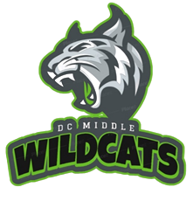

2023-24 Student Handbook

Home of the Wildcat Nation!

7611 Whitesville Road, Columbus, GA 31904 (706) 748-2678

Double Churches Middle School

Mission, Vision, and Values of DCMS & MCSD

Mission: To inspire and equip all students to achieve unlimited potential.

Vision: The MCSD is a beacon of educational excellence where all are known, valued and inspired.

Values: MCSD fosters a healthy organization where…
WE embrace equity and diversity
WE hold ourselves and others to the same high standards
WE commit to continuous learning and improvement
WE treat everyone with dignity and respect
… as WE serve the needs of others

Administration

Dr. Michael Seckinger Principal
Dr. Christy Russell Asst. Principal
Jessica Morgan-Nelson Academic Dean
Vanessa Ellis Academic Coach
Elisia Oller School Counselor
Kwame Brown Athletic Director
Kimiun Woods Asst. Athletic Director
Eretha Smith Dean – Wildcat Academy

Terry Baker Region Chief “Best in the West”
Dr. David Lewis MCSD Superintendent

Table of Contents

Arrival to School …………………………….…………............. 4
Attendance and Absences …………………………..……....... 5
Breakfast and Lunch Program ………………………………… 8
Care and Use of School Property …………………………… 14
Conferences, Guidance, Clinic & Media Center………… 14
Valuables and School Dress Code ………………………….. 19
Academic Courses, Grading, Report Cards …..…….. 19-23
School Safety …………………………………………………….. 24
Student Behavior and Discipline …………………………… 25
DCMS Bell Schedule ……………………………………………. 34
MCSD 2023-24 Calendar ……………………………………… 35

Note from the DCMS Administrative Team

This student handbook is intended to supplement the MCSD 2023-24 Student Handbook & Code of Conduct with school-level information we believe will be helpful to our students and parents. In no way will the policies and procedures at DCMS conflict with any of MCSD’s established policies, procedures, and school board decisions.

Please be advised, because unforeseen events can take place during a school year, DCMS administration reserves the right to amend or revise the policies and procedures within this handbook, to ensure the school environment remains safe and conducive to student achievement. Updates to this handbook will be available to download throughout the year from our school’s website.

Arrival to School

Students may enter DCMS no earlier than 7:40 am. After 7:40 am students are to move directly to the cafeteria for breakfast or to the gymnasium for dismissal to ILT at 8:10 am. Students should not be on school property other than at supervised times.

Attendance and Absences

DCMS is committed to the philosophy that every student should attend every class, every period, every day. Daily attendance and promptness are expected in all classes and are essential for success in school.

1. Daily Absence Reporting:
a. Parents/guardians should notify the school each day a student is absent.
b. Students who are absent without a parent or guardian’s excuse may be considered truant.
c. All absences, including those approved in advance by parents or guardians or school administration, except those for school-sponsored activities, will count against a student’s attendance.
d. DCMS encourages parents to schedule doctor and dental appointments after school hours.
e. Excessive absences will affect a student’s academic achievement.
f. Parents/guardians may be required to submit supporting documentation in order to excuse the absence of their student if student absenteeism is excessive. For example, in order for the absence to be excused, parents/guardians may be asked to submit written notification from a licensed physician stating the reasons why a student is unable to attend school.
g. Students who are absent (excused or unexcused) the day of an extracurricular activity (dance, sporting event, trip, etc.) are not allowed to attend the extracurricular activity.
h. Students who are excessively tardy (5 times) to school will not qualify for recognition for perfect attendance.

2. Tardiness
Students arriving after 8:10 am are considered tardy. Upon entry the student reports to the front office. If the student has a note from parent excusing the tardy that note should be provided to the staff member. Students arriving after 8:35 am will need to be accompanied by a parent/guardian. Student and parent are to buzz in at the front door. In order to be counted present, a student must attend at least half of the school day (11:50 am). If a student must leave the building for an appointment during physical education class, he/she may secure a pass from the front office before school begins to make check-out easier.

Students who are frequently tardy, either at the beginning of the day or to classes during the day, may be subject to the below disciplinary measures:

* Three unexcused tardy days, school contacts parent/guardian.
* Five unexcused tardy days, referral to School Administrator (Principal) or designee and a mandatory parent conference and counselor referral.
* Ten unexcused tardy days, referral to School Social Worker and to support agencies outside of the district, as Principal deems appropriate (DFCS, Juvenile, et al).
3. Excused/unexcused Absences

In the case of a necessary absence from school, a student must bring a written note from the parent/guardian, doctor, court, or dentist. The note should state the student’s name, date(s) of absence(s), reason for the absence(s), date of excuse, appropriate signature and phone number so parent, physician, agency can be reached to verify the note. The note must be given to the HR teacher on the day the student returns to school. The absence shall remain unexcused if no note is brought within three days.

State law recognizes the following reasons as excused absences:

- Personal illness
- Death in immediate family
- State recognized religious holidays
- Principal’s approval of attendance at school related experiences
- Absences mandated by governmental agencies
- Instances where attendance would be hazardous
- Serving as a page in the General Assembly of Georgia
Unexcused absences include, but are not limited to, the following:
- Oversleeping (student or family)
- Missing the bus
- Babysitting
- Joining the family on vacation
- Skipping school
- Cutting class
- Out of school suspension
- Car trouble
- Out of class for discipline referral
- Failing to bring a note from parent about absence
Potential consequences for repeated unexcused absences
5th Absence: Social worker referral
10th Absence: Social worker referral and Attendance Agreement
15th Absence: Social worker referral and Court referral

4. Make-Up Work
When a student is absent, it is the student’s responsibility to ask for missed assignments within 3 school days of returning to school. The student must return all make-up work to each teacher within the time limit decided upon by the teacher. It is the student’s responsibility to turn in make-up work without having to be given reminders. This includes students returning from suspension.
The DCMS policy allows students to make-up work from the beginning of the 9 weeks to progress report time, then from progress report time to final report card subject to late work penalty which is teacher discretion. Students are not permitted to make up work after progress report time for the final report card. (i.e. assignments due weeks 1-4 must be completed before progress report. Assignments due weeks 1-4 cannot be made up after the progress report.)
5. Extended Illness or Injury
In case of an extended illness or injury, parents should contact the counselors to determine if the services of a visiting teacher are required. A hospital/ homebound teacher may be assigned to a student who will be absent for ten or more days due to illness or injury.

6. Check In / Check Out
Proper identification is required and person must be in IC or on student information sheet. It is helpful for the parent to know which class the student is in at the time the parent wants the student dismissed.
NOTE: If it is necessary for an older brother, sister, or friend to pick up a student, the student must bring a note to the office by 9:05 am. The office receptionist will call the parent to verify the note. All special request notes must be brought to the office at the beginning of the day in order to be verified by office personnel.
Students will not be checked out after 2:40 pm unless an appointment card/printout from the doctor’s office can be presented or faxed. Transportation arrangements or changes in transportation arrangements should be made prior to the student coming to school.
7. Dismissal Procedures
School is dismissed at 3:10 pm.
a. All bus students should be at the bus loading area or in a classroom.
b. All students attending an “After School Program” should be in the designated area.
c. All students attending detention should be in the appropriate room.
d. All students attending other after school activities should be in the appropriate room or area.
e. Car riders must be picked up no later than 3:40 pm.

8. After School Activities: Athletic events, dances, concerts, club meetings, etc.
Students are supervised after school hours only for school-sponsored meetings and activities. Parents should be prompt in picking up their children from activities. Parents assume full responsibility for supervision of the students beyond a 15 minute period after the closing of any school event. Parents and students should not depend upon the school telephone being available so that a student may call when the school event is over.
NOTE: Students who are not picked up within the given time after the ending of an event will not be allowed to attend extracurricular activities.

School Nutrition
School Nutrition Program (SNP)
School Year 2024

Mission Statement of the Muscogee County School Nutrition Program is to provide a nutrition program that will maintain and improve the health of school children and the educational community and encourage the development of sound nutritional habits that will foster academic success.

USDA has regulations that the School Nutrition Program (SNP) has to meet to be in compliance with their guidelines. Caloric and nutrient requirements are based on age and grade. Also, MCSD Board Approved Wellness Program (EEE and EE-R) encourages and promotes healthy guidelines to be followed including, but not limited to, FDA standards for portion sizes and the elimination of the consumption of fried foods as well as foods containing > 35 % sugar by weight. School lunches also offer a variety of foods, whole grains, and fat free and low-fat milk choices. Muscogee County School District shall abide by nutrient standards of the School Nutrition Program for all foods sold and served on campus during the school day. The sale of foods or beverages to students on school premises other than through SNP is prohibited from 12:01 a.m. until 30 minutes after the end of the school day. Food shall not be used as a reward or punishment. The use of candy and other food rewards for academic performance or good behavior is prohibited. Fundraising efforts shall be supportive of healthy eating, encouraging the sale of non-food items or nutrient dense foods. USDA regulations ban the sale of foods of minimal nutritional value.

The School Nutrition Program provides a healthy breakfast and lunch choice for students every day. Students may bring their own lunches from home. Restaurant containers are not allowed in the cafeteria. Parents are encouraged to have lunch with their children and a school lunch may be purchased to eat in the cafeteria with the students.

School meals may be captured at the point of sale in a variety of ways. Pin pads or bar code scanners will be used.

Community Eligibility Provision (CEP)

The Community Eligibility Provision (CEP) was established by Congress through the Healthy, Hunger-Free Kids Act of 2010, which reauthorized the Child Nutrition Programs. CEP aims to increase access to the School Meal Programs by offering breakfast and lunch at no charge to all students, without the need to process or collect individual free and reduced meal applications. Forty-one of our schools are CEP schools. Please contact your student’s school office or call the School Nutrition Office at (706) 748-2386 to see if your student’s school is a CEP school.

Non-CEP Schools:
Aaron Cohn Middle School
Blackmon Road Middle School
Britt David Magnet Academy
Clubview Elementary
Columbus High School
Double Churches Elementary
Eagle Ridge Elementary
Mathews Elementary
North Columbus Elementary
Northside High School
Rainey-McCullers School of the Arts
Veterans Middle School

Free and Reduced Meal Priced Meal Applications (Non-CEP Schools Only):
If your student is enrolled in one of the 12 Non-CEP schools (see list above), a new application must completed and approved every school year before your child can qualify for free or reduced-price meal benefits. For quicker processing, an online application is available at www.myschoolapps.com. If you prefer, a paper application is available upon request at your child’s school or at the School Nutrition Office at 2960 Macon Road. If completing a paper application, we must receive the original since these applications are scanned. We cannot accept a faxed or copied application. ONLY ONE application needs to be completed for your entire household. If someone receives SNAP (Supplemental Nutrition Assistance Program) OR TANF, you must include the current CASE number on the application (NOT the EBT or food stamp card number) and indicate whether the program is SNAP or TANF. We receive thousands of applications every year. Completed applications are processed within 10 days. You will be notified with a letter regarding the outcome of your application.

Applications CANNOT be approved if they are not completely filled out so please COMPLETE ALL REQUIRED FIELDS on the application. Until your application is approved, please provide your child(ren) with money to purchase meals.

If you have an approved MCSD application from the previous year on file, benefits will be extended for the first 30 days of the new school year (or until a new eligibility determination is made, whichever comes first). After 30 days, your child’s status will change to PAYING and they will be charged for meals until a new application is approved. If your application is denied or incomplete, please call our office with any questions at 706-748-2389. Applications can be submitted at any time throughout the year, especially if your income goes down, you lose your job, your family qualifies for SNAP or TANF benefits, or there is a change in your family size. For quicker processing of meal benefit applications, the Family Meal Application is available online at www.myschoolapps.com. If you prefer, you may complete a paper application at your child’s school or at the School Nutrition Office located at the Muscogee County Public Education Center, 2960 Macon Road. Computers will also be available in the School Nutrition Main office.

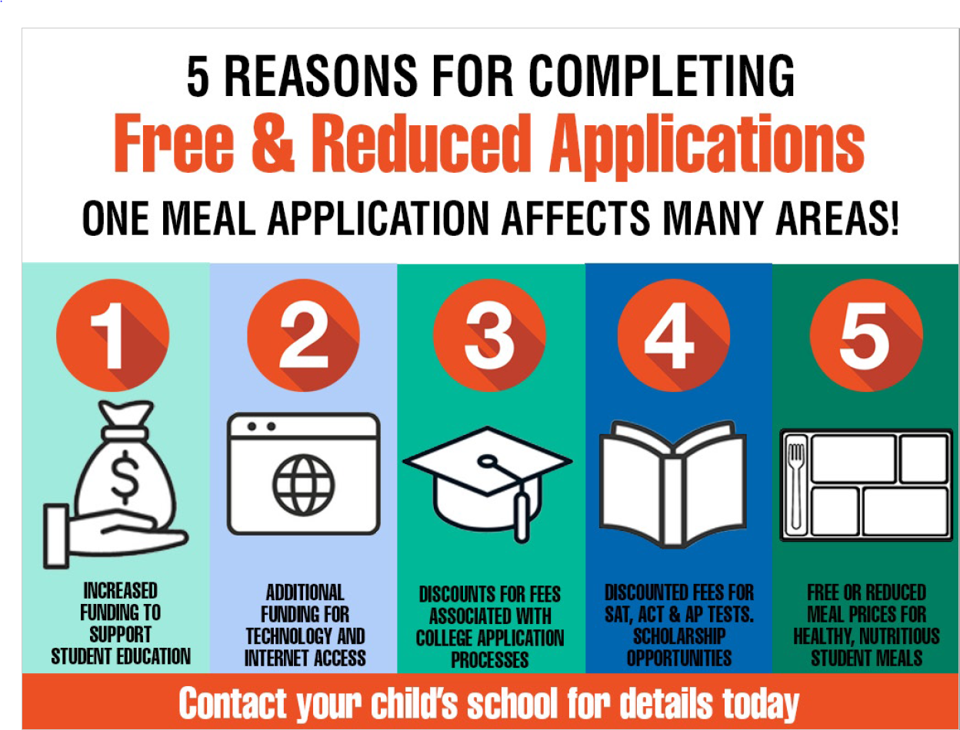

Paying for School Lunch
Muscogee County SNP does accept personal checks as payment for meals in our cafeterias. Payments
may be made by cash, money order, cashier’s check, traveler’s check, or on-line via our online payment system, My School Bucks, using your credit or debit card.
www.MySchoolBucks.com

School Meal Prices: Prices are subject to change based on USDA reimbursements rates

BREAKFAST PRICES
Elementary, Paid |  | 1.00
Middle/High, Paid |  | 1.25
Reduced |  | .30
Adult, MCSD Staff  Adult, Outside MCSD |  | 1.75
Adult, Outside MCSD |  | 2.00
LUNCH PRICES
Elementary, Paid |  | 2.45
Middle/High, Paid |  | 2.70
Reduced |  | .40
Adult, MCSD Staff |  | 4.00
Adult, Outside MCSD |  | 4.50
Free and reduced priced meals for breakfast and lunch are available for eligible students. Parents may contact the School Nutrition Manager at any school for more information.

Charging Meals
Charging meals is discouraged, but may be necessary in certain cases. Elementary students will be allowed to charge a total of three breakfasts and three lunches. Middle and high school students will be allowed to charge a total of one breakfast and one lunch. If your child reaches his/her charge limit and does not have money in his/her account, and does not have cash with which to purchase their meal, an alternative meal will be provided. There is no provision for adults to charge. No charges will be accepted for a la carte items. Students will not be able to charge any meal after May 1st through the duration of the school year. It is necessary that all outstanding charges be paid to the cafeteria Manager prior to the last day of school. Please respond promptly to messages that you receive, both written and phone calls, regarding charges on your student’s account.

Menus
Monthly menus can be found on your school’s website. Menus may change on a very short notice due to supply chain issues, market conditions, deliveries, or special school activities.

Special Dietary Needs

MCSD School Nutrition will make meal modifications and substitutions to the regular school meals for a student with a disability that restricts their diet. The Special Dietary Needs Prescription Form must be completed and signed by a licensed physician, unless the child has a healthcare plan or an IEP/504 Plan on file, and returned to MCSD School Nutrition Program, including the school cafeteria manager and the Nutrition Specialist before the school cafeteria can provide any modifications or substitutions. A form and instructions can be found on the School Nutrition page of the MCSD web site, or at the school clinic or cafeteria. You may contact the School Nutrition office at 706-748-2386 for more information.

A nutrition analysis chart for menu items is available on the website. Please be aware that there are factors that may affect a product’s actual nutritional value and/or ingredient composition at any given time: Supply chain issues may cause substitutions; manufacturers’ formulations may change without notice. USDA donated products may become available at any time during the year and may replace a purchased item. Product brands may change during the year as new bids are approved. Schools may be using inventory from a previous bid or manufacturer. Our recipes may change during the school year. A la carte snack items vary from school to school, so check with the Nutrition Manager at your student’s school for specific information.

Seamless Summer Option
SNP provides breakfast and lunch at various schools throughout the district during the summer. Please check the website or call 706-748-2386 for locations. All children up to 18 years of age receive a free meal. Adults may purchase a lunch.

Care and Use of School Property
Chromebooks, Textbooks and Media Center Checkouts
DCMS students will be held responsible for the proper care of all books, supplies, Chromebooks, accessories or equipment furnished to them by the school. Students who deface, damage or lose (including theft) school property shall be required to pay for the damage or loss.

Lockers
DCMS students will be permitted to use lockers during the 2023-24 school year. Beginning verification week, students can rent a locker for $10 per year (separate fee for gym lockers). Students are not allowed to share their locker with other students.

Book Bags

At this time, DCMS does not limit the type of schoolbags (clear, mesh, solid, etc.) students can bring to school. However, school administration maintains the right to inspect any book bag so as to ensure that no items are brought to the school in violation of MCSD’s rules and procedures concerning contraband items, weapons, and drugs/alcohol.
Conferences, Guidance, Clinic and Media Center
Parent/Teacher Conferences
DCMS teachers and administration encourages parents and guardians to schedule a conference if questions or concerns exists regarding a student’s academic achievement or classroom behavior.
a. Upon notification by note, email, or phone that a conference is requested, the teacher or administrator will schedule the earliest conference date and time that allows all of the students’ teachers to be in attendance. Note: parents should expect the meeting to be several days in advance, especially if student data must be collected prior to the meeting.
b. Because many DCMS teachers coach or have other extracurricular commitments, parents should not expect same day meetings.

Guidance and Counseling Services

DCMS is staffed with a highly qualified counselor committed to providing responses services to all students. These services include individual counseling, curriculum guidance, crisis support, and social/emotional development.
Students desiring a visit to Guidance must first notify their teacher. In the cases of an emergency, the teacher will document the student’s location and send the student to Guidance with a signed pass. In nonemergency cases, the teacher will notify Guidance of the request and the student will be called to Guidance at an appropriate time.
No-Contact Orders
In the rare cases that DCMS guidance and administration is unable to successfully resolve student-to-student conflict, a no-contact order may be put into effect so as to temporarily pause any contact between the students. While a no-contact order is in place, the students are not allowed to communicate to, or about, the other student(s) listed on the order, to include email, text, or social media posts, chats, and discussions. Because no-contact orders are put into place to prevent tension from escalating into physical conflict or severe class disruptions, students violating a no-contact order will be subject to In-School Intervention (ISI) and/or out-of-school suspension. Parents have the right to request a no-contact order; however, only DCMS administration has the right to revise, pause, or cease the no-contact order.
Bullying

Bullying is defined as any willful attempt, or threat, to inflict pain/injury on another person or any intentional display of force which gives the victim reason to fear or expect immediate harm over a period of time. Further, DCMS holds that every student is entitled to a school day free of directed insults, profanity, derogatory language, inappropriate physical contact, and any other form of verbal or physical harassment. DCMS administration requests that students and parents contact the school immediately if any of the above occurs so that an investigation can be initiated.
Potential outcomes for bullying include counseling, no-contact order, ISS/OSS, and assignment to an alternative educational setting if the bullying behavior continues.
As with all school policies and procedures, any parents or students that believe their bullying concerns have not been fully addressed should contact the school principal via phone or email: Seckinger.michael.e@muscogee.k12.ga.us.
Racial Slurs
DCMS holds that racial slurs have no place in an educational setting. Racial slurs – words or phrases that refer to members of racial and ethnic groups in a derogatory manner, only serve to defame, dehumanize, and suggest that certain groups are unworthy of equality. DCMS students directing racial slurs to DCMS students, faculty, or staff will face ISI with repeated actions resulting in out-of-school suspension (OSS).
The N-Word
DCMS recognizes the complexities of the N-word, in one context it may be viewed as an extreme insult while in another it may be received as a term of endearment. At DCMS, we hold that the N-word is intentionally derogatory and linked to racism and violence towards a specific group of students. As a result, the use of the N-word will not be tolerated with users subject to the same disciplinary consequences as other racial slurs.
Sexual Harassment
Sexual harassment is defined as the making of unwelcome, inappropriate, and hurtful sexual remarks or physical advances. This includes actions specifically targeting students identifying as lesbian, gay, bisexual, transgender and queer (LGBTQ). As with bullying, DCMS has no toleration for sexual harassment in any of its forms and mandates students to inform a teacher, administrator, or guidance if they experience it or witness it occurring to another student so that DCMS administration can immediately initiate an investigation.
Potential outcomes for sexual harassment include counseling, no-contact order, ISI/OSS, and assignment to an alternative educational setting if the harassment continues.
As with all school policies and procedures, any parents or students that believe their sexual harassment concerns have not been fully addressed should contact the school principal via phone or email: Seckinger.michael.e@muscogee.k12.ga.us.

LGBTQ

DCMS is committed to providing a learning environment in which all students can thrive and achieve their full educational potential. DCMS also recognizes that LGBTQ students often report discrimination, bullying, and the inability to fully affirm their identities. As discussed above, DCMS will not accept any behavior that prevents LGBTQ students from having a school environment that is safe, secure, welcoming, and where they feel a sense of belonging. Please contact DCMS administration immediately if there are any questions or concerns regarding the school’s mission to be inclusive and supportive to all students.

Clinic

There is a part-time nurse to supervise the clinic. Limited space allows only one student to be served. Students who are ill will report to the Clinic area where a parent will be called. The school does not supply any medication. Any medication whether over the counter or prescribed, must be supplied in the original container. Loose pills in a baggie or other container and liquid medicine in an unlabeled container cannot be dispensed. Prescription medicine, including inhalers, must have a copy of the pharmaceutical label attached to the container. Students cannot have medication, over the counter or prescribed, in their possession. All medications are to be delivered to the Clinic area and registered. The parent must complete a special form/ document before any medication can be administered at school. The student is responsible for reporting during the day to take his/her medication.
Media Center

The school Media Center contains many books, audiovisual items and technological equipment. A qualified media specialist is available to assist students.

The student will be charged a replacement value for lost and/or damaged library books. The student whose name appears as the checkout name will be held responsible for the book. The student is responsible for the book no matter where the book is left. A student must check out the book before it is taken home. Failure to pay for lost or damaged books/materials/ equipment may result in limiting the use of the Media Center resources to in-school use only.

Sign In: The student must sign in at the podium when they enter the Media Center without the teacher.
Checking Out a Book: All students will use their GTID to check out books. A book is due two weeks from the day it is checked out, excluding holidays.
Overdue Materials: If a student has overdue materials/books or has any outstanding fines from the previous year he/she may NOT check out any media center materials/books until the prior debt is paid.
Fines & Fees
Care and Use of School Property - Chromebooks, Textbooks, and Media Center Checkouts: Students will be responsible for properly caring for all books, supplies, Chromebooks, and accessories or equipment furnished by the school. A student who defaces, damages, or loses school property must pay for the damage or loss (see MCSD Board Policy JS: Student Fees, Fines, and Charges).

All students have been issued a Chromebook (to include Case and Charger) to use during the school day. Students must always be responsible for their Chromebook/Case/Charger. To be good stewards of taxpayer dollars, students must be responsible for caring for their Chromebook and not damaging it in any way. Chromebooks are to be always carried in a case when not in use. Students who damage Chromebooks and/or accessories can be assessed a replacement fee as per Board (see MCSD Board Policy JS: Student Fees, Fines, and Charges).

A Parent/Student must pay all fees and fines owed to the school promptly. Parents/Students must clear all fines or expenses during the year the fines are assessed. Fines must be paid/cleared where they were assessed before moving to the next level in school.

Valuables at School
Per MCSD policy, “MCSD personnel cannot search for personal items lost or misplaced while at school”.

Dress Code
- Chests, backs, shoulders, and midriffs must be covered.
- Shorts, dresses, skirts, skorts, and other garments may be no shorter than three (3) inches above the top of the knee.
- Leggings and jeggings are allowed as long as they are free of holes.
- No pants, shorts, or skirts may have holes above the knee.
- Students can wear any pants with holes above the knee if leggings are worn underneath.
- Pajamas and blankets are not permitted in school.
- Shoes must be secured to the foot in the front and/or the back. No slides, slippers, or shower shoes. Crocs are allowed.
- Hats, caps, bonnets/shower caps, sunglasses, rollers, picks, combs, and bandanas are not to be worn in the building during school.
- Hoodies may be worn; however, the hood is not to be worn during school.
- Administration retains the right to amend DCMS dress code policy at any time for any clothing that causes a distraction to the learning environment.

Traditional Academic Subjects

All DCMS students will take courses in the mathematics, sciences, language arts, and social studies each year in grades 6-8. Note: Select students will have the opportunity in 8th grade to earn high school credit in Physical Science, Algebra I and Spanish.

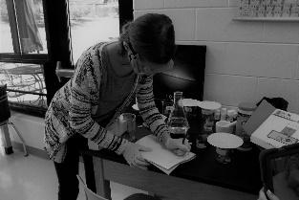

Special Education Services

DCMS’s highly qualified faculty and staff are trained to ensure that all students can achieve academic excellence. Students with special needs who meet the eligibility requirements are provided services in academic areas and emotional support as is warranted. The students receive help during all or part of the school day throughout the year. Information about these programs can be obtained from the classroom teacher, counselors or the administration.

Connections Courses
Connections classes provide students with a variety of interesting experiences that go beyond the traditional academic curriculum. These classes carry the same weight as academic classes. Students have a rotation of different connection classes each year, or take band, orchestra or chorus for the entire year.

Art

Art is taught to sixth, seventh, and eighth grade students. Students are taught visual awareness through the elements and principles of art by exploring drawing, painting, ceramics, printmaking, puppetry and sculpture. Student works are exhibited in the school, community, and several art exhibits.

Band

Band offers students in all grades the opportunity to learn to play musical instruments in the brass, woodwind and percussion families. Previous musical experience is not necessary. To help ensure student success, the band director counsels each student in selecting an instrument that is best suited for the student. Students have the opportunity to receive instruction in full band, small ensemble, and solo performance. A variety of musical styles are covered including symphonic, jazz, rock, Broadway, and pop.

Chorus

Choral music courses provide opportunities for students to develop their musical potential and aesthetic understanding through singing in a choral ensemble. These courses seek to give students in grades 6-8 experiences in the study and performance of a diverse repertoire of music. Study of vocal/choral music includes the cultivation of a beautiful singing tone, aesthetic understanding, and the ability to read music with fluency, the polishing of performance skills, responsible rehearsal habits, discipline, and the value of collaboration.
The chorus performs several times during the year and attends the district choral large group performance evaluation each year. Students in chorus have the opportunity to participate in the district honor choir and a chance to audition for the all-state chorus.
Computer Education

The purpose of the computer education program is to provide each student with an opportunity to understand both the capabilities of electronic information systems as well as an opportunity to know their applications and impact on society. Each student is provided hands-on experience using computer hardware and current types of applications software.
Computer education for sixth grade students is an introduction to microcomputers and keyboarding. Students learn to operate the computer. They work with prepared computer programs that support the middle school curriculum The seventh-grade students will learn database and word processing skills. This computer utilization allows students to become more proficient with computers. Eighth grade computer courses combine keyboarding, computers, and technology of the business world to give students practical ideas of courses to take at high school as the course applies to careers. The utilization of word processing, database and spreadsheet helps students to create well designed, well-structured presentations for use in business and private life.
Health

Health is required for all students at each grade level. Units on human growth and development, human sexuality, drug abuse prevention, mental health, nutrition, safety and first aid are all part of the curriculum. Special emphasis is placed on skills such as responsible decision-making, refusal skills and conflict management. These life skills help students learn to appropriately meet the challenges of adolescence.

Orchestra

The orchestra program begins in sixth grade and offers sequential instruction to students through eighth grade. The program offers ensemble instruction in violin, viola, cello, and string bass. Previous musical training is not required Practice at home and concert performance are expected of students. Some instruments are available through the school.
Physical Education

All students take physical education. Physical education offers students instruction in team and individual sports. Students participate in activities such as volleyball, basketball, field hockey, soccer, softball, line dancing, and team handball.
Participation is an important part of the physical education grade. Students are required to dress out daily and must have a written note signed by the parent if they cannot participate. If the student cannot fully participate, the teacher will modify the program for up to three days. It should be used to cover colds, flu and short-term illnesses. When a student needs to be excused from physical education for more than three days, a doctor’s note is required Students are responsible for their personnel items during physical education. Lockers with combinations are provided in the locker room.

Junior Leadership Corp (JLC)

JLC Lessons are designed to enhance students' leadership skills including: time and money management, goal setting, healthy relationships, working with groups, health and physical fitness, community service initiatives, and leadership in a diverse world. In addition to the JLC curriculum, students are required to wear the JLC uniform one day a week, participate in drill and ceremony training, and perform ten hours of community service each semester.

Spanish

HS Spanish is offered for eighth grade student for one HS credit.

Grading Periods

DCMS operates on a nine weeks academic grading period. At the midterm of a nine weeks period, any student with a grade of F will receive a midterm progress report. Report cards are issued to students at the end of each nine weeks. Students are to return the signed report card to the homeroom teacher. The grading scale approved by the Muscogee County School District is as follows:
- = 100-90 Excellent progress
- = 80-89 Good progress
- = 70-79 Needs improvement
F = 69 and below Not passing
Principal’s List and Honor Roll

Principal’s List honors outstanding DCMS students who have earned all A’s in a grading period while Honor Roll recognizes those DCMS students who have earned all B’s or better on their report cards.

Riding the Bus

Students who live within the MCSD Bus Zone (as defined by the distance from their house to the school) are eligible to ride the school bus. Riding the bus is a privilege. Improper conduct on the bus will result in that privilege being denied. Students riding a bus will be expected to ride their designated bus. Each bus driver has complete charge of students riding the school bus. The Student Conduct Behavior Code applies. Students who refuse to obey the bus rules will be disciplined and may forfeit their right to ride the bus. Parents who have concerns about a bus driver should contact the school administration and transportation.
We urge all parent to appreciate the disciplinary action taken and to discuss this with their student to prevent further occurrences of inappropriate bus behavior. Consequences for continued misbehavior may result in your student being removed from the bus utilizing the following progressive plan:
1st Offense: parent contact, development of bus contract
2nd Offense: parent contact, one day suspension from bus
3rd Offense: parent contact, up to 3 days suspension from bus
4th Offense: parent contact, up to 5 days suspension from bus
5th Offense: parent contact, student suspended from the bus for the remainder of the semester.
Emergency Drills
In order to maintain a safe environment for DCMS students to study and learn, it is necessary that we practice our emergency and crisis response plans by having drills designed to exercise our procedures. We will be conducting various drills throughout the school year. This letter is to promote awareness of the importance of this, as well as to understand each type of drill. The students and staff of your school will be practicing 3 primary emergency drills. They are “fire drills”; “lockdown drills and “severe weather drills”. Each type of drill is explained below:
a. Fire drills
The school will conduct a “fire drill” each month (except for two severe weather months) that school is in session. This is a Fire Code requirement as well as a requirement by Muscogee County Schools. We want each student to understand and be aware of the importance of this drill when the fire alarm is sounded.
b. Lockdown drills
The school will conduct periodic “Lockdown Drills”. This type of drill will secure the school building and safely shelter all students, staff and visitors inside the building. The purpose of this drill is to keep the students safe from any danger outside or inside the building. During a “lockdown drill” all of the perimeter doors to the classrooms and school building will be locked. They will remain locked until the danger or issue outside or inside the building is removed. To enable everyone to remain safe, no one will be allowed to enter or exit the building until the authorities authorize such a release.
c. Severe weather drills
The “Severe Weather” drill will be conducted twice a year. The purpose of this drill is to prepare students to move to a secure location within the building in case of severe weather or tornados.
If your student has a severe allergy, mobility, or any issue that would give you concern that they would not be able to follow basic instructions if there was a cause to relocate during an emergency, please see someone in the front office about an DCMS Emergency Sheet or contact Dr. Seckinger at 706-565-3026, to discuss any concerns.
Individual Money-Making Projects

Students are not allowed to sell or trade items at school. The school should not be used as a place for distributing items sold outside the school. Any such items will be held at the school office for a parent to get.
Student Insurance

The Muscogee County School District offers student accident insurance to all students in the Muscogee County School District. This information is available to the parent at a nominal fee. Interested parents may contact the school office for information. If a parent does not wish to take out the Student Accident Insurance, then the student’s health insurance is the responsibility of the parent. The Muscogee County School District does not carry health coverage on students.
Athletic Physicals / Medical Forms
No student may participant (including tryouts) in any DCMS Athletic Event or Team without a current physical/ medical form on file.

Student Behavior and Discipline

Positive Behavioral Interventions and Supports (PBIS)

PBIS is intended to create a positive school climate by focusing on teaching good behavior in the same way that we teach math or science. Although consequences for unexpected behaviors still occur, being proactive and preventative through the use of proven behavioral strategies is the focus and more energy and time is spent recognizing students who exhibit positive behaviors. PBIS is consistent with the core principles of Response to Intervention (RtI) including multiple levels or “tiers” of interventions and supports.

Every school has a unique “PBIS” framework, DCMS’s is discussed in the following section. Parents are encouraged to contact the school administrator or PBIS coach to learn more. The District PBIS Coordinator (Dr. Kenya Gilmore) may also be contacted at PBIS@muscogee.k12.ga.us, call 706-748-3292 or visit our webpage @ https://muscogee.k12.ga.us/p/Divisions/StudentServices/School-WidePBIS/Information.

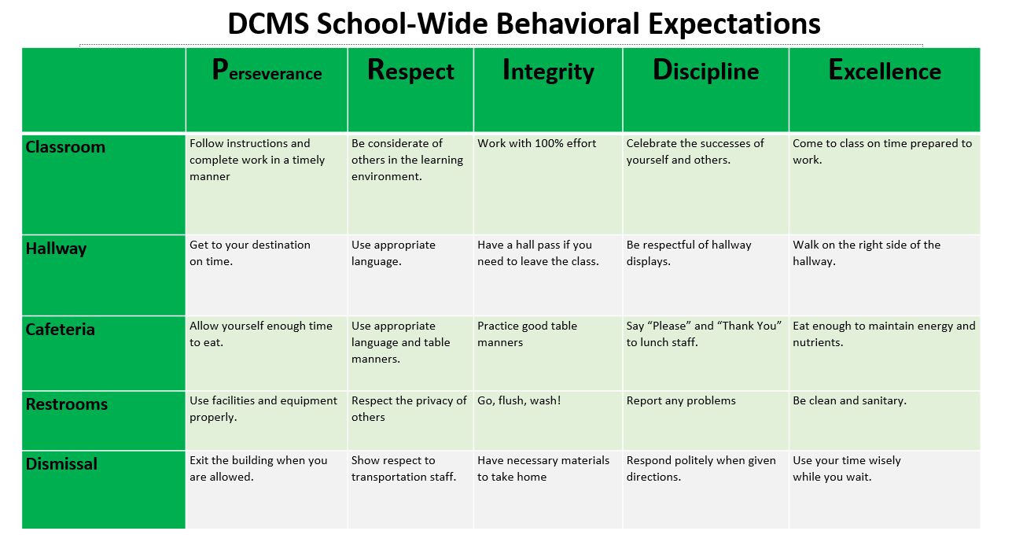
PBIS Matrix

PBIS TIER Reward System

Bronze: Tier 3 students
Little to no reward opportunities.

Silver: Tier 1 & 2 students

Hallway celebrations, field days, movie days, Kona Ice visits, dances, athletic events, pep rallies, etc.

Gold: Tier 1 students with all A’s and B’s

All Silver Tier rewards plus Freedom Fridays, Assignment passes, etc.

Standards for Discipline and Behavior Limitations

No DCMS student, faculty, or staff member has the right to the following:
- Negatively impact the quality of classroom instruction.
- Physically injure themselves or others or threaten injury.
- Discriminate against others (to treat others as though they are not as good as you).
- Damage or destroy materials.
- Steal from others.
- Impose on others (to force someone to see, do or hear something that they do not want).
- Interfere with others (to make a sound or movement that keeps others from hearing, seeing or concentrating or from participating in class).
- Misrepresent to others (to make a false report about yourself or others).
Student Cell Phones
DCMS students are not allowed to use or have in their possession a cell phone during the school day. Students are instructed to secure their cell phones in their lockers and retrieve at dismissal. All contact between students and parent/guardians must take place using the school phones. Any cell phone visible to DCMS faculty or administration is subject to collection, secured in the school safe, and only returned to the parent during normal office hours (7:40 am – 3:10 pm).
Any student that refuses to hand their cell phone to a DCMS teacher or administrator will be Out of School (OSS) suspended for 3 days.
Students with repeated events of cell phone use in the classroom will be assigned to In-School Intervention (ISI) for 1-3 days.
Out of Class Passes
In addition to the bathroom times established by individual teachers and the time provided during lunch each day, each student will receive a weekly pass that allows for three passes out of class each day. If a student loses or misplaces their Out of Class pass, they must “earn” another pass through their ILT teacher.

General Rules and Information

- Public display of affection is not allowed.
- Gum and candy are not allowed in school or on the school bus.
- Radios, MP3 players, video games i.e. any electronic device, are not to be brought to school.
- Students who wish to use the telephone must have a “phone” pass and check with the front office before using the telephone.
- All food is restricted to the dining room unless otherwise instructed.
- Fast food items (i.e. McDonald’s, Burger King, Taco Bell, etc.) may not be eaten in the dining room.
- The school accepts no responsibility for items that are lost, damaged or stolen.
- Aerosol cans, hair spray, cologne sprays, whiteout, inhalants, breath sprays or any other item that might be dangerous to the health of students are unacceptable at school.
Local Discipline Procedures
1. The classroom teacher is the first line of student management. The philosophy of the school is to provide an optimum learning environment for all students. If a student continues inappropriate behavior and after teacher interventions are tried (review of class rules/procedures, re-teach, and practice), an administrative discipline referral will be the next step. Teachers will use the Wildcat Behavior Tracker to track minor discipline in the classroom. Wildcat Behavior discipline data is cumulative and will be used to inform discipline consequences.
2. Administrative Detention is assigned by administrators. Twenty-four hour notice is given for parents to provide transportation and prompt pick-up. Failure to report to an assigned detention will result in additional consequences. The purpose of detention is to put responsibility of behavior on the student so that self-discipline can be developed.
3. In-School Intervention (ISI) is another more serious form of discipline. Students may be placed in ISI for continuous disruptive behavior or serious infractions of rules. ISI is designed to allow students to remain in school so that their educational process is not interrupted.
Students in ISI are isolated from their peers and must remain in the ISI room for part of or the entire school day. Students are under the direct supervision of a classified employee of the school district during this period of time. Students are expected to complete their assignments in ISI. If a student fails to finish the assignments, he/she may receive additional time in ISI. If a student is disruptive while assigned to ISI, additional days of ISI or out of school suspension will be considered.
4. Out of School Suspension (OSS) from school is a disciplinary procedure used if the above procedures are ineffective. A student can be suspended for 10 days without appearing before the Muscogee County School District Discipline Tribunal. The principal may call a tribunal hearing, if he/she feels the situation warrants or suspension is beyond ten school days. A student may also be suspended from school for any serious infraction of rules and regulations. A suspended student must request make up school work. Work requested, by student, but not picked up, or incomplete upon return will receive a “0.”
5. If rules are broken on days before holidays or summer break, students will receive consequences upon returning to school.
Minor Offenses (Level 1)
Level 1 offenses are behaviors that are considered distracting to another student’s learning or to the teacher’s teaching. When these minor offenses occur, the teacher will handle them in the classroom or in detention. Each teacher will be responsible for his/her own detention. Detention notices will be sent home to give parents 24 hour notice prior to detention. This condition can be waived if parents can be contacted and agree to detention on that day. In addition to these forms, parent contacts will be made when repeated minor offenses occur. Minor offenses include, but are not limited to, the following:
- Talking without permission
- Inappropriate volume level
- Disruptive actions – clowning, not keeping hands/feet to self, arguing, yelling out, teasing
- Eating food without permission
- Name calling, insulting
- Minor damage to school property, technology or resources.
- Not following instructions, refusal to work
- Not having necessary supplies
- Minor pushing or tripping

DCMS teachers and administrators will make every reasonable effort to intervene before student misbehavior becomes serious. Reasonable efforts would include, but not be limited to, the following:
- Verbal reprimand
- Team meeting with student
- Referral to counselor
- Silent lunch
- Parent contact
- Parent conference
- Student behavior contract
- Detention
- Temporary removal (timeout) from classroom or school event.

When reasonable teacher and/or administrator efforts do not result in improved behavior, a referral to the office may result in, but not be limited to, the following:
- Detention (one or more days)
- Administrative conference with student and parents
- In School Intervention
- Out of School Suspension
- Banishment from after school activities (including athletics participation) for a specified period of time.
Major Offenses (Levels 2)
Students who exhibit level 2 discipline infractions will receive more intense consequences. Basic guidelines for each offense are listed in parenthesis in the following manner (1st offense, 2nd offense, 3rd offence, etc.). Discipline is always determined by administration and can be adjusted as needed.
Level 2 (Major Offenses): Any behaviors, which threaten the learning environment of other students, cannot and will not be tolerated. The following behaviors have no place at DCMS and will result in serious consequences: Major offenses include, but are not limited to, the following:
- Skipping class or detention
- Inappropriate displays of affection
- Blatant defiance / disrespect of adults
- Horseplay
- Misbehavior on bus
- Repeated dress code violations
- Hitting, roughing, and physical abuse with intent
- Destroying/stealing property
- Disruption, or attempt to disrupt, any mode of electronic communication or distribution (i.e., hacking, spamming, cyber bullying, etc.)
- Fighting, bullying, sexual harassment/sexual advances, threatening another student.
- Using profanity, disrespectful or abusive language, and/or gesture toward another student.
- Leaving class without permission.
- Rudeness to guests of the school or while on field trips.
- Forgery or cheating
- Continuous disruptive behavior
- Intimidation of peers or adults
- Theft (severity of threat will determine the need for police charges and/or referral to tribunal)
- Vandalism
- Throwing objects, shooting objects with rubber bands, or otherwise causing objects to fly through the air in a way that is potentially dangerous.
- Using cell phone to record fight or other inappropriate behavior action.
- Posting derogatory or defaming material related to DCMS and its faculty, staff, students and parents to social media.

Extreme Offenses (Level 3)

Level 3 (Extreme/Critical Offenses): These offenses are behaviors that are considered serious enough to result in immediate referral to the office. Extreme offenses include, but are not limited to, the following:

- Excessive aggressiveness / Out of control fighting
- Leaving school property without permission
- Weapon possession or use
- Tampering with and/or setting off the fire alarm.
- Starting a fire
- Sexual activity on campus
- Threatening teacher or other adult school personnel
- Hitting, biting, physical assault on teacher or other adult school personnel.
- Profanity or gestures towards adults
- Constant defiance to persons of authority
- Possessing and/or using tobacco products, lighters, matches, etc...
- Skipping school
- Indecent exposure (referral to tribunal if genitals are exposed)

This is not an exhaustive list of offenses, only the most common ones. All consequences are subordinate to MCSD policies and subject to change at the discretion of the administration.
Severity of consequences may be altered during weeks leading up to long breaks (i.e., Christmas break, Spring break, end of school, etc.).
Fighting
With the potential for injury to students, bystanders, faculty and staff, DCMS is committed to doing everything possible to avoid student fights and provide severe concequences for students that participate or incite physical conflict.
Please note, final concequences will be determined based on factors such as evidence of planning/premeditation, injuries, multiple students “piling on,” etc. Minimum concequences for fighting is OSS and unable to participate in extracurriculur events for the remainder of the year. Maximum concequences include criminal charges and/or referal to MCSD Tribunal for assignment to an alternative school.
Scenerio #1: Student fight, two students, no evidence of planning or premeditation, and no injuries. Concequences: 3 days OSS, required meeting with 2nd Chance Restorative Justice counselor, and both students are unable to participate in extracurriculur activities (including athletics).
Scenerio #2: Student fight, 2 on 1, evidence of planning, with injuries. Concequences: 5-10 days OSS, required meeting with 2nd Chance Restorative Justice counselor, all students are unable to participate in extracurriculur activities (including athletics), and criminal charges brought by MCSD SRO. Possible referral to MCSD Tribunal.
Scenerio #3: Student fight, administration investigation found that Student A, while not directly involved in the fight, incited the fight by going between the two students multiple times, sharing with each student rumors/gossip. Concequences: 3 days OSS, required meeting with 2nd Chance Restorative Justice counselor, and student unable to participate in extracurriculur activities (including athletics).
Scenerio #4: Student records fight and shares with multiple individuals with the video being uploaded to social media. Concequences: 3 days OSS, required meeting with 2nd Chance Restorative Justice counselor, and student unable to participate in extracurriculur activities (including athletics). Video must be removed from social media before student can return to school.
Possessing/Sharing Nude Images
Any student that is found to possess or share at school nude or pornagraphic images faces immediate OSS of 5-10 days and referral to MCSD Tribunal for assignment to an alternative school for no less than 45 days.
PBIS Matrix

2023-24 School Year Bell Schedule
7:40 to 8:10 Building Opens
8:10 to 8:35 ILT/Homeroom
8:40 to 9:35 1st Period
9:40 to 10:35 2nd Period
10:40 to 11:35 3rd Period
11:40 to 1:10 4th Period & Lunch
1:15 to 2:10 5th Period
2:15 to 3:10 6th Period

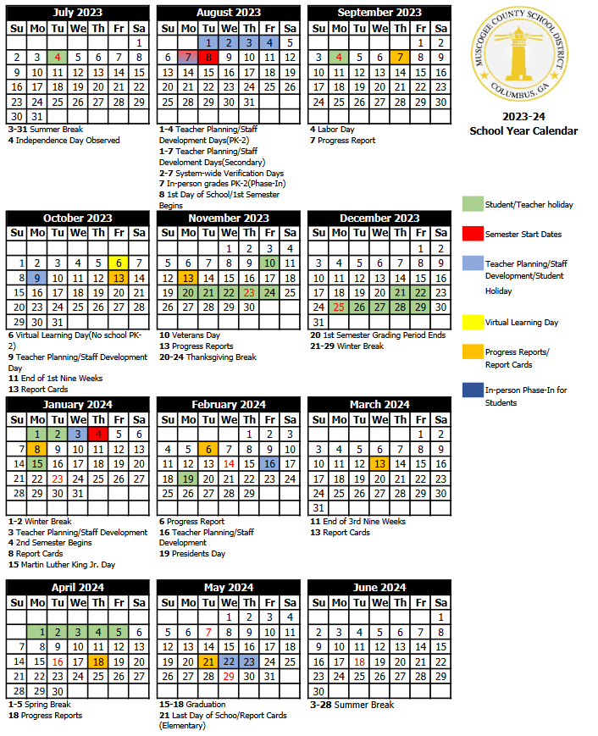
MCSD 2023-24 School Year Calendar

