Set Aside Survey
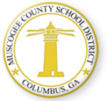

Title I Parents, Family Members, and Other Community Education Stakeholders of Muscogee County,

The Muscogee County School District (MCSD) annually receives a Title I, Part A Federal Grant for schools with a high percentage of students who are eligible to receive free or reduced priced school meals. Schools that receive funds from this grant are classified as Title I schools. Currently, there are 38 schools in MCSD that receive Title I funds.

One of the provisions of this grant is the requirement for the District to set aside 1% of its Title I, Part A money to fund
activities that build parents’ capacity to become partners with schools to help their children achieve academically. You, as a parent, family member, or other educational community stakeholder, may assist the MCSD Title I Department in making decisions about how the set aside funds will be used in the 2020-2021 school year.

You may participate in the decision making process by completing the Title I Stakeholder survey below. Please return to your child’s school prior to September 23, 2020.Please select three choices.

More Technology Resources (hotspots, chromebooks, etc.)

Parent and Family Engagement Books, Pamphlets, and Brochures

Parent and Family Engagement Training Workshops, Conferences, or Parent Focus Groups

Materials for Improving Mathematical Skills

Materials for Improving Reading and Writing Skills

SAT, ACT, and ASVAB Books/College Prep Materials and/or Training

Bilingual Resources (specify language)

Other Suggestions

Please leave your feedback on this form or scan the QR Code above to complete the survey online.

Comments or Feedback:

School Name: Date:

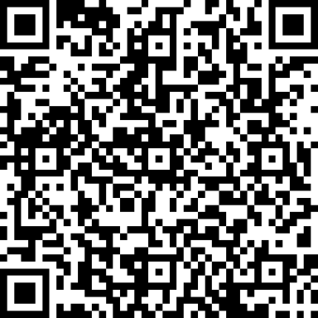

Thank you for your input!

Revised: August 3, 2020

