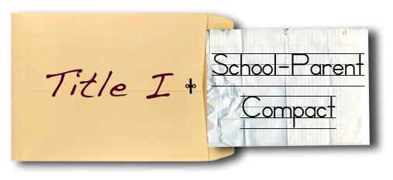

What is a School-Parent Compact?

A School-Compact for Achievement is an agreement that parents, students and teachers develop together. It explains how parents and teachers will work together to make sure all our students reach grade-level standards.

Effective School-Parent Compacts:
Communication about Student Learning

Waddell Elementary is committed to frequent two-way communication with families about children’s learning. Some of the ways you can expect us to reach you are:

- Weekly homework folders
- Monthly “check-in note and phone calls”
- Updates on the school’s website
- Grade level meetings on understanding student progress
- Parent-teacher conferences in November and March
- Current grades on the Parent Portal

Waddell Elementary
Principal
Mrs. Tonya Douglass
6101 Miller Road
Columbus, GA. 31907
Office: 706-569-3722 / Fax: 706-569-3727

- Link to goals of the School Improvement Plan
- Focus on student learning skills
- Describe how teachers will help students develop those skills using high-quality instruction
- Share strategies parents can use at home
- Explain how teachers and parents will communicate about student progress
- Describe opportunities for parents to volunteer, observe and participate in the classroom

How is the School-Parent
Compact Developed?

The parents, students, and staff at Waddell Elementary developed this School-Parent Compact for Achievement. Teachers suggested home learning strategies, parents add ideas to make them more specific, and students told us what would help them learn. Meetings are held each year to review the Compact and make changes based on student needs.

Parents are welcome to contribute
comments at anytime

If you would like to volunteer, and /or observe in the classroom please contact the school at 706-569-3722.

Building Partnerships
- Parents are invited to attend monthly parent workshops and activities sponsored at the school.
- Parents are invited to volunteer, participate and observe at the school and in their child’s classroom.
- Parents are invited to visit the Parent Resource Room/Area to check-out materials to use with their child at home.

Waddell Elementary
Revised September 26, 2017

School-Parent Compact 2017-2018

Our Goals for Student Achievement

District Goals

The Muscogee County School District will create an environment that focuses in Tier 1 instruction while targeting individual student needs, leadership development, and customer service.

Waddell’s Goals

#1 By May 2018, 100% of staff will be trained in Tier 1 School-Wide Positive Behavioral Interventions and Supports (PBIS) and at least 5 out of 10 critical elements will be developed to 80% as measured by the Tiered Fidelity Inventory (TFI) and Self-Assessment Survey (SAS).

#2 By May 2018, 100% of Waddell’s faculty will be trained, and 85% will effectively use the strategy of clarifying, sharing, and understanding learning intentions and success criteria during their instruction in all content areas.

Our Students:
Students are encouraged to participate in the educational process. A successful student takes ownership of his/her learning and sets high educational goals.
- Set goals for myself to succeed in school and reach for the stars in all content areas.
- Ask questions to gain knowledge and understanding in all content areas.
- Work hard to display positive behavior.
- Work with my parents and teachers to become a successful student.

Our Parents:
Parents are expected to participate in the education of their children. Without the cooperation and partnership between parents and school staff, we cannot effectively help a student reach his or her full potential. The major role of parents is to continually show the child that they are interested and supportive of how their child is doing in school.
- Reinforce goals my child has set for himself/herself.
- Work with my child in all content areas to ensure success.
- Communicate with my child’s teacher regarding any questions or concerns about my child’s academics.
- Reinforce positive behavior at home and school.
Parental Engagement Does Make a Difference!

Our Teachers:
Teachers are expected to work with students and their families to support students’ success in reading and math. Some of our key connections with families will be:
- Coordinate activities and share strategies with families on how to help students at home.
- Monitor student progress in all content areas and update parents frequently.
- Establish open lines of communication with parents concerning their child’s school performance and behavior.
- Make sure all students get help as soon as it’s needed.

