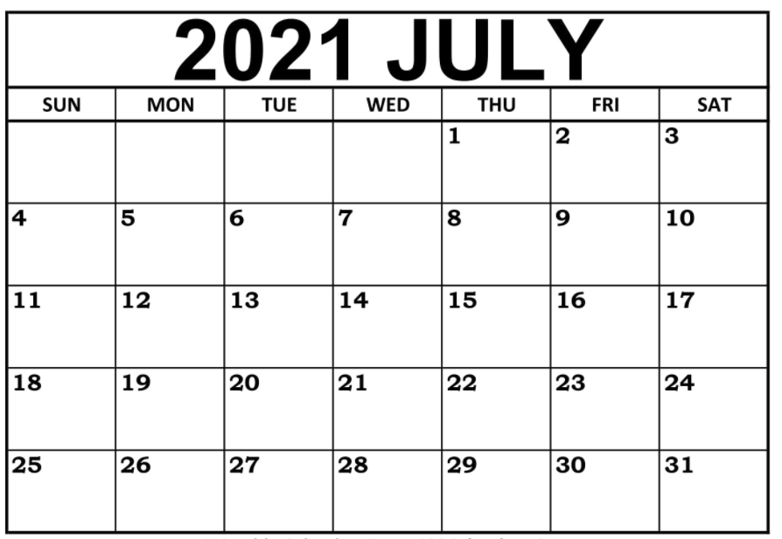



**Join our VMMS Soccer GroupMe**

**by scanning the QR Code. All information**

**will be sent Via GroupMe**

**Coach Rodriguez Contact:**

**Rodriguez.Jeremy.V@muscogee.k12.ga.us**

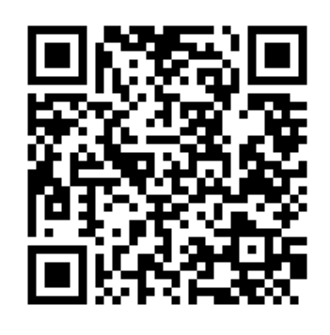

**3:00 – 5:00**

**@ VMMS**

**3:00 – 5:00**

**@ VMMS**

**3:00 – 5:00**

**@ VMMS**

**3:00 – 5:00**

**@ VMMS**

**3:00 – 5:00**

**@ VMMS**

**3:00 – 5:00**

**@ VMMS**

* **ALL DATES AND TIMES ARE TENTATIVE AND SUBJECT TO CHANGE**
* **AN AUGUST WORKOUT CALENDAR WILL BE SENT OUT THE LAST WEEK OF JULY**
* **WATER BOTTLE, GYM CLOTHES, TENNIS SHOES (BRING CLEATS IF YOU HAVE THEM)**