Changing Zoom Name

When a student clicks a Zoom link, they get this screen, where they then would need to click “Leave Meeting” and then click “Leave Meeting” again on the pop-up:
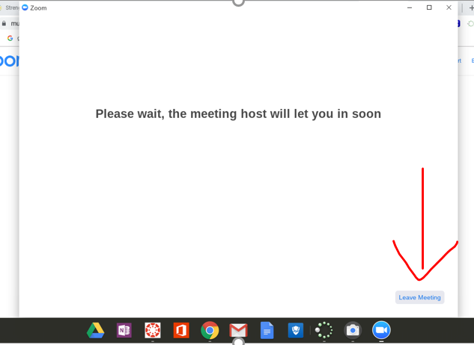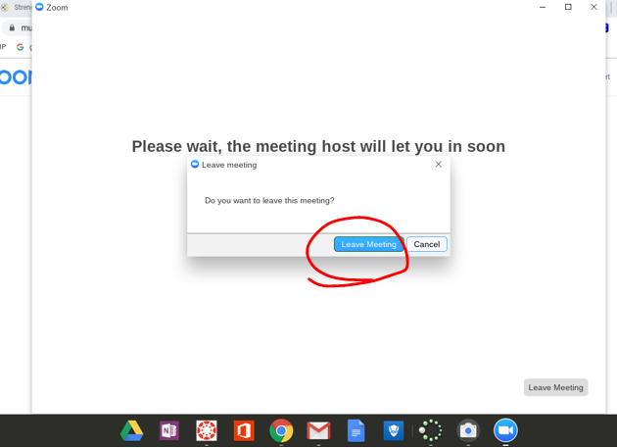

This screen will pop up where they click “Join a meeting”:

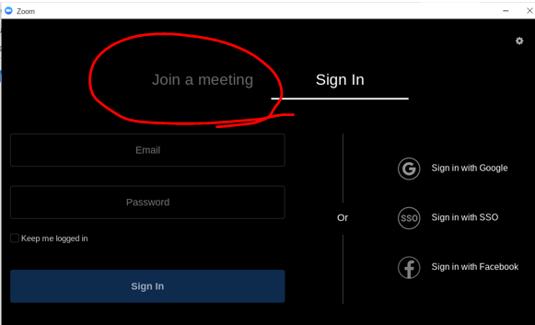
On the next screen they can type in their name:
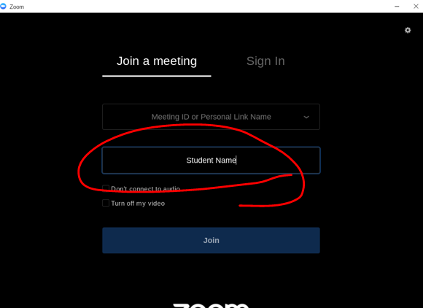
They can then click to find the meeting they were in:
