Step 1: When students are logging in at home, they will still go through Clever to get on to the program.
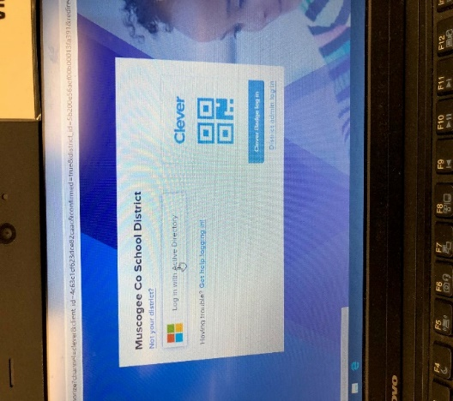

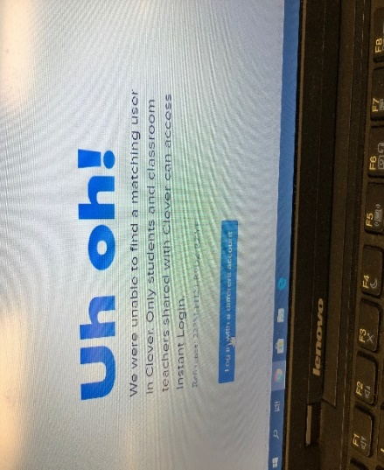
Step 2: Student will get the “Uh Oh!” message. It is okay. They will need to click on the bottom blue button (log in with a different account).

Step 3: Students enter their gtid@mcsdgas.com
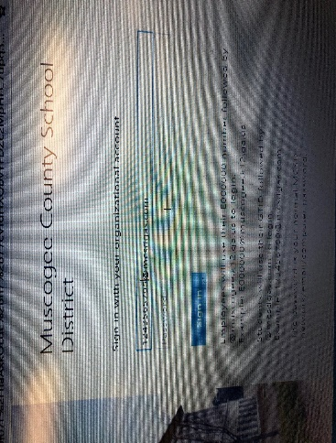
Password is mcmmddyy

