

**What is a School-Parent Compact?**

A School-Parent Compact for Achievement is an agreement that parents, students and teachers develop together. It explains how parents and teachers will work together to make sure all our students reach grade-level standards.

**Effective School-Parent Compacts:**

* Link to goals of the School Improvement Plan

**Communication about Student Learning**

WH Spencer High school is committed to frequent two-way communication with families about children’s learning. Some of the ways you can expect us to reach you are:

* *My Big Campus* & *Facebook*  real-time announcements
* Monthly note and phone calls
* Updates on the school’s website
* Current grades on the *Infinite Campus* Parent Portal
* Parent-Teacher conferences on understanding student progress & to audit transcripts for graduation

William H. Spencer High School

Dr. Johnny Freeman, Principal

1000 Fort Benning Drive

Columbus, Georgia 31903

<http://sites.muscogee.k12.ga.us/spencer/>

* Focus on student learning skills
* Describe how teachers will help students develop those skills using high-quality instruction
* Share strategies parents can use at home
* Explain how teachers and parents will communicate about student progress
* Describe opportunities for parents to volunteer, observe and participate in the classroom

**How was the School-Parent Compact Developed?**

The parents, students, and staff at WH Spencer High school developed this School-Parent Compact for Achievement. Parents met on **November 12th** to discuss opportunities for engagement. Teachers suggested home learning strategies during faculty meetings and students gave ways that would help them to learn. Meetings are held each year to review the compact and make changes based on student needs.

**Parents are welcome to make suggestions or visit at any time.**

If you would like to volunteer, participate, and/observe in the classroom please contact the front office, PTO, Parent Liaison or Teacher.

**Building Partnerships**

* Parents are invited to attend monthly parent workshops and activities sponsored at the school
* Parents are invited to volunteer, participate and observe at the school and in their child’s classroom
* Parents are invited to visit the Parent Resource Room/Area to check-out materials to use with their child at home

**W.H. Spencer High School**

**School-Parent Compact, for**

**Student Achievement**

**2019-2021**

***Revised: August 25, 2020***



**Goals for Student Achievement**

**District Goals:**

By July 2023, the Muscogee County School District will implement a Leadership Development Program, Personalized Learning, a Multi-Tiered System of Support (MTSS) with a “Culture of Kindness”.

**School Goals:**

**Smart Goal #1**: By May 2021, 100% of teachers will implement and demonstrate evidenced-based instructional strategies of effective feedback and formative assessment as measured by walkthrough data, gradebooks, and student work samples.

**Smart Goal #2**: By May 2021, 100% of teachers will be trained on school-wide positive supports and 80% will implement SWPBS that includes incentives, consequences and teaching of social emotional learning skills as measured by the SAS, TFI and walk through data.

**Our Students:**

**Students are encouraged to participate in the educational process. A successful student takes ownership of his/her learning and sets high educational goals.**

* Set goals for myself to succeed in my all-academic standards.
* Discuss my individual learning goals with my parents
* Maintain positive behavior that allows me reach my full academic potential.
* Maintain good work-study habits and continue strive to all I can be in academics success.



**Our Parents:**

**Parents are expected to participate in the education of their children. Without the cooperation and partnership between parents and school staff, we cannot effectively help a student reach his or her full potential. The major role of parents is to continually show the child that they are interested and supportive of how their child is doing in school.**

* Instruct, encourage, and teach your child the importance of high school years.
* Always show positive behavior no matter what the situation or circumstances are.
* Communicate with my child’s teacher regarding any questions or concerns about your child’s individual goals for learning abilities.
* Attend parenting activities to expand the potential and reach my child goals pertaining his or her academics.

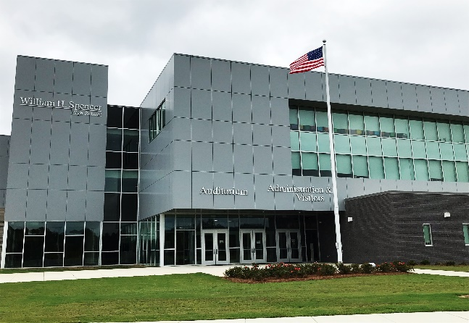

**Our Teachers:**

**Teachers are expected to work with students and their families to support students’ success in reading and math. Some of our key connections with families will be:**

* Develop and send home materials for students to help parents support the learning goals
* Create a partnership with every family in my classroom and provide opportunities for parents to volunteer, observe and participate in classroom activities
* Coordinate activities for parents and students in order to share strategies with families on how to help students at home
* Always maintain a positive approach in any situation.
* Establish open lines of communication with parents concerning their child’s school performance.

