Building Partnerships
- Parents are invited to attend monthly parent workshops and activities sponsored at the school.
- Parents are invited to volunteer, participate, and observe at the school and in their child’s classroom
- Parents are invited to visit the Parent Resource Room/Area to checkout materials to use with their child at home.

What is a School-Parent Compact?
A School Compact for Achievement is an agreement that parents, students and teachers develop together. It explains how parents and teachers will work together to make sure all our students reach grade-level standards.
Communication about Student Learning

South Columbus Elementary School is committed to frequent two-way communication with families about children’s learning. Some of the ways you can expect us to reach you are:
- Weekly homework folders
- Monthly “check-in” note and phone calls
- Updates on the school’s website
- Grade level meetings on understanding student progress
- Parent-teacher conferences in Fall and Spring
- Quarterly Parent Guides sent home

South Columbus Elementary School
Mrs. J. Dawn Jenkins, Principal
Mrs. Melanie L. Bastien, Assistant Principal
1964 Torch Hill Road
Columbus, GA 31903
706-683-8833

Effective School-Parent Compacts:
- Link to goals of the School Improvement Plan
- Focus on student learning skills
- Describe how teachers will help students develop those skills using high-quality instruction
- Share strategies parents can use at home
- Explain how teachers and parents will communicate about student progress
- Describe opportunities for parents to volunteer, observe and participate in the classroom

How is the School-Parent Compact Developed?
The parents, students, and staff at South Columbus Elementary School developed this School-Parent Compact for Achievement. Teachers suggested home learning strategies, parents added ideas to make them more specific, and students told us what would help them learn. Meetings are held each year to review the compact and make changes based on student needs.

Parents are welcome to contribute comments at anytime
If you would like to volunteer, participate, and /or observe in the classroom please contact-Tracy Belt (706) 565-2989 Central Region FSC

South Columbus Elementary School
School, Parent, Home Compact for Student Achievement
2018-2019
Revised: August 8, 2018

Our Goals for Student Achievement

District Mission
- Our mission is to inspire & equip all students to achieve unlimited potential.
District Goals
- The Muscogee County School District will create an environment that focuses on tier 1 instruction while targeting individual student needs, leadership development, and customer service.
School’s SMART Goal
- ​ By May 2019, 100% of teachers will be trained on PBIS in the Classroom and 85% of teachers implementing these practices effectively with an emphasis on: ​​

Module 3-Consequence System for Academic Engagement ​​
Module 4-Instructional Practices for Student Engagement ​
​
- By May 2019, 100% of teachers in grades K-5 will receive training utilizing a balanced literacy framework that includes effective reading and writing instruction and 85% of teachers will successfully implement the strategies as measured by walk through/focus walk data. ​

Our Students:
Students are encouraged to participate in the educational process. A successful student takes ownership of his/her learning and sets high educational goals.
- K-2nd will set goals for themselves to succeed in school, reach for the stars in Reading and Math, and discuss our goals with our families.
- K-2nd will practice our math facts each night at home to improve our speed and accuracy.
- 3rd -5th will let our teachers and families know if we need help with Math and Reading.

Our Students:

Students are encouraged to participate in the educational process. A successful student takes ownership of his/her learning and sets high educational goals.
- Set goals to succeed in school, reach for the stars in Reading and Math, and discuss our goals with our families.
- Maintain good behavior to increase academic achievement.
- Let our teachers and families know if we need help with Math and Reading.
- Work on our Math and Reading skills at home, using the materials our teachers send home.

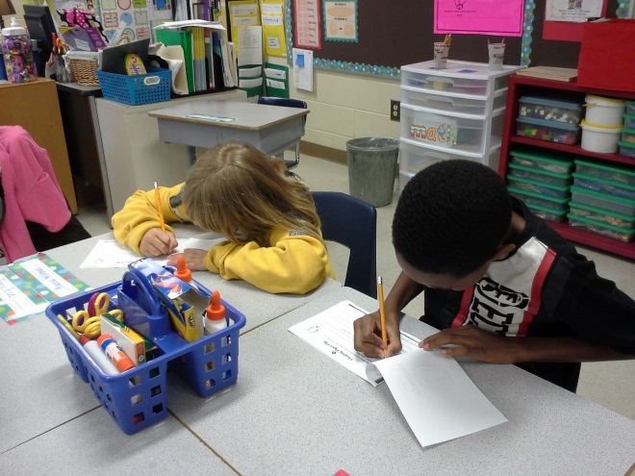

Our Parents:
Parents are expected to participate in the education of their children. Without the cooperation and partnership between parents and school staff, we cannot effectively help a student reach his or her full potential. The major role of parents is to continually show the child that they are interested and supportive of how their child is doing in school.
- Use Reading and Math materials and strategies the teacher sends home each week to help our children improve their academic abilities.
- Help our children see how important it is to maintain good behavior for academic achievement.
- Communicate with our children’s teacher regarding any questions or concerns about our children’s individual goals for learning.
- Attend Reading and Math Night as well as at least one other parenting workshop with our children to practice new ways to support him/her in Reading and Math.
.
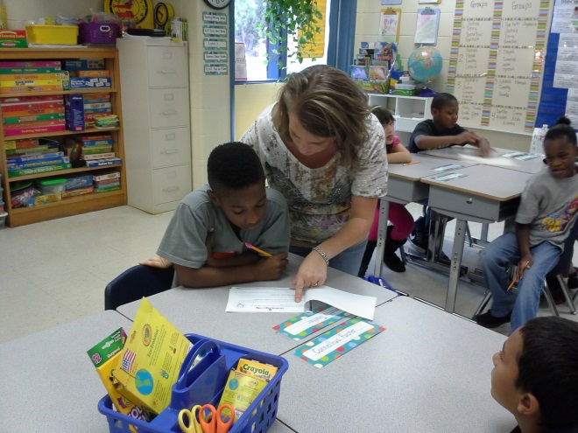

Our Teachers:
Teachers are expected to work with students and their families to support students’ success in reading and math. Some of our key connections will families will be:
- Create a partnership with every family in our classroom and provide opportunities for parents to volunteer, observe, and participate in classroom activities.
- Coordinate activities for Math and Literacy Night and share strategies with families on how to help students at home.
- Reinforce positive behavior to increase student achievement.
- Establish open lines of communication with parents concerning their child’s school performance.

