Building Partnerships
- Parents are invited to attend monthly parent workshops and activities sponsored at the school.
- Parents are invited to volunteer, participate, and observe at the school and in their child’s classroom
- Parents are invited to visit the Parent Resource Room/Area to check-out materials to use with their child at home.

What is a School-Parent Compact?
A School Compact for Achievement is an agreement that parents, students and teachers develop together. It explains how parents and teachers will work together to make sure all our students reach grade-level standards.
Communication about Student Learning

South Columbus Elementary School is committed to frequent two-way communication with families about children’s learning. Some of the ways you can expect us to reach you are:
- Weekly homework folders
- Monthly “check-in” note and phone calls
- Updates on the school’s website
- Grade level meetings on understanding student progress
- Parent-teacher conferences in Fall and Spring
- Quarterly Parent Guides sent home

South Columbus Elementary School
Mrs. J. Dawn Jenkins, Principal
Mrs. Felicia Thompson Assistant Principal
1964 Torch Hill Road
Columbus, GA 31903
706-683-8833

Effective School-Parent Compacts:
- Link to goals of the School Improvement Plan
- Focus on student learning skills
- Describe how teachers will help students develop those skills using high-quality instruction
- Share strategies parents can use at home
- Explain how teachers and parents will communicate about student progress
- Describe opportunities for parents to volunteer, observe and participate in the classroom

How is the School-Parent Compact Developed?
The parents, students, and staff at South Columbus Elementary School developed this School-Parent Compact for Achievement. Teachers suggested home learning strategies, parents added ideas to make them more specific, and students told us what would help them learn. Meetings are held each year to review the Compact and make changes based on student needs.

Parents are welcome to contribute comments at anytime
If you would like to volunteer, participate, and /or observe in the classroom please contact-Tracy Belt (706) 565-2989 Central Region FSC

South Columbus Elementary School
School, Parent, Home Compact for Student Achievement
2016-2017
Revised 9/1/16

Our Goals for Student Achievement

District Goals

- By 2017, all schools will meet or exceed the state average in reading on the Georgia Milestones Assessment

School’s SMART Goals

- By May 2017, 60% of all K-5 students will attain a Lexile score that fall within or above their grade level.
- By May 2017, the number of students in Tier 1 in the PBIS pyramid will increase from 89% to 91%.

Our Students:
Students are encouraged to participate in the educational process. A successful student takes ownership of his/her learning and sets high educational goals.
- K-2nd will set goals for themselves to succeed in school and reach for the stars in reading and math and discuss our goals with our families.
- K-2nd will practice our math facts each night at home to improve our speed and accuracy.
- 3rd -5th will let our teachers and families know if we need help with math and reading
- 3rd-5th will work on our math and reading skills at home, using the materials our teachers send home

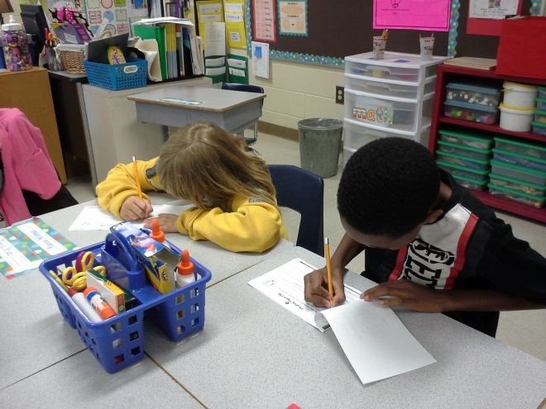

Our Parents:
Parents are expected to participate in the education of their children. Without the cooperation and partnership between parents and school staff, we cannot effectively help a student reach his or her full potential. The major role of parents is to continually show the child that they are interested and supportive of how their child is doing in school.
- K-2nd parents will use reading and math materials and strategies the teacher sends home each week to help our children improve their academic abilities.
- K-2nd parents will help our children see how to use math and reading to pursue his/her interest and goals
- 3rd-5th parents will communicate with our children’s teacher regarding any questions or concerns about our children’s individual goals for learning.
- 3rd-5th parents will attend Reading and Math Night as well as at least one other parenting workshop with our children to practice new ways to support him/her in reading and math
.
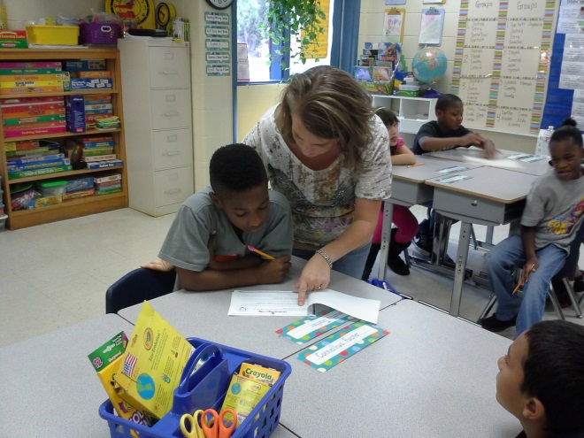

Our Teachers:
Teachers are expected to work with students and their families to support students’ success in reading and math. Some of our key connections will families will be:
- K-2nd teachers will create a partnership with every family in our classroom and provide opportunities for parents to volunteer, observe and participate in classroom activities
- K-5 teachers will coordinate activities for Math and Literacy Night and share strategies with families on how to help students at home.
- K-2nd teachers will make sure all students get help as soon as it’s needed
- K-5th teachers will establish open lines of communication with parents concerning their child’s school performance

