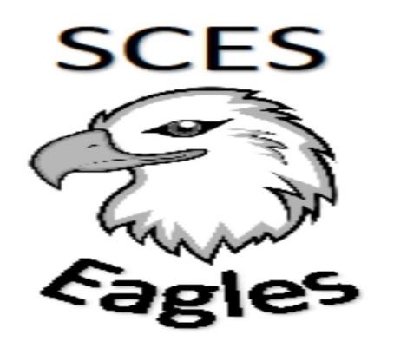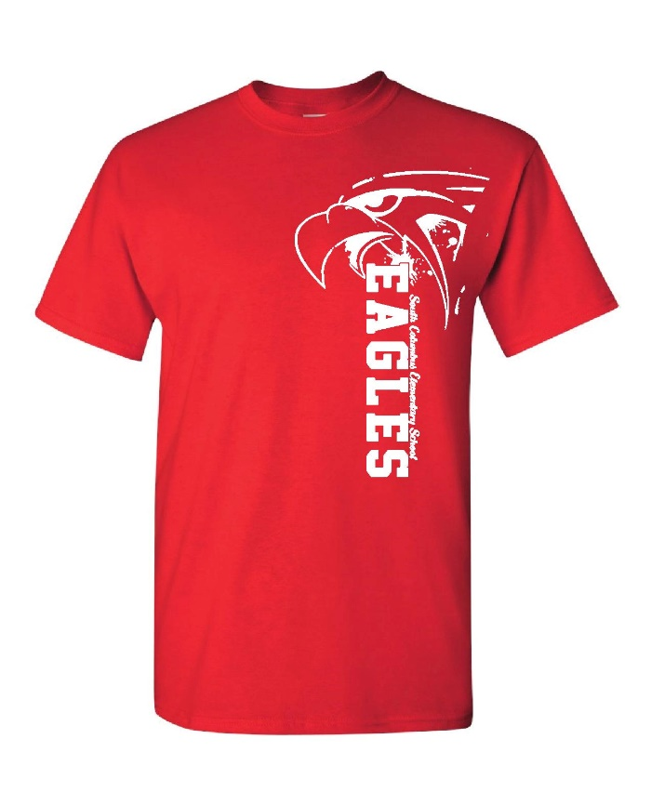
Shirts come in Red or Blue.

$8.00
SPIRIT WEAR

Our New 2017-2018 Spirit Wear Shirts will be on sale during Verification Day, August 2nd, 2017.
$8.00 each if purchased on Verification Day. Shirts will be $10.00 each after Verification Day.
Spirit shirts can be worn each day with uniform pants.

