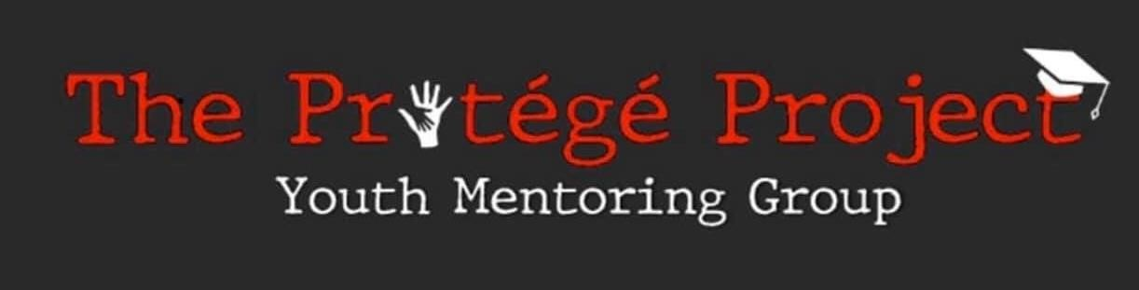
The Joyce T. Bernard Unsung Hero Award
Criteria:
- Must be a graduating senior of the Class of 2020 at a Muscogee County school (private or public).
- Must have achieved a minimum cumulative unweighted G.P.A. of 3.0 through the first semester of your senior year. (Please provide an official transcript)
- Must use the scholarship to further your education beyond the high school level at any college, university, trade, technical, or junior college.
- Must have proven involvement in at least two community or school-based activities over the past year. Involvement includes organizing, volunteering or supporting activities which displays a positive impact on the community.
- Application includes an original 500 words essay that answers the following: “What are your most important extra-curricular or community activities? What made you join these activities? What made you continue to contribute to them?” Provide details of your efforts and how it has currently impacted your school and/or the community.
Application Process:
Application, essay, two letters of references any additional information should be submitted to The Protégé Project, Inc. via mail or email on or before February 28, 2020 by 5:00 P.M. Essays must be mailed to 233 12th Street, Suite 730, Columbus, Georgia 31901or emailed to info@theprotegeway.org. This award will be presented at The Protégé Project, Inc. Inaugural Black Tie Gala on March 7, 2020. A check will be made out to the award winner. The award recipient must be present at the Gala to receive. Visit Eventbrite.com or call (706) 584-3044 for tickets.
About the Joyce Thornton Bernard Unsung Hero Award:
The Unsung Hero Award recognizes students who have made a positive impact or influence in their community, while demonstrating exemplary academic performance, a positive attitude, willingness to help other, and a commitment to excellence!

