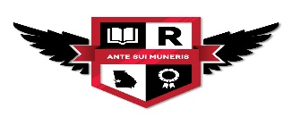
Rothschild Leadership Academy
6th-8th School Uniforms SY21-22
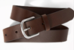
Boys – 6th Grade: White or Grey Shirts
- Black, Grey, or Khaki pants with belt
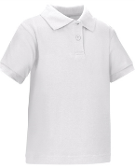
- Black, Grey, or Khaki shorts with belt
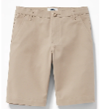
- Grey or White
- long-sleeve or short sleeve
Polo style shirt or button down shirt
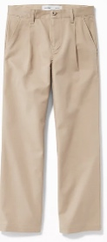
- Grey or White
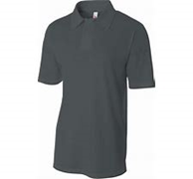
Round neck or V-neck sweater
- Grey or White Sweater Vest
- Black or Khaki light-weight jacket
Or long sleeve sweater
No hood

Girls – 6th Grade: White or Grey Shirts
- Black,Grey or Khaki pants with belt
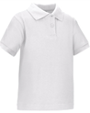
- Black, Grey, or Khaki shorts with belt
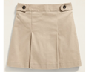
- skirt/ skort (Length appropriate)

- White or Grey long-sleeve or short sleeve
Polo style shirt or button down shirt
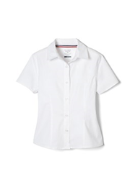
- White or Grey, or Round neck or
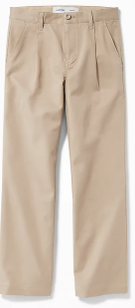
V-neck sweater
- White or Grey Sweater Vest
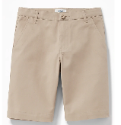
- Black or Khaki light-weight jacket
No hood

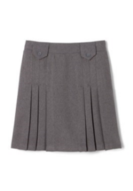
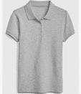

- Girls & Boys- 7th Grade: Black Shirts
- Black, Grey, or Khaki pants or skirts with belt 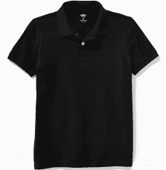 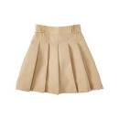
- Black, Grey, or Khaki shorts with belt
- Black long-sleeve or short sleeve
- Polo style shirt or button down shirt
- Black Round neck or V-neck sweater
- Black Sweater Vest
- Black or Khaki light-weight jacket
Or long sleeve sweater
No hood

- Girls & Boys- 8th Grade: Red Shirts
- Black, Grey, or Khaki pants or skirts with belt 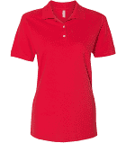
- Black, Grey, or Khaki shorts with belt
- Red long-sleeve or short sleeve
- Red Polo style shirt or button down shirt
- Red Round neck or V-neck sweater
- Red Sweater Vest
- Black or Khaki light-weight jacket
Or long sleeve sweater
No hood
