**Third Grade Supply List**

**MCSD Supply List**

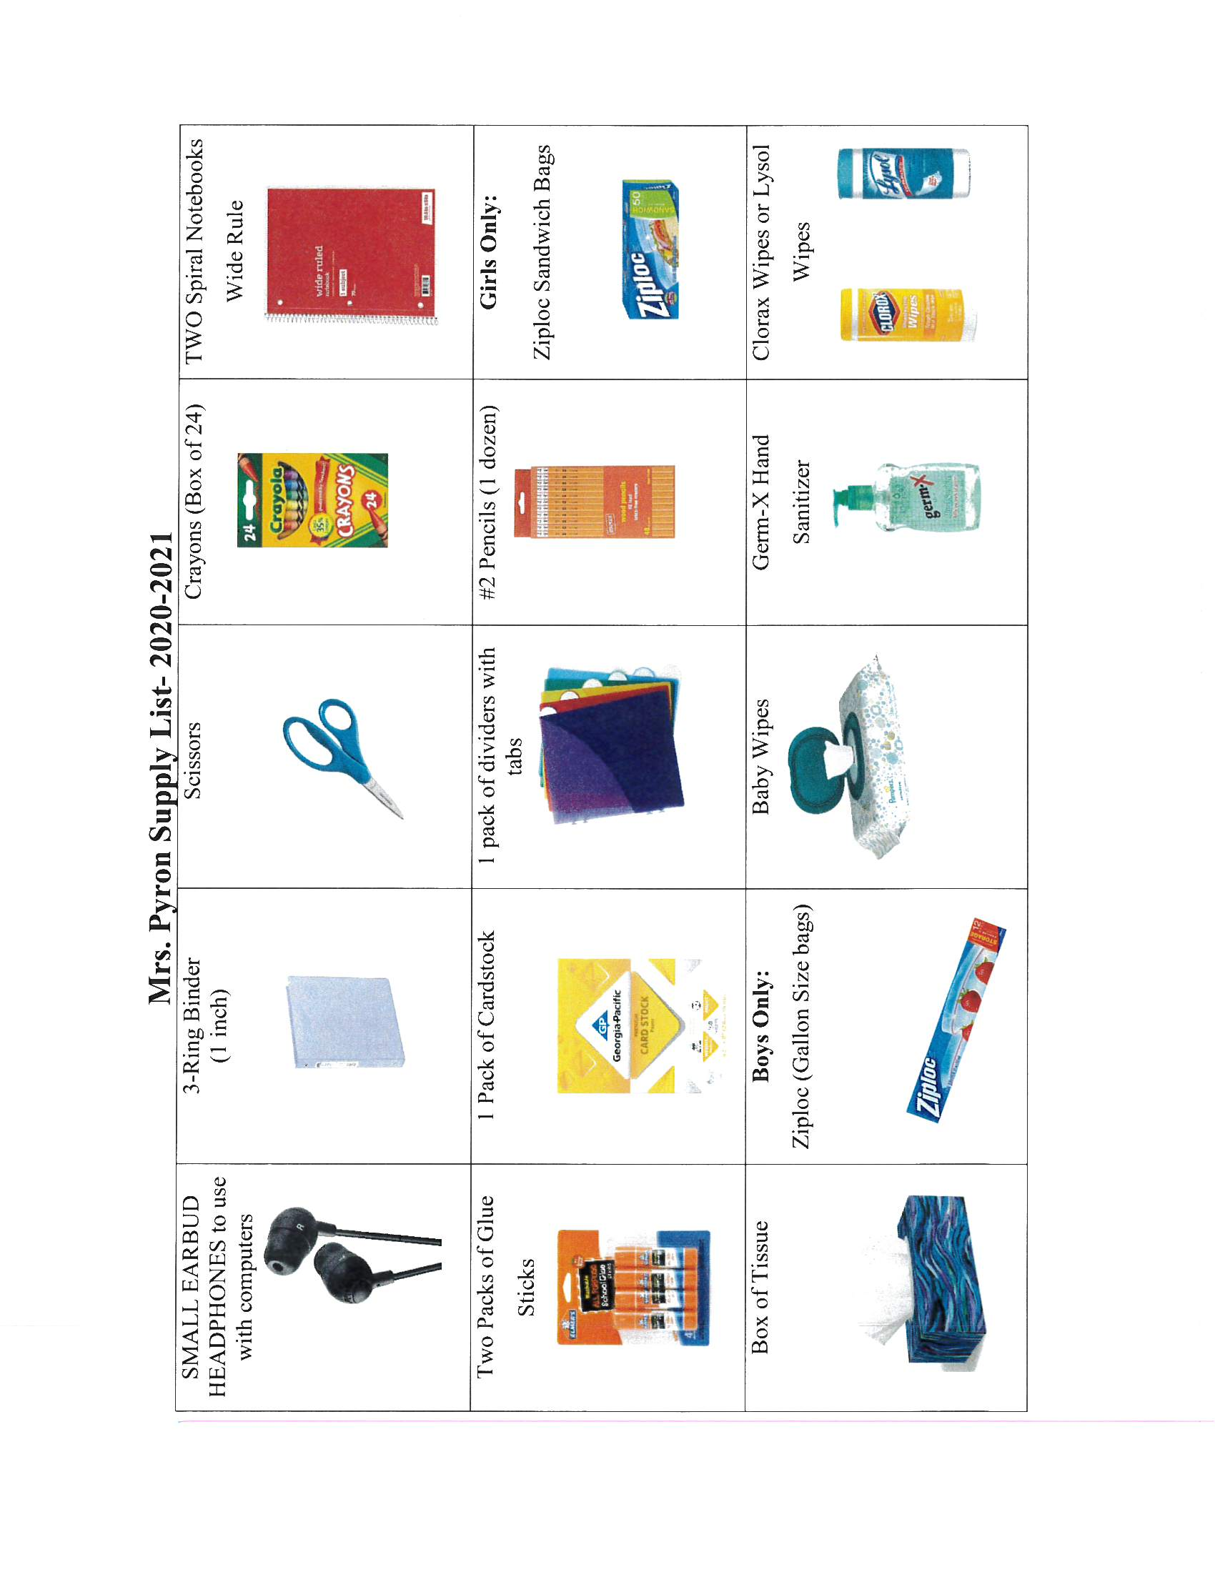

**Third Grade Wish List**

