River Road Pre-K Information
Welcome to Pre-K,
There is not a school supply list for pre-k. YAY!!! We have all of those things in class ready to use and will divide the supplies up for individual use this year. Your child will need…..
- beach towel and small blanket for rest time
- seasonal change of clothes (to be left in his/her book bag)
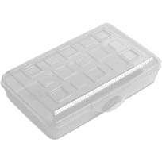
- average size book bag (no mini back packs)
- water bottle (brought daily and full)
- plastic pencil box and ear buds...
like pictured (optional but
requested to divide shared supplies) $1 at most stores
Your child’s beach towel and small blanket (no comforters, large, or thick blankets) must fit easily into his/her cubby as he/she will be the one putting it away daily. The cubby boxes are approximately the size of a shoebox. You child’s change of clothes should be in a Ziploc bag with his/her name and left in his/her book bag for emergencies. We will send home towels and blankets every Friday to be washed. Please put your child’s name on EVERYTHING.
If you would like to donate any of the following we are always in need of Band-Aids, tissue, baby wipes, Clorox wipes, cleaning supplies, hand sanitizer, paper cups, paper plates, treasure box goodies, individually wrapped candies for a quick sweet reward (no disc candies please), and individually wrapped snacks for snack time. Any donations are greatly appreciated.
Also, if you feel more comfortable supplying consumable items for your child he/she will need crayons, markers, scissors, a glue bottle, and 2 glue sticks. However, this is not necessary. It’s just an option.
Thank you,
Pre-K Team

