WHAT IS A
Communication about
Student Learning

- Parent Portal/Class Dojo
- Updates on the School’s Website
- Parent-Teacher Conferences
- Connect –Ed messages
- Zoom Meetings
Principal
Mr. Philip Bush

Assistant Principal
Dr. Jan Thomas

516 Heath Drive
706-748-3072

Access our school’s website at www.muscogee.k12.ga.us
SCHOOL-PARENT COMPACT?
A Home-School Compact is an agreement that parents, students, and teachers develop together. It explains how they will work together to make sure all students reach grade-level standards. Meetings are held each year to review and revise the compact based on the school’s academic achievement goals and student’s needs. For all students that reside in residential facilities served by the Muscogee County School District, parental involvement correspondence and activities will be mailed to each facility where students reside.

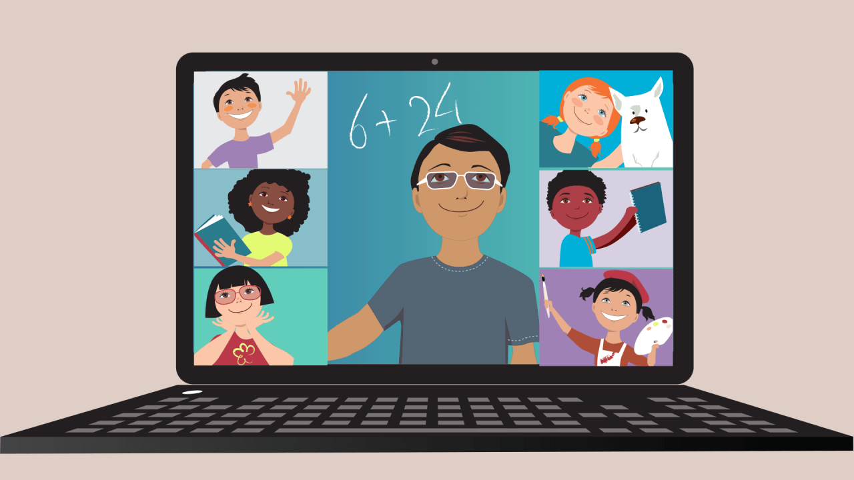
River Road Elementary
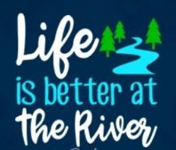

Our Goals for Student Achievement

District Goals
By July 2023, the Muscogee School District will implement a Leadership Development Program, Personalized Learning, a Multi-Tiered System of Support (MTSS) with a “Culture of Kindness”.

School’s SMART Goals
Instructional Goal
By May 2021, 100% of K-5 teachers will demonstrate growth in creating an academically challenging environment by differentiating instructional strategies that support personalized learning as measured by walk-throughs, lesson plans, and student data.

Climate Goal
River Road will continue towards full implementation of all Tier 1 Critical elements of school-wide PBIS with 90% fidelity by May 2021 as measured by the Tier Fidelity Inventory.

Climate Goal

2019-2021
Revised 8-10-2020

Revised 9-14-2016

As Parents, we will….
- Communicate with our child’s teacher regarding any questions or concerns about my child’s performance.
- Check our child’s homework folder or agenda book daily.
- Make sure my child is at school and arrives on time prepared for the day.
- Attend parent meetings to better assist my child.

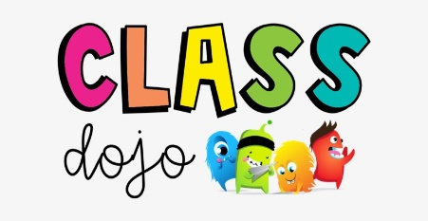

As a School, we will….
- Help parents stay connected through multiple ways of communication.
- We will monitor student progress to ensure student success.
- We will model and teach wanted behaviors with positive rewards.
- We will provide workshops to assist parents.
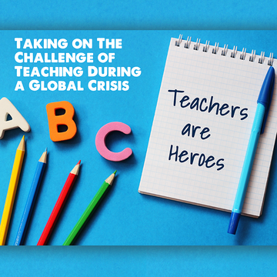

As Students, we will….
- Ask questions if we don’t understand our class room or homework assignments.
- Follow the rules and be respectful, responsible, and safe.
- Study and do our very best on tests/Georgia Milestones Test.
- Practice our writing and read each night to reach our AR and Lexia goals.

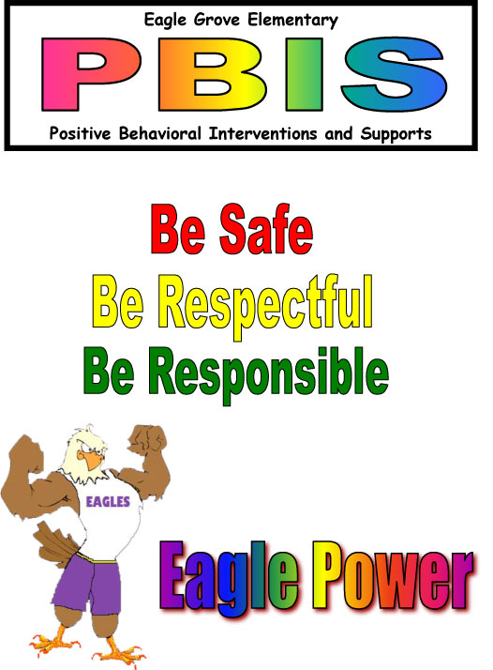
R

[Grab your reader’s attention with a great quote from the document or use this space to emphasize a key point. To place this text box anywhere on the page, just drag it.]
[Grab your reader’s attention with a great quote from the document or use this space to emphasize a key point. To place this text box anywhere on the page, just drag it.]
[Cite your source here.]

