

**District Goals**

By July 2023, The Muscogee County School District will implement a Leadership Development Program, Personalized Learning, a Multi-Tiered System of Support (MTSS), with a “Culture of Kindness”.

**School’s Smart Goals**

**Instructional Goal** - By May 2021, 100% of K-5 teachers will demonstrate growth in creating an academically challenging environment by differentiating instructional strategies that support personalized learning as measured by walk-throughs, lesson plans, and student data.

**Climate Goal-** River Road will continue towards full implementation of all Tier 1 Critical elements of school-wide PBIS with 90% fidelity by May 2021 as measured by the Tier Fidelity Inventory.

**Climate Goal**

River Road Elementary

**Parent and Engagement Policy**

**Revised 2019-2021**

Revised 8-10-2020

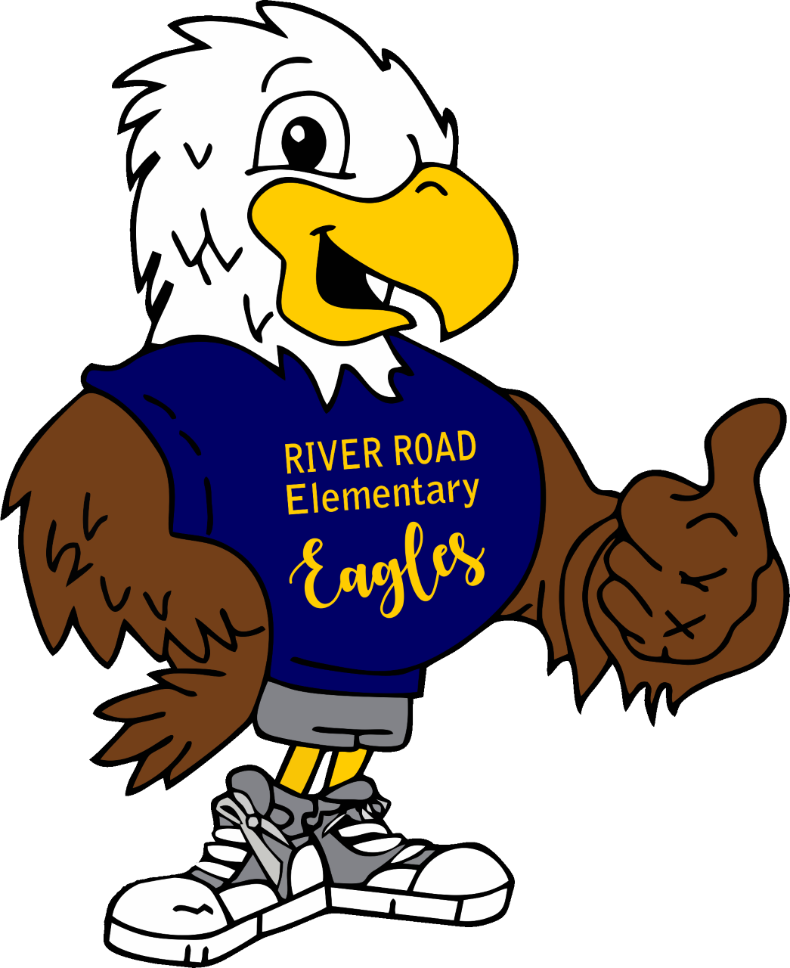

RIVER ROAD ELEMENTARY

**2019-2021**

**Revised 8-10-2020**

**WHAT IS TITLE I?**

River Road Elementary is identified as a Title I school as part of the Every Student Succeeds Act (ESSA). Title I is a federal grant that was designed to ensure that all children receive a high quality education and reach grade level proficiency. Title I programs must be based on effective means of improving student achievement and include strategies to support parent and family engagement. All schools must jointly develop with all parents a written parent and family engagement policy.

***Parent & Family Engagement Policy!***

**What is it?**

The Parent and Family Engagement Policy describes how River Road Elementary will provide opportunities to improve parent engagement to support student learning. River Road Elementary values the contributions and involvement of parents in order to establish a partnership for the common goal of improving student achievement. The Parent and Family Engagement Policy describes the different ways the school will support parent engagement and how parents can be involved.

**How is it developed?**

River Road Elementary welcomes parent input and comments at any time regarding the Parent and Family Engagement Policy. All parent feedback will be used to revise the plan for next year. The Parent and Family Engagement Policy is available for parents to view and provide feedback throughout the year. River Road Elementary also distributes a Title I Survey to ask parents for suggestions on the Parent and Family Engagement Policy and the use of funds for parent involvement.

**Who is it for?**

All parents at River Road Elementary are encouraged and invited to fully participate in the opportunities described in the Parent and Family Engagement Policy. River Road Elementary will provide full opportunities for the participation of parents with limited English, parents with disabilities, and parents of migratory children.

**Where is it available?**

The Parent and Family Engagement Policy will be sent home with each student and is also available in the Parent Resource room and on the school’s website.

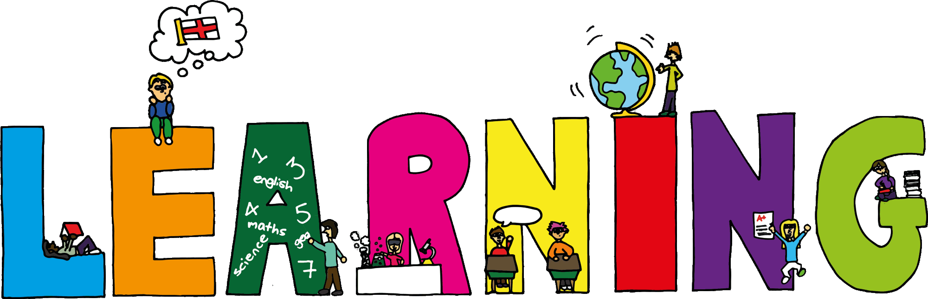

**Parent & Family**

**Engagement Activities**

**Title 1 Annual Parent Meeting**

Learn about our Title I program including: Parent and Family Engagement Policy, School Improvement Plan, School- Parent Compact, and parent involvement opportunities.

**Georgia Milestones Assessment Meeting**

Overview of the state testing which measures how well students learn the knowledge and skills outlined in the state-adopted content standards while gaining knowledge on improving test scores.

**Parent Literacy Workshop**

Obtain information on the Reading Wonders Curriculum and resources available.

**Parent Math Workshop**

Provide an overview of the curriculum and share available resources to support student learning.

**Technology Talk/Homework Help**

Stay abreast of student’s school progress via Parent Portal and learn the latest resources to help support student learning.

**ESOL Meet & Greet**

How can I support my child at home in these areas.

**Moving on UP!**

Transition activities for incoming kindergartners and 5th graders going to middle school.





**School Plan for Student Success!**

River Road Elementary will take the following measures to support parents and families in the following ways.

* Ensure all information related to school and parent programs, meetings, and activities are published in both English and Spanish, posted on the school’s website, Connect-Ed, flyers, and posted on school’s marquee.
* Conduct staff development on parent involvement practices and effective strategies for staff to communicate and build partnerships with parents.
* Partner with Head Start, Pre-K programs, daycares to share information about parent engagement activities that will help prepare parents and their child for kindergarten.
* Partner with middle schools to share information with parents and 5th grade students on what to expect in middle school.
* Provide materials at parent meetings, workshops, and school events

to help parents work with their child at home.

* Create and maintain a Parent Resource room/area to allow parents opportunities to check-out materials to assist them with helping their child at home.
* Survey parents to provide workshops and trainings that meet the needs of the parents and support parental involvement at the school.
* Collaborate with the community and Partners in Education to increase participation and awareness of the school parental involvement plan and activities.
* For all students who reside in residential facilities served by the Muscogee County School District, parental involvement correspondence and activities will be mailed to each facility where students reside.

Assistance to Parents at River Road Elementary

Tammy Caldwell, Title I Family Services Coordinator

706 748-3072