Possible problems and resolutions with Parent Portal Accounts

HINT: You may verify the parent does not have a Portal Account on the parent’s Demographics tab>Person Identifiers>Portal Username
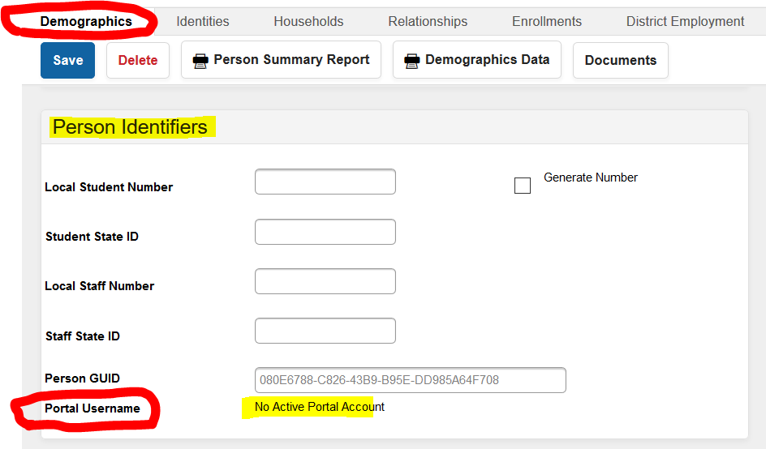

- Parent has a portal account, but forgot their username or password.
Action: DIS will have to reset the parent password.
School Action: Check the demographics tab to verify the parent has a portal account. Please submit a work order with the parent and student name.

- Parent/Guardians does not have a parent portal account.
School Action: Search for the Student. Verify on the relationship tab that the parent has a Start Date and both the Guardian and Portal box are checked. School may forward to the parent the Parent Portal Activation Instructions.

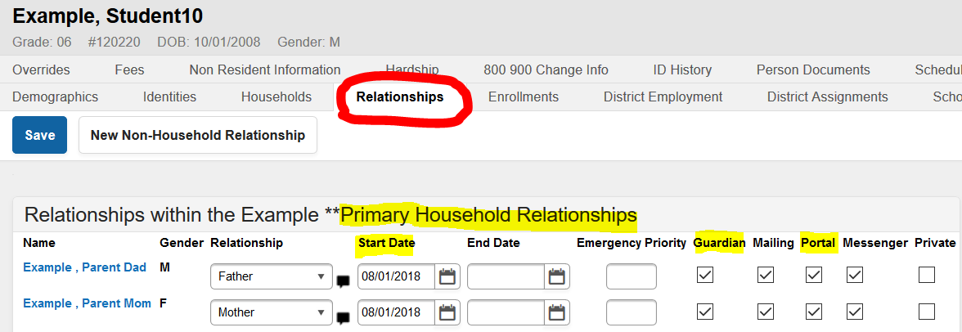

- All district employees, by default, may login to the Parent Portal with their employee number and password. Please verify they are listed on their student relationship tab with a Start Date and both the Guardian and Portal box are checked.

