**Richards Middle School**

**Parent Meeting on the State Assessment (GMAS)**

**and Homework Success**

* **Get important information and the latest updates on the State Assessment Test (GMAS)** 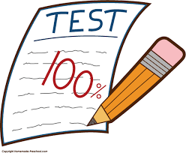
* **Learn how you can help your child achieve Homework Success**
* **Plus Review/Revise the school’s Parent and Family Engagement Policy, School-Parent Compact, and complete the Title I Annual Evaluation Survey**



### Date:

**Wed. March 14, 2018**

### Time:

### 3:00 pm

### Location:

### Richards Middle School Rm# 301

### 