Feedback  All Stakeholders at Reese Road Leadership Academy are invited to give suggestions, comments, and feedback. For any part of the Parent and Family Engagement Policy/ School-Parent Compact, that you feel is not satisfactory with the students’ and the school’s goals for academic achievement, please provide suggestions and feedback. Please send those suggestions and/or feedback to the school office and/or Parent Contact Representative.  Thank you for your continued support!  Please scan the QR Code to provide feedback: |  |  | Our Parent Resource Center/Area has learning games, books, workbooks, and many other resources available for families to checkout or keep for use at home. Our Family Services Coordinator is Ms. Cathy Covington. She is ready, willing and available to help you find resources, navigate the Parent Portal, connect with teachers, and learn about ways you can help your children at home. Our Parent Center/Area is located in the Leadership Store/Conference Room next to the Target Computer Lab (Room 101). Hours of Operation are Tuesdays & Wednesdays from 8:00 a.m. - 3:00 p.m. and Thursdays from 8:00 a.m. – 1:00 p.m.  Please contact Ms. Covington for additional information about our Parent Resource Center, resources available for checkout, and volunteer opportunities.  School Phone Number: 706.569.3684  Email: Covington.Cathy.L@muscogee.k12.ga.us  Muscogee County School District Mission  Website: http://sites.muscogee.k12.ga.us/  reeseroad  Our mission is to inspire and equip all students to achieve unlimited potential.  Muscogee County School District Vision  MCSD is a beacon of educational excellence where all are known, valued, and inspired. |  |  | Parent and Family Engagement Policy & School-Parent Compact 2021-2022  REESE ROAD LEADERSHIP ACADEMY  Revised: August 4, 2021  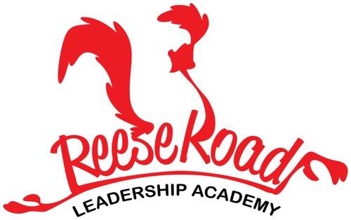  Principal, Mrs. Katrina Collier-Long  Asst. Principal, Mrs. Candace Lockhart  3100 Reese Road  Columbus, GA 31906  706.569.3684  http://sites.muscogee.k12.ga.us/reeseroad  “Great Happens Here”
Visit Our Parent Resource Center/Area
Our School Goals  Reese Road Leadership Academy will provide all students with high quality curriculum and instruction in a supportive and effective learning environment to meet high academic standards.  School’s SMART Goals:  - By July 2022, all MCSD schools will implement a Core Four area of Personalized Learning with cohorts of teachers who participate in training and implement practices around the identified Core Four area with 85% fidelity as measured by status reports, walk-throughs and survey feedback.  - By May 2022, all Reese Road teachers will be trained on a Core Four area of Personalized Learning by identified model teachers who were previously trained to implement the practices around the identified Core Four area with 85% fidelity as measured by status reports, walk-throughs and survey feedback.  - By May 2022, all Reese Road teachers will be trained to implement PBIS expectations and Leader in Me Student/Family Engagement initiatives as measured by 100% of our teachers implementing an in class acknowledgement system with recognition of 100% of our students.  Parent and Family Engagement Standards  Reese Road Leadership Academy and our parents have adopted the National PTA Standards for Family-School Partnership as the school’s model in engaging parents, students, and the community.  The National PTA Standards are:  - Welcoming All Families  - Communicating Effectively  - Supporting Student Success  - Speaking Up for Every Child  - Sharing Power  - Collaborating with Community | L |  | Working Together To Ensure Success  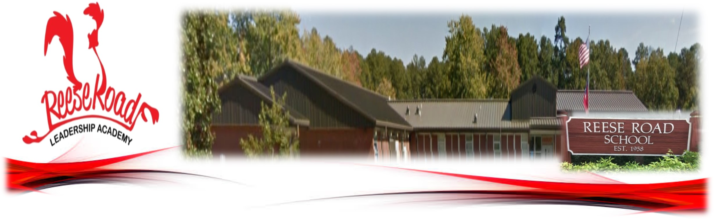  Reese Road Leadership Academy will…  - Reese Road will train all teachers to implement personalized learning for students.  - Reese Road will coordinate Literacy Technology Night and share strategies with families on how to help students at home.  - Reese Road will implement multiple successful learning targets to increase students’ achievement through rigor and differentiated focused instructional strategies.  - Reese Road will establish open lines of communication to help build parent capacity.  Mrs. Katrina Collier-Long, Principal  Mrs. Candace Lockhart, Asst. Principal  Dr. Guilda Bazard-Joseph, Guidance Counselor  Ms. Amy Thompson, Academic Coach  Mrs. Apryl Manuel, Secretary  Mrs. Brittany Earnest, Clinic  Ms. Cathy Covington, Parenting Coordinator  “Great Happens Here” |  |  | As Students, we will…  - Students will set achievement goals for themselves to succeed in school, reach for the stars in reading, writing, and math, and discuss our academic goals with their families.  - Students will work hard to meet the academic expectations of our school throughout the learning day.  - Students will work on leadership skills to increase academic achievement.  - Students will work on math and reading skills at home, using the materials our teachers send home.  As Families, we will…  - Parents will use reading and math materials and strategies the teacher sends home each week to help our children improve their academic abilities.  - Parents will help our children see how to use writing and reading to pursue his/her interest and career goals. They will also communicate with teachers with any questions and/or concerns.  - Parents will increase knowledge in technology to help children at home.  - Parents will attend parenting workshops to learn new ways to support students in different academic areas.

Our District Goals
- By July 2022, MCSD will have implemented a tiered leadership development program aligned with Georgia’s Systems of Continuous Improvement to prepare current and future leaders to an effectiveness level of 90% as measured by participant and supervisor surveys.  - By July 2022, 100% of teachers will implement evidence-based Tier 1 instructional strategies through the standards-based classroom framework with 75% of teachers implementing them effectively as measured by teacher evaluations, student achievement and student Lexile scores.  - By July 2022, all MCSD schools will implement a Core Four area of Personalized Learning to a school-selected level of effectiveness as measured by a District-wide rubric, status reports, walk-throughs, and progress monitoring towards individual school goals.  - By July 2023, all MCSD schools will implement Multi-Tiered System of Supports (MTSS) at a level 3 rating or higher as measured by the School MTSS Fidelity of Implementation Rubric.  - By July 2022, MCSD will increase awareness of and adherence to the district’s Mission, Vision and Values to create a “Culture of Kindness” for all stakeholders to an effectiveness level of 75% as measured by stakeholder surveys. |  |  | ENGAGING AND EMPOWERING FAMILIES WITH…  School Measures to Provide Required Assistance: Reese Road Leadership Academy will take the following measures to promote and support parents:  Curriculum Information: Inform parents throughout the year about what their child is learning by providing parent and family engagement meetings and workshops, parent-teacher conferences, information on Canvas, and on our school website.  Student Progress Monitoring: Ensure families are familiar with the online resource Infinite Campus (Parent Portal) that allows families to view grades, attendance, schedules, assessments, course history, and much more. Monitoring student progress in school is an important way to be involved in their education.  Parent Resources: Create and maintain a Parent Resource Area/Room to allow parents opportunities to checkout materials to assist them with helping their child at home. Resources are available in English and Spanish.  Staff Trainings: Conduct staff development quarterly on parent engagement practices and effective strategies for staff to communicate and build partnerships with parents.  Communication: Ensure schools publish all information related to school workshops, programs, meetings, and activities in both English and Spanish and communicated on a regular basis.  Transition Support: Partner with early childhood programs, elementary schools, middle schools, high schools, college and career organizations, parent resource centers, or other programs (as applicable) to help prepare families and their children for successful school transitioning.  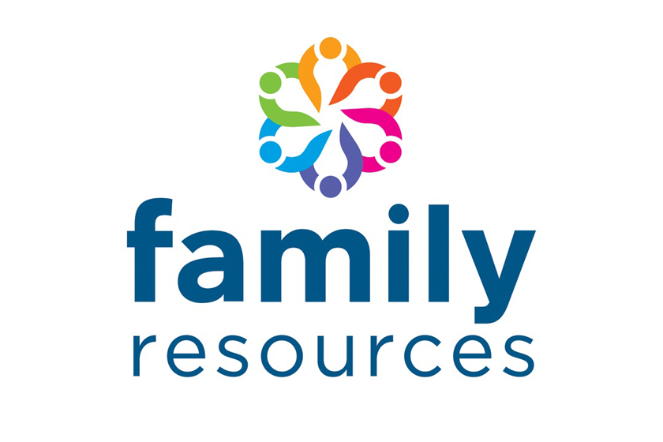 |  |  | Communication  Reese Road Leadership Academy is committed to keeping open lines of communication with families. We have several ways to communicate. We utilize two-way communication through the school website, email, phone calls, parent conferences, social media, Infinite Campus and Canvas to reach our students and families. Reese Road Leadership Academy will also provide materials at conferences and workshops to help parents work with their children at home. Parents can request additional conferences by contacting the school or their child’s teacher. Transportation and childcare may also be offered for parents to prevent barriers to family engagement. For all students who reside in residential facilities served by the Muscogee County School District, family engagement correspondence and activities will be mailed to each facility where students reside. If you need interpretation and/or translation services, please contact the school at 706.569.3684.  Some of the ways you can expect us to reach you are:  - Weekly homework folders  - Connect-Ed phone calls and/or text messages  - Canvas  - Class Dojo  - Updates on the school’s website  - Parent Emails  - Parent-teacher conferences  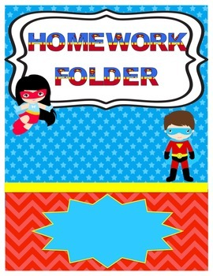  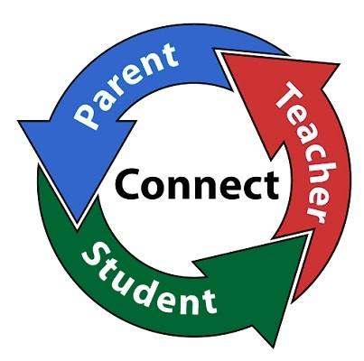
How is the Parent and Family Engagement Policy and School-Compact developed and revised?  Each Title I school will conduct a yearly annual meeting to review and revise the Parent and Family Engagement Policy and School-Parent Compact. Each school will invite all families to provide input on revisions to the policy/compact. Families are welcome to provide input throughout the year via feedback forms, emails, comments, or telephone. The revised policy/compact will be available throughout the year in our parent resource area and on our school website.  Where is the Parent and Family Engagement Policy and School-Compact available and who is it for?  The Family Engagement Policy/School-Parent Compact and all other Title I information is designated for all families and is available on our school’s website under the Title I Parent Section. Families can also find paper copies of the Parent and Family Engagement Policy/School-Parent Compact in our Parent Center/Area and at Parent and Family Engagement meetings. All families at Reese Road Leadership Academy are encouraged and invited to fully participate in the opportunities as described in our Parent and Family Engagement Policy/School-Parent Compact. Reese Road Leadership Academy will provide full opportunities for the participation of families with limited English, parents with disabilities, and parents of migratory children. |  |  | What is a Parent and Family Engagement Policy?  The Parent and Family Engagement Policy describes how Reese Road Leadership Academy will provide opportunities to improve parent and family engagement to support student learning. Reese Road Leadership Academy values the contributions and involvement of families in order to establish partnership for the common goal of improving student achievement. The Parent and Family Engagement Policy describes the different ways the school will support parent and family engagement and how families are encouraged to be full partners in the decision-making of their child’s education.  What is a School-Parent Compact?  The School-Parent Compact is a written agreement that outlines how our school, our students, and our families will work together to ensure the academic success of all students. An effective School-Parent Compact contains the following elements:  - Jointly-developed by families, school staff, students, community business partners, and other stakeholders during our annual review meeting  - Clear learning goals that are linked to the school’s improvement plan  - Specific skills students will learn during the year  - Strategies that staff, families, and students will use to improve student learning  - Ways to extend learning at home  - Methods teachers and family members will use to communicate about student progress  - Opportunities for family members to observe and participate in the classroom  - Review and revise the School-Parent Compact at meetings and workshops throughout the year to assure we are diligent in our efforts to support academic success for all students |  |  | What is Title I?  Reese Road Leadership Academy is identified as a Title I school as part of the Every Student Succeeds Act (ESSA). Title I is a federal grant that was designed to ensure that all children receive a high quality education and reach grade level proficiency. Title I programs must be based on effective means of improving student achievement and include strategies to support parent and family engagement. Parents and family members of children receiving services shall be involved in the decisions regarding how funds reserved are allotted for parent and family engagement activities and resources.  Building Partnerships  Reese Road Leadership Academy collaborates with families and community partners to provide multiple workshops and trainings at various times that meet the needs of the parents and support Parent and Family Engagement at the school. We will offer the following activities to build our partnership with families:  - Annual Title I Parent Meeting - To inform parents of the requirements of Title I and the school’s participation as well as the parents’ rights under Title I.  - Parent and Family Engagement/School-Parent Compact Review Meeting  - Reading and Literacy Meeting  - Technology Meeting  - Georgia Milestones Meeting  - Transition Meetings  - Additional Activities To Build Parent Capacity  Please visit our website regularly and check emails/notifications to learn about dates, times and other details about upcoming events.  http://sites.muscogee.k12.ga.us/reeseroad  