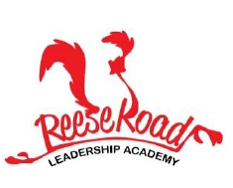
LEADERSHIP LEDGER
Reese Road Leadership Academy, 3100 Reese Road Columbus, GA 31907
Phone: 706-569-3684 Website: Reese.Muscogee.k12.ga.us
February 19, 2021

Spotlight News
Black History Month
Ruby Bridges
Hello Families,
We have had an exciting month learning of those who have gone before to pave the way in black history. This week we will focus on Ruby Bridges – the young black girl who made a way for all children to attend the school of their choice no matter their ethnicity! If your child is learning from home at this time, please use the link and password below to view. Make sure you watch the movie of this incredible young girl.
Link:
https://vimeo.com/281344437

Learn more about the NED Shows at https://www.thenedshows.com/

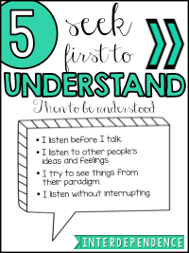

JOIN THE RRLA PTA
Please remember to join our PTA. The fee is $5.00. Let’s make to 100% of our school involved with the PTA to support our school!
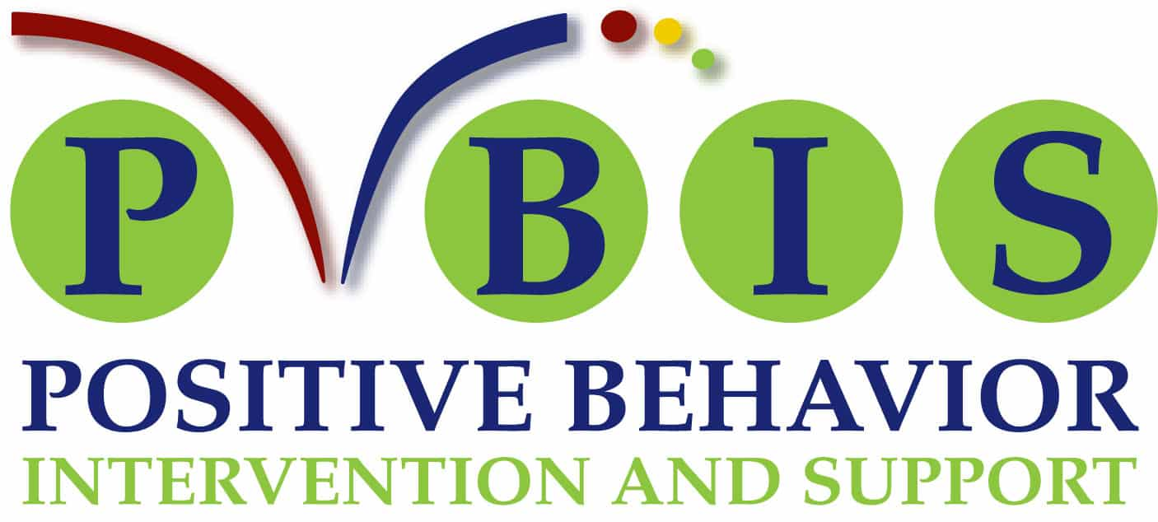RRLA Virtual Matrix
. 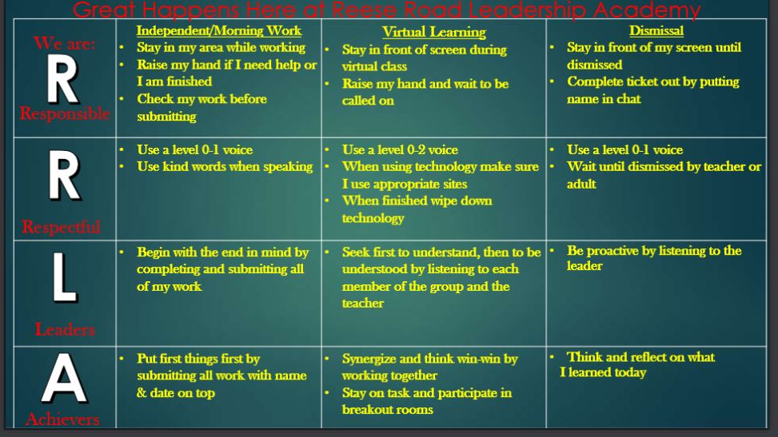
Coming up in February

Thursday February 18 Black History Family Game Night
Friday February 19 Ruby Bridges Movie
Tuesday February 23 HBCU Virtual Tour
Friday February 26 Virtual Wax Museum

Thank you Seasonal Concepts
For your generous donations to the RRLA raised gardens! The students loved planting and the gardens show off our amazing school!

MONDAY | TUESDAY | WEDNESDAY | THURSDAY | FRIDAY
Rib-A-Que Sandwich  Turnip Greens  Onion Rings  Milk Choices  Fruit | Mini Cheese Calzones  Black Beans  Tossed Salad w/ Dressing  Milk Choices  Fruit | Corn Dog  Oven baked Chips  Potato Salad  Baked Beans  Milk Choices  Fruit | Crispy Chicken Drumstick  Corn bread  Mashed Sweet Potatoes  Collard Greens  Milk Choices  Fruit | Pepperoni Pizza  Tossed Salad w/ Dressing  Chili Lime Corn  Milk Choices  Fruit

