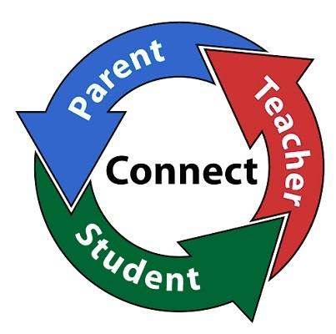
Communications Regarding Student Learning….

- ClassDojo
- Connect-Ed messages
- Updates on the school’s website
- Parent-teacher conferences
- Parent Portal

Reese Road Leadership Academy
3100 Reese Road
Columbus, Georgia 31907
706.569.3684 (phone) 706.569.3686 (fax)

Katrina Collier-Long, Principal
Candace Lockhart, Assistant Principal
Cathy Covington, Family Services Coordinator

School Website:
http://sites.muscogee.k12.ga.us/reeseroad
Facebook page @RRLARoadrunners
Instagram @ReeseRoadLeadershipAcademy
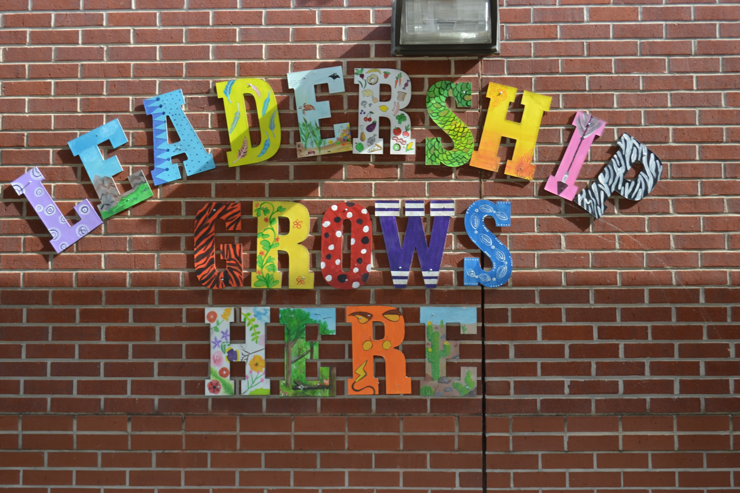

What is a School-Parent Compact?

A School-Parent Compact is an agreement that parents, students, and teachers develop together. It explains how parents, students and teachers will work toward becoming lifelong learners. Meetings are held each year to review the compact and make changes based on student needs. Parents are welcome to contribute comments at any time. For all students who reside in residential facilities served by the Muscogee County School District, parental involvement correspondence and activities will be mailed to each facility where students reside.

Effective School-Parent Compacts:
- Link to goals of the School Improvement Plan.
- Focus on student learning skills.
- Describe how teachers will help students develop those skills using high-quality instruction. Share strategies parents can use at home.
- Explain how teachers and parents will communicate about student progress.
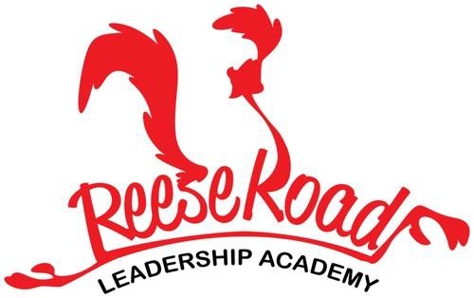
School-Parent Compact 2019-2021
Revised 8/31/2020

District Goals
By July 2023, the Muscogee County School District will implement a Leadership Development Program, Personalized Learning, a Multi-Tiered System of Support (MTSS) with a “Culture of Kindness”.
School’s Wildly Important Goals (WIG’s)
Goal #1 By May 2021, 100% of the staff will be trained on the PBIS Classroom Modules 3 and 4 with 75% of teachers implementing the evidence-based strategies effectively.
Goal #2 By May 2021, 100% of teachers will implement writing with rigor by utilizing STEM Journals and the Engineering Process in their learning and classroom practices with 90% fidelity.
Schoolwide WIG 100% of Roadrunners will reach their individualized reading growth goal by May 2021.

As a school, we will…..
- Implement writing with rigor by utilizing STEM Journals and the Engineering process.

- Help parents stay connected through multiple ways of communication i.e., Class Dojo, Parent-Teacher conferences, Parent Portal, and the school’s website.

- Provide excellent educational experiences and a safe and nurturing environment conducive to learning and positive behavior.

- Engage students in active learning and monitor student progress to ensure student success.

As parents, we will….
- Communicate with my child’s teacher regarding any questions or concerns about my child’s academic performance.

- Make sure my child is at school and arrives on time prepared to have a productive day.

- Promote and expect positive behavior.

- Know my child’s Lexile score and ensure my child reads 20 minutes each night for literacy practice.

As students, we will…..
- Articulate schoolwide PBIS expectations.

- Ask questions if we don’t understand our class room or homework assignments.

- Know my Lexile score and read for 20 minutes each night for reading practice.

- Practice my writing skills.

- Strive to become a lifelong learner.

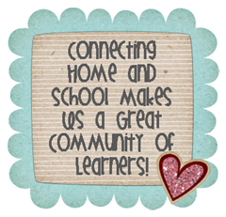

[Grab your reader’s attention with a great quote from the document or use this space to emphasize a key point. To place this text box anywhere on the page, just drag it.]
[Grab your reader’s attention with a great quote from the document or use this space to emphasize a key point. To place this text box anywhere on the page, just drag it.]
[Cite your source here.]

