**Reese Road Leadership Academy**

**Katrina Collier-Long, Principal**

**Candace Lockhart, Assistant Principal**

**3100 Reese Road Columbus, Georgia 31907**

**706.569.3684**

[**http://sites.muscogee.k12.ga.us/reeseroad**](http://sites.muscogee.k12.ga.us/reeseroad) **Facebook page @RRLARoadrunners**

**Instagram @ReeseRoadLeadershipAcademy**

**District Goals**

By July 2023, the Muscogee County School District will implement a Leadership Development Program, Personalized Learning, a Multi-Tiered System of Support (MTSS) with a “Culture of Kindness”.

**School’s Wildly Important Goals (WIG’s)**

**Goal #1** By May 2021, 100% of the staff will be trained on the PBIS Classroom Modules 3 and 4 with 75% of teachers implementing the evidence-based strategies effectively.

**Goal #2** By May 2021, 100% of teachers will implement writing with rigor by utilizing STEM Journals and the Engineering Process in their learning and classroom practices with 90% fidelity.

**Schoolwide WIG** 100% of Roadrunners will reach their individualized reading growth goal by May 2021.

**What is Title I?**

Reese Road Leadership Academy is identified as a Title I school as part of the Every Student Succeeds Act (ESSA). Title I is a federal grant that was designed to ensure that all children receive a high quality education and reach grade level proficiency. Title I programs must be based on effective means of improving student achievement and include strategies to support parent and family engagement.

**Parent and Family Engagement Policy 2019-2021**

*Plan Revision Date: 8/31/2020*

**What is it?**

The Parent and Family Engagement Policy describes how Reese Road will provide opportunities to improve parent engagement to support student learning. Reese Road values the contributions and involvement of parents in order to establish partnership for the common goal of improving student achievement. The Parent and Family Engagement Policy describes the different ways the school will support parent engagement and how parents can be involved.

**How is it developed?**

Reese Road welcomes parent input and comments at any time regarding the Parent and Family Engagement Policy. All parent feedback will be used to revise the plan for next year. The Parent and Family Engagement Policy is available for parents to view and provide feedback throughout the year. Reese Road also distributes a Title I Annual Survey to ask parents for suggestions on the Parent and Family Engagement Policy and the use of funds for parent involvement.

**Who is it for?**

All parents at Reese Road are encouraged and invited to fully participate in the opportunities described in the Parent and Family Engagement Policy. Reese Road will provide full opportunities for the participation of parents with limited English, parents with disabilities, and parents of migratory children.

**Where is it available?**

The Parent and Family Engagement Policy will be sent home with each student and is also available in the Parent Resource room, the front office of the school and on the school’s website.

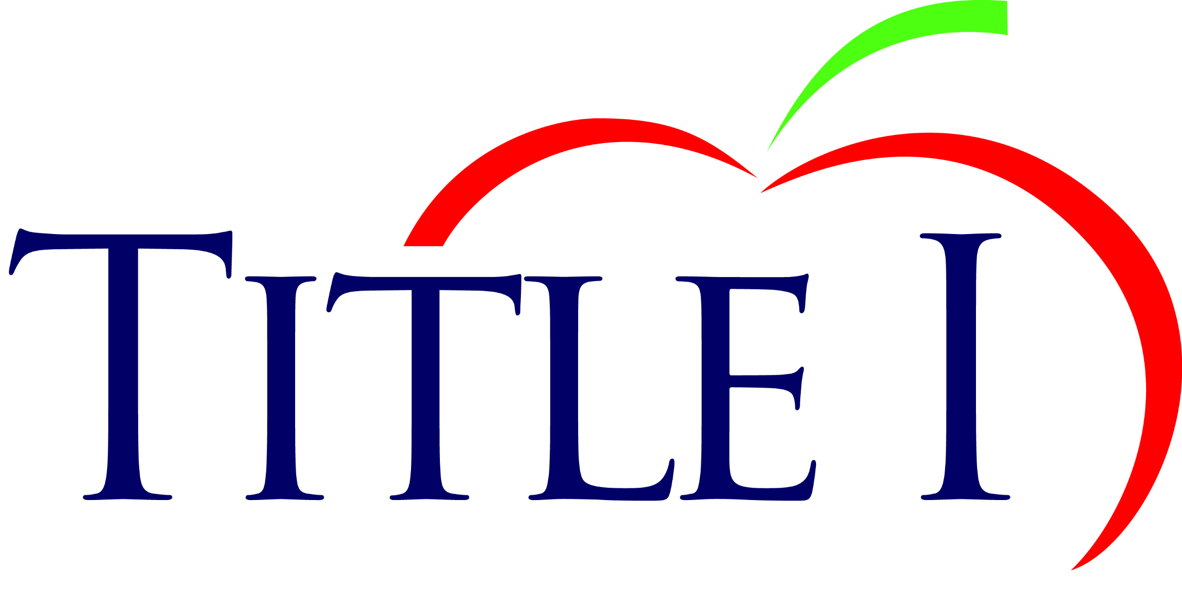

**What is a School-Parent Compact?**

As part of the Parent and Family Engagement Policy, Reese Road and our families will develop a School-Parent Compact. A School-Parent Compact is an agreement that parents, students, and teachers develop together. It explains how parents, students and teachers will work toward mastery of grade-level standards. The compact will be reviewed and updated annually based on feedback from parents, students, and teachers.

**Parent and Family Engagement Program and Activities at Reese Road Leadership Academy**



Virtual Title I Annual Parent Meeting – August 2020

Experience a new way of learning through Zoom, a live video/audio conferencing chat platform. Gain knowledge of the Title I program, to include the Parent and Family Engagement Policy, School-Parent Compacts, schoolwide plan, parent requirements, etc.

Virtual Open House – August 2020

Meet your child’s teacher and our friendly and helpful school staff for the 2020-2021 school year live on Zoom.

Smart Goal Workshops – November 2020

Inform students and parents about our updated school goals to help support student learning.

Academic Workshops – Fall 2020/Winter 2021

Parents will learn necessary skills for student success.

State Assessment Workshop - February 2021

Teachers will demonstrate various "models of instruction" used in the classroom for their students.

Elementary to Middle School Transition - April 2021

Gain helpful information to assist students in transitioning to middle school.

**School Measures to Provide Required Assistance**

* Ensure all information related to school and parent programs, meetings, and activities are posted on ClassDojo, the school’s website, included in monthly newsletters, Connect-Ed, flyers, and posted on school’s marquee.
* Conduct staff development on parent involvement practices and effective strategies for staff to communicate and build partnerships with parents.
* Partner with Head Start, Pre-K programs, and daycares to share information about parent engagement activities that will help prepare parents and their child for kindergarten.
* Share information in the school’s newsletter and on the website for parents to understand the schools’ academic standards and assessment as well as ways parents can monitor their child’s progress.
* Provide materials at conferences, workshops, and activities to help parents work with their child at home.
* Create and maintain a Parent Resource room to allow parents opportunities to check-out materials to assist them with helping their child at home.
* Listen to parents to provide workshops and training that meet the needs of the parents and support parental involvement at the school.
* Collaborate with the community and Partners in Education to increase participation and awareness of the school parental involvement plan and activities.

**Contact Reese Road Leadership Academy at 706.569.3684.

Cathy Covington, Title I Family Services Coordinator