What is a School-Parent Compact?
A School-Compact for Achievement is an agreement that parents, students and teachers develop together. It explains how parents and teachers will work together to make sure all our students reach grade-level standards.
Communication about Student Learning

Key Elementary School is committed to frequent two-way communication with families about children’s learning. Some of the ways you can expect us to reach you are:
- Weekly homework folders
- Monthly “check-in” note and phone calls
- Updates on the school’s website
- Grade level meetings on understanding student progress
- Parent-teacher conferences in Fall and Spring
- Quarterly Parent Guides sent home

Key Elementary School
Principal, Dr. Jacqueline Flakes
Academic Dean, Ms. Sonia Moore
2520 Broadmoor Dr.
Columbus, GA 31903
706-683-8797

Effective School-Parent Compacts:
- Link to goals of the School Improvement Plan
- Focus on student learning skills
- Describe how teachers will help students develop those skills using high-quality instruction
- Share strategies parents can use at home
- Explain how teachers and parents will communicate about student progress
- Describe opportunities for parents to volunteer, observe and participate in the classroom
How is the School-Parent Compact Developed?
The parents, students, and staff at Key Elementary School developed this School-Parent Compact for Achievement. Teachers suggested home learning strategies, parents added ideas to make them more specific, and students told us what would help them learn. Meetings are held each year to review the Compact and make changes based on student needs.

Parents are welcome to contribute comments at any time.

If you would like to volunteer, participate, and /or observe in the classroom, please contact the school at 706-683-8797.

Building Partnerships
- Parents are invited to attend monthly parent workshops and activities sponsored at the school.
- Parents are invited to volunteer, participate, and observe at the school and in their child’s classroom
- Parents are invited to visit the Parent Resource Room/Area to check-out materials to use with their child at home.

Key Elementary School
School-Parent Compact for Student Achievement
2017-2018
Revised 09/26/2017

Our Goals for Student Achievement

District Goals
The Muscogee County School District will create an environment that focuses in Tier 1 instruction while targeting individual student needs, leadership development, and customer service.

School’s SMART Goals
PBIS/School Climate Goal: By May 2018, four evidence-based classroom systems modules (1 per month) have been delivered to all teachers and the practices are evident in greater than 75% of the classrooms.

Academic/Instructional Goal: By May 2018, 80% of teachers will use explicit focused instruction strategies to convey critical content in their teaching.

Our Students:
Students are encouraged to participate in the educational process. A successful student takes ownership of his/her learning and sets high educational goals.
- K-2nd students will practice math facts each night at home to improve speed and accuracy with addition and subtraction.
- K-2nd students read each night for 20 minutes.
- 3rd-5th students will practice math facts each night at home to improve speed and accuracy with multiplication and division facts.
- 3rd-5th students will complete 100 % of their homework assigned each week.
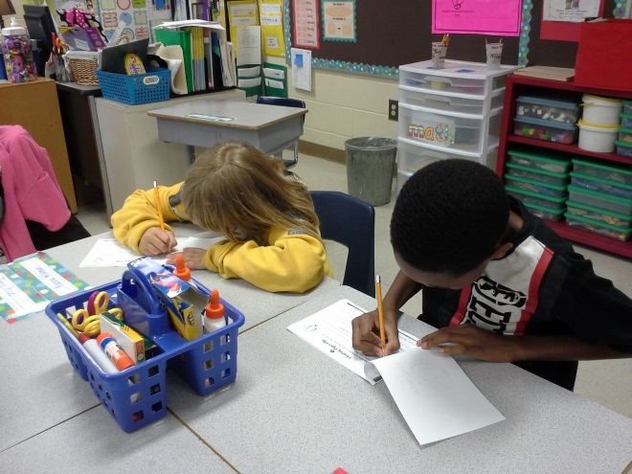

Our Parents:

Parents are expected to participate in the education of their children. Without the cooperation and partnership between parents and school staff, we cannot effectively help a student reach his or her full potential. The major role of parents is to continually show the child that they are interested and supportive of how their child is doing in school.
- All parents will Practice math facts with their child each night.
- K-2nd parents will listen to their child read a story 3 times a week and ask questions about the story as they read.
- 3rd-5th parents will practice math facts and work on math strategies each week to help their child improve on academic abilities.
- 3rd-5th parents will help ensure their child complete 100 % their homework assigned each week.

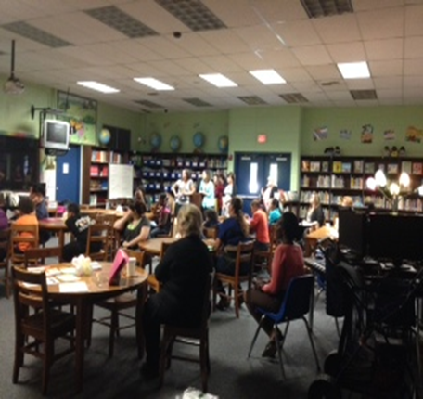

Our Teachers:
Teachers are expected to work with students and their families to support students’ success in reading and math. Some of our key connections will families will be:
- All teachers will keep parents up to date with student progress in class. Communicate successes and struggles and maintain an open line of communication.
- All Teachers will make sure all students get help and intervention as soon as a need is identified.
- All teachers will send home learning materials in reading and math for students to practice at home.

