
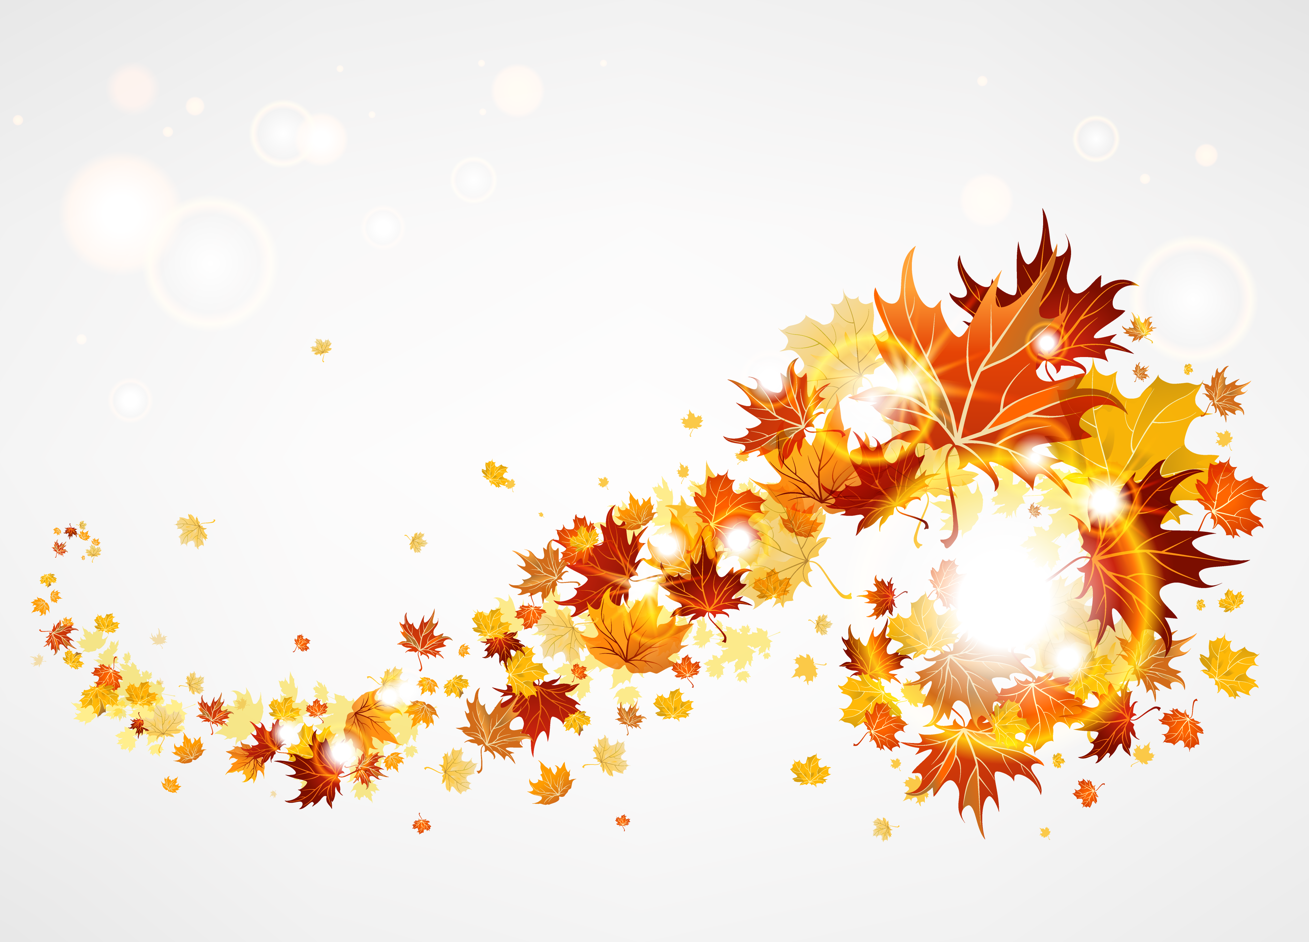

We have five of YALSA’s Teens’ Top Ten books for 2017

2018 Winners will be announced later in October

Scythe by Neal Shusterman

The Sun is Also a Star by Nicola Yoon

Lady Midnight by Cassandra Clare

Heartless by Marissa Meyer

P.S. I Like You by Kasie West

We have magazines and newspapers for your reading pleasure. We also have old magazines if you need any for projects for your students.

Professional Library for teachers. We may have books for your educational purposes.

iTeach: A Guide to the Most Useful Apps for the Classroom

Roland B. Daniel Media Center at Jordan High October 2018

Teen Read Week
October 7th – 13th
Theme
"It's Written in the Stars: READ"
Please encourage your students to come to the Media Center to check out the latest books available.



Literary Birthdays:

Anne Rice October 4

Jackie Collins October 4

R. L. Stine October 8

E. E. Cummings October 14

Oscar Wilde October 16

Arthur Miller October 17

Anne Tyler October 25

Sylvia Plath October 27

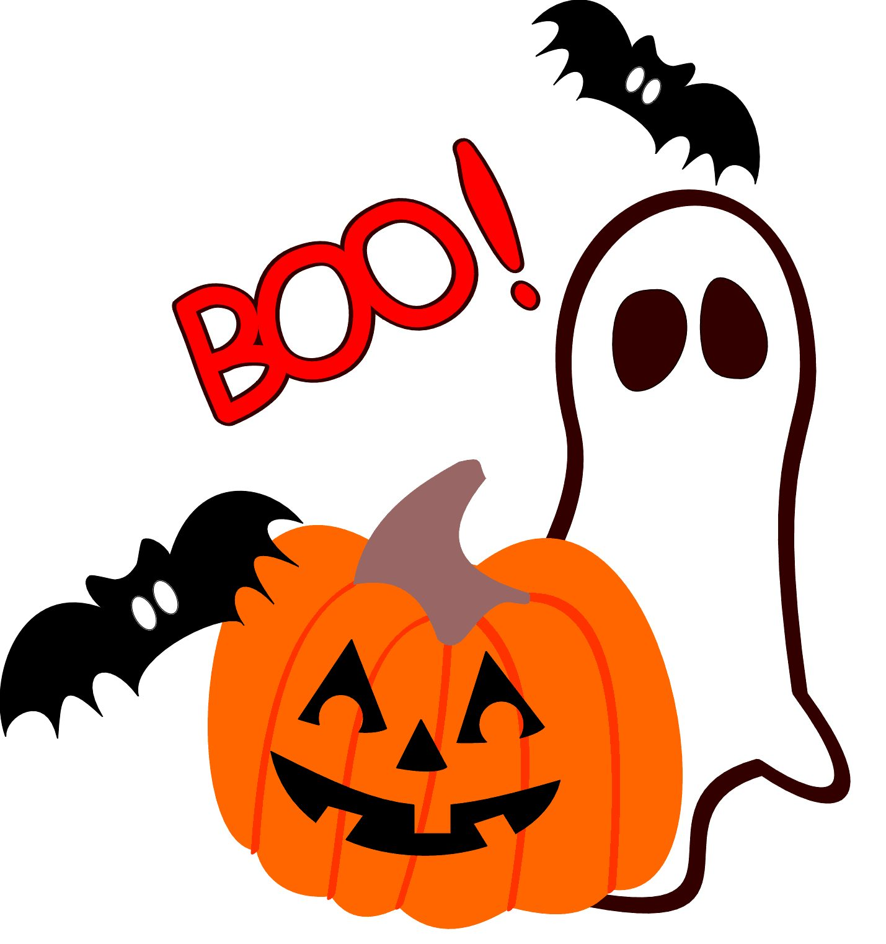

What’s Happening in our school?
We have lots of new books this year and will be getting more soon. Don’t forget Destiny to search our collection. We have ebooks as well. Requests for new books are always accepted. Book Club meets second Tuesday of the month during lunch. (October 9th)

Reques

Nooks
We have a class set of Nooks for your use. Please see Mrs. Breland.

Galileo password: valve

New Books

Warcross by Marie Lu

Turtles All the Way Down by John Green

Wonder Woman: Warbringer by Leigh Bardugo

Once and for All by Sarah Dessen

In the Time you Spend on Social Media Each Year, you Could Read 200 Books

