J. D. Davis Elementary School
UNIFORM POLICY

All J.D. Davis scholars (Kindergarten thru 5th Grade) are to wear the school uniform and colors. Uniforms help set a tone that is conducive to learning and help students to focus more on learning. All scholars will be expected to wear any combination of the following colors (on any day) as listed below:
BOTTOMS: Shorts/pants/skirts/“skorts”/jumpers: navy or khaki (ONLY)
Mondays-Thursdays
TOPS: Shirts with a collar: navy or red (ONLY)

“School Spirit Day”
Fridays
Scholars may dress in the above listed uniform attire, or they may wear a
J. D. Davis Spirit Shirt (or uniform top) and jeans.
Jeans with holes are NOT permitted.
* NO HOODIES! Scholars are NOT permitted to wear hoodies. A hoodie is defined as a sweatshirt with a hood attached.
*Scholars will not be required to wear a uniform on school picture days or certain special days. A notice will be provided.
In addition, all scholars will tuck in their shirts and wear a belt if their pants/shorts have belt loops. It is our goal to maintain an orderly, well-managed environment in which logos on shirts and/or ill-fitting attire (sagging pants) are not distractions to our day.
Scholars must also wear proper shoes. Flip-flops, slides, house shoes, shower shoes, heels, and/or slippers are NOT allowed to be worn at J.D. Davis. They are a danger to the students who are, at times, required to walk up and down stairs and run.
At no time should a scholar wear a covering over the head (hoodie, hat, cap, bonnet, scarf, etc.) with the exception of religion or a special day at school (Fund Raiser or Fun Friday Theme Day).
It is imperative that all parents/guardians and scholars understand that the dress code policy will be strictly enforced. The following progressive response strategies will be enforced for uniform violation:
1st Offense | Verbal Warning; Parent contact to bring uniform to school
2nd Offense | Letter Home; Parent contact to bring uniform to school
3rd Offense | After School Detention and parent required to provide transportation home; Parent contact to bring uniform to school
4th Offense | Parent and scholar required to go before the Behavior Support Committee; Parent contact to bring uniform to school

As always, we thank you for your assistance and your cooperation in ensuring that your child receives the best possible educational experience possible!
Warmest regards,
Principal Williams and the Uniform Committee

J. D. DAVIS UNIFORM ATTIRE
TOP COLORS (w/ a collar): RED OR NAVY BLUE
BOTTOM COLORS: KHAKI OR NAVY BLUE

JEANS (WITHOUT HOLES) MAY ONLY BE WORN ON FRIDAY (ONLY) WITH A UNIFORM TOP OR JDD SPIRIT SHIRT!

HOODIES ARE NOT PERMITTED!
JEANS WITH HOLES ARE NOT PERMITTED!

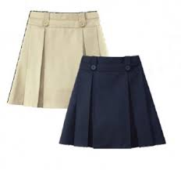
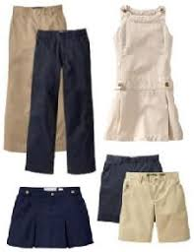
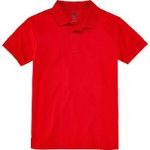
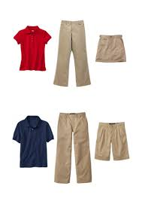
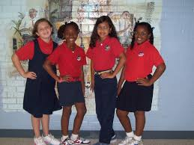
Following are some links where you can find school uniforms:
Walmart
https://www.walmart.com/cp/school-uniforms/1086304
Macy’s
https://www.macys.com/shop/kids-clothes/kids-school-uniforms?id=30057
Old Navy
http://www.oldnavy.com/products/school-uniforms.jsp
Burlington Coat Factory
http://www.burlingtoncoatfactory.com/burlingtoncoatfactory/school-uniforms-67089.aspx
Shop Around Town: Bargain Town, Brown Avenue Beauty Supply Store, any Walmart, J. C. Penny, Ross, Citi-Trends

J.D. Davis has a “Uniform Closet!” We are asking for parents to help us by donating “gently worn” uniforms that your children have outgrown.
Don’t spend a lot of money! Check out our local Goodwill stores for school uniforms!

