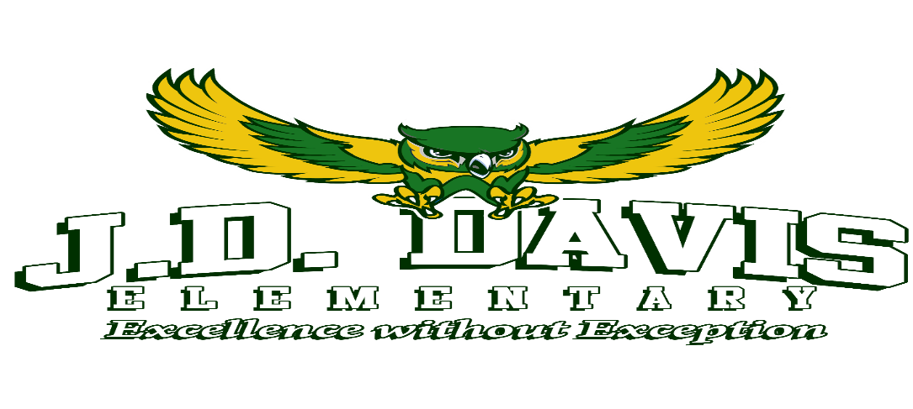

J. D. Davis Basic Supply List 2021-2022

Grades K – 2
- Personal Face Mask that can be washed daily and worn again
- Personal Water Bottle with secure top to avoid spills or a J. D. Davis Water Bottle
- Ear buds/headphones for computer use
- Index Cards (2 packs)
- 3-Ring Binder ( ½ -Inch)
- Composition Book (Primary Preferred)
NEEDED Classroom Donations for K-5
- Hand sanitizer
- Baby wipes
- Hand soap
- Paper towels
- Disinfecting wipes
- Lysol spray
- Kleenex
- Glue Sticks (2 or more)
- #2 Pencils (5 Dozen)
- Notebook Paper (Wide-Ruled)(1 – 2 only)
- Markers
- Scissors (safety)
- Erasers
- Crayons
- Book bag

Grades 3 – 5
- Personal Face Mask that can be washed daily and worn again
- Personal Water Bottle with secure top to avoid spills or a J. D. Davis Water Bottle
- Ear buds/headphones for computer use
- 3-Ring Binder (1-Inch) ● Pens (Black or Blue ink)
- Erasers ● Ruler
- 3-Prong Pocket Folders (5 or more) ● Markers
- 2 Packs of Dividers with Tabs ● Crayons
- Composition Books (2 or more) ● Index Cards (2 packs)
- #2 Pencils (5 Dozen) ● Glue Sticks (2 or more)
- Notebook Paper (Wide Rule) ● Book bag

COVID-19 REQUIREMENT: Masks are OPTIONAL but strongly recommended. Per CDC Guidelines “if you are NOT fully vaccinated and aged 2 or older, you should wear a mask in indoor public places.”
Masks are required on ALL MCSD School Buses per Federal Guidelines.

