Fort Patriots Track Schedule 2020-2021
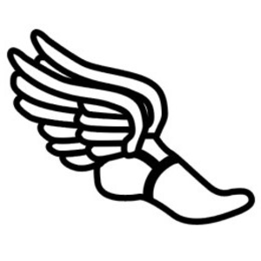

2/22/21 Mon. Various Schools @5:30 Kinnett
3/2/21 Tues. Various Schools @5:30 Kinnett
3/8/21 Mon. Various Schools @5:30 Kinnett
3/15/21 Mon. Various Schools @5:30 Kinnett

Head coach: D. Bryant
AD: Coach Ward

