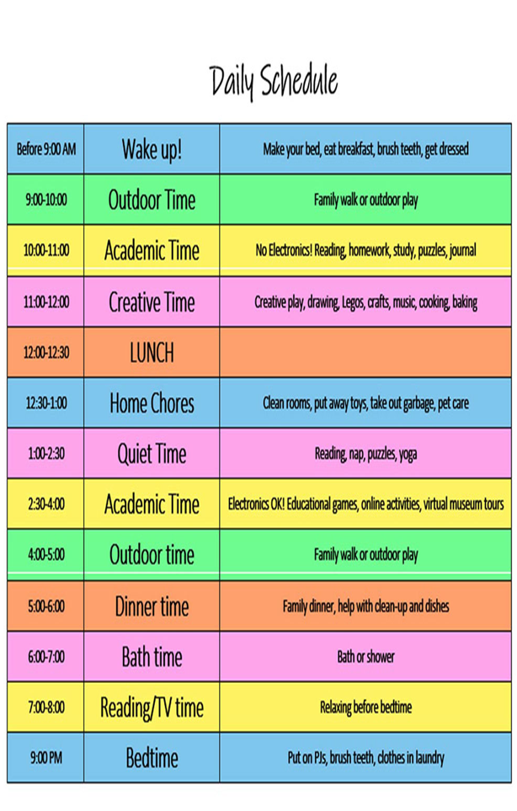
Setting Up for Success While At Home Together
Stick to a consistent routine daily. Set expectations about getting up, getting dressed, and eating breakfast
Limit endless snacking
Create a schedule for each day with your children to break up the time
Put a limit on social media
Don’t have the TV on in the background all day
For children without their own phones, set up a FaceTime playdate with a friend and let them chat using your phone
Dedicate time every afternoon to organizing and cleaning up to keep chaos and germs at bay.
Make dinner together.
Go old school! Have story time, play a board game, or try to learn a new language together during evening family time.

