FSLMA Dance Team Tryouts

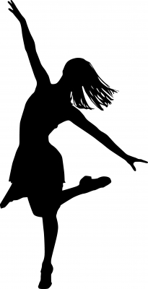
Dance Team Tryouts
August 20th – August 22nd
4:15-5:00p
Location: Cafeteria

Dance Team Final Tryout
August 23rd
4:30-5:30p
Location: Cafeteria

***A physical MUST be on file in order to tryout***

Contact Mrs. Jones with any questions or concerns.
(706) 569-3740

Fort Service Learning Magnet Academy
Dance Team...“The Best Dance Team in the World!”

***ON THE DAY OF TRYOUTS, FRIDAY, August 23rd, ALL DANCERS MUST WEAR A WHITE TOP AND BLACK BOTTOMS (MUST BE SCHOOL APPROPRIATE). ANYONE NOT IN APPROPRIATE ATTIRE ON THIS DAY WILL NOT BE ALLOWED TO TRYOUT***

Dear Parents/Guardians,

I am delighted that your daughter is trying out for FSLMA 2019-2020 Dance Team “The Best Dance Team in the World”. I thank you for your participation and look forward to a great season. Before your daughter decides to commit to the dance team, there are several imperative things you should know.

1. All dance team members will, at times, be required to wear a hair piece (ponytail).
2. The total fee for a dance team member is $300, FULL PAYMENT will be due by Friday, September 6, 2019.
3. Dance team members will dance at all home football and basketball games. FSLMA dance team members will also dance at PTA meetings, various school functions, and some outside of school functions as well.
4. All dance team members are required to have a physical on file.
5. All dance team members will be required at times to wear light makeup (eye shadow, lipstick or gloss)
6. You cannot receive a refund if your daughter quits or is dismissed from the team. ***

Dance Team Tryout Expectations

- All participants are expected to abide by all FSLMA and Muscogee County School district rules.
- All participants are expected to have all required paperwork completed and turned in by the first day of tryouts.
- All participants are expected to be present each day and on time to all tryouts.
- All participants MUST be picked up no later than 5:00p on August 20-22 and no later than 5:30p on August 23rd.
- All participants are expected to give their best effort in every activity.
- School appropriate clothing is required for all tryout days.
- All participants are expected to have a positive and cooperative attitude

***ON THE DAY OF TRYOUTS, FRIDAY, August 23rd, ALL DANCERS MUST WEAR A WHITE TOP AND BLACK BOTTOMS (MUST BE SCHOOL APPROPRIATE). ANYONE NOT IN APPROPRIATE ATTIRE ON THIS DAY WILL NOT BE ALLOWED TO TRYOUT***
--------------------------------------------------------------------------------------------------------------------------------------------------

Student signature_______________________________________ Date___________________

Parent Signature ______________________________________ Date__________________

Parent Phone Number: ______________________________________

Thank you,
Mrs. Jones
PROUD Dance Team Sponsor

**This form must be signed and returned to Mrs. Jones by August 20, 2019 in order for dancers to participate in Dance Team Tryouts**

FSLMA Dance Team Fee
Dance Team Supply List

Uniforms ---------------------------------------------------------------------------------- $120.00
Jazz shoes ---------------------------------------------------------------------------------- $30.00

Dance T-shirt-------------------------------------------------------------------------------$20.00

Dance Jacket/Pullover -------------------------------------------------------------------$45.00

Hairpiece ------------------------------------------------------------------------------------$15.00

Dance bag --------------------------------------------------------------------------------- $20.00

Mandatory FSLMA Athletic Fee ----------------------------------------------------- $50.00*

Total fees $300.00

FULL payment is due by Friday, September 6th

FSLMA Dance Team Practice Rules
- Dance team participants only at practice.

- Be on time and ready to practice.

- Be kind. There is no room for personal conflicts. Do not bring them to practice.

- Warming up is not optional. To participate you must warm up.

- No unnecessary talking or playing during practice.

- Wear school appropriate clothes to practice.

- Hair must be worn away from the face. No bandanas or large hair decorations

- No jewelry

- No gum, candy or soda during practice.

- Attendance at every practice is expected in order to perform at events. If dancer is not able to attend all tryout days, she will not be permitted to participate in final tryouts.
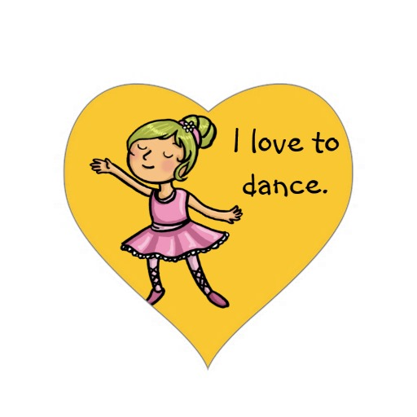
**Official Dance Team Bylaws will be issued to dancers upon making the 2019-2020 Dance Team**

2019-2020 Dance Team
Teacher Recommendation Form

Student Name: _____________________________
Teacher Name: _____________________________

***************Only teacher completes below this line***************
(Please return directly to Mrs. Jones)
In what class(es) or activities have you observed the above student? _________________
___________________________________________________________________
 | Excellent | Good | Average | Fair | Needs Improvement
Relating to Others
Attendance
Punctuality
Cooperativeness
Personal Appearance
Self-Expression
Reliability
Initiative
Leadership Qualities
Comments:

Special talents or strong points:

____________________________________ Signature ____________________ Date

