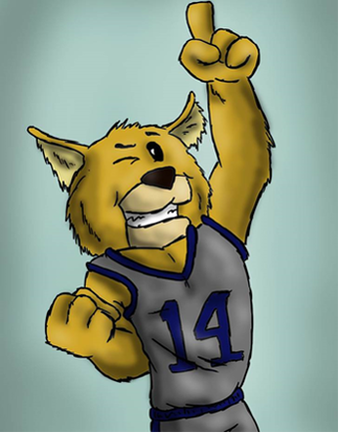



**School Climate Survey**

Now is the time to take our School Climate Survey for 2019-2020. This parent survey is the guiding principle for our school climate rating on CCRPI (College and Career Ready Performance Index) and is how the state grades our school. Please click the link below to take the survey!!

[https://gshs.gadoe.org/parents](https://nam02.safelinks.protection.outlook.com/?url=https%3A%2F%2Fgshs.gadoe.org%2Fparents&data=01%7C01%7Caviles.kevin.d%40muscogee.k12.ga.us%7C873970048d6645250f2808d7467cc4ca%7C69cbf85251034521a4fc0ca208202372%7C0&sdata=MxWOv4cyBUTPPqzWpDO62LmHgQL2XodtxEUJS%2FMqKhs%3D&reserved=0)

Welcome to our 2019-2020 School Year

“We INSPIRE young minds to CHANGE the world”

**Forrest Road Elementary**

**Weekly Newsletter**

**February 10th – 14th, 2020**



* **Parents, please remember that we are a uniform school. Students should be dressed in uniform Monday-Friday unless otherwise noted. Uniform top colors are yellow, navy, and light blue and bottoms are khaki and navy. Thank you for your support!!**
* We have “Read Across America/Dr. Seuss Week” T-Shirts for sale. The shirts are $8 and available in sizes Youth Small to 4XL. Orders are due Wednesday, February 12th and forms have been sent home with students. Dr. Seuss week is March 2nd-6th.
* Forrest Rd will be hosting a Valentine’s Dance on Thursday, February 13th from 4:00-5:30pm for 3rd- 5th grade students only. The cost to attend is $5 and will need to be paid by Wednesday, February 12th. **Only Forrest Road students can attend and students will need to be picked up promptly at 5:30pm!!!**



**Upcoming Events**

* **Wednesday, February 12th**

Kona Ice—please have money in by 11AM

* **Thursday, February 13th**

Valentine’s Day Dance for 3rd-5th graders—4:00-5:30pm

* **Monday, February 17th**

President’s Day—No School

* **Wednesday, February 28th**

Black History Walk



**School Hours**: 8:00AM-2:30PM **Breakfast Hours**: 7:15AM-7:45AM

**NO student Check Outs after 2:00 PM**

**You must ALWAYS present your ID when checking out or visiting!!!**

**Please remember to bring in an excuse when your child is absent!!!!**