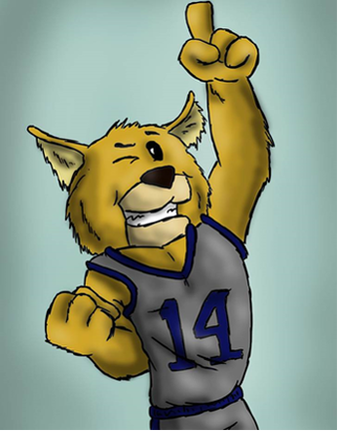jones

**ESPLOST Funds**

Your ESPLOST dollars at work:

* New classroom furniture
* Painting throughout the building
* Fencing around the building added, updated, or replace
* New playgrounds
* Activity Field
* Flooring replaced
* Bathrooms updated
* Student technology
* School sign lighting

**School Climate Survey**

Now is the time to take our School Climate Survey for 2019-2020. This parent survey is the guiding principle for our school climate rating on CCRPI (College and Career Ready Performance Index) and is how the state grades our school. Please click the link below to take the survey!!

[https://gshs.gadoe.org/parents](https://nam02.safelinks.protection.outlook.com/?url=https%3A%2F%2Fgshs.gadoe.org%2Fparents&data=01%7C01%7Caviles.kevin.d%40muscogee.k12.ga.us%7C873970048d6645250f2808d7467cc4ca%7C69cbf85251034521a4fc0ca208202372%7C0&sdata=MxWOv4cyBUTPPqzWpDO62LmHgQL2XodtxEUJS%2FMqKhs%3D&reserved=0" \t "_blank" \o "Original URL: https://gshs.gadoe.org/parents. Click or tap if you trust this link.)

Welcome to our 2019-2020 School Year

“We INSPIRE young minds to CHANGE the world”

**Forrest Road Elementary**

**Weekly Newsletter**

**January 21, 2020**

**School Hours**: 8:00AM-2:30PM

**Breakfast Hours**: 7:15AM-7:45AM

**NO student Check Outs after 2:00 PM**

**You must ALWAYS present your ID when checking out or visiting!!!**

**Please remember to bring in an excuse when your child is absent!!!!**

**Upcoming Events**

* **Monday, January 20th**

MLK JR Holiday-No School

* **Thursday, January 23rd**

Wildcat Walk for Principal List & Honor Roll students.

3rd-5th grade—9AM 1st & 2nd grade—1PM

* **Saturday, January 25th**

Helen Ruffin Reading Bowl @ Northside High

* **Tuesday, January 28th**

Test Prep and Fine Arts Night from 5-7PM (All Grades)

* **Wednesday, January 29th**

Kona Ice—please have money in by 11AM.



* Parent, please remember that we are a uniform school. Students should be dressed in uniform Monday-Friday unless otherwise noted. Uniform top colors are yellow, navy, and light blue and bottoms are khaki and navy. Thank you for your support!!
* We will be having our 2nd Nine Weeks **WILDCAT WALK** on Thursday, January 23rd to honor our Principal’s List and Honor Roll students in grades 1st-5th. 3rd-5th grade will begin at 9 AM and 1st-2nd grade will begin at 1 PM.
* Parents please join us for our **Test Prep and Fine Arts Night** on Tuesday, January 28th from 5-7PM for all grade levels. We will be discussing tools that can help our students succeed on the upcoming standardized testing and will feature are and music from our 5th graders.
* Last chance to order your Forrest Road Socks. They are $15 a pair and come in your choice of blue or white. Order forms are located in the front office. We will be submitting our order at the end of the month.