EAST COLUMBUS MAGNET ACADEMY

KNIGHT NOTES: January 14 - 18, 2019

A LOOK AT THE WEEK AHEAD:
Character Word of the Month: Resilience (The capacity to successfully manage high levels of change)
Character Word of the Week: Self-Confidence (Realistic positive attitude and trust in one’s self)
MONDAY, JANUARY 14TH
- ECMA Debate Team Room 809, 4:00 – 5:15pm, Sponsor Ms. K. Arnold
- Girls’ Basketball practice, 4:15 – 5:30pm, Coach Lumpkin
- Boys’ Basketball practice, 5:30 – 7:30pm, Coach Dye
- Dazzling Knights Dance Team Practice 4:00 – 6:00 pm, Sponsor Mrs. Brandy Wells-Adams

TUESDAY, JANUARY 15TH
- REPORT CARDS – Will go home with your child
- FINAL ECMA Magnet testing (3:00PM – 6:00PM)
- Advance Band Practice 4-5pm, Sponsor Mr. Ryan Cutliff
- Girls’ Basketball practice, 4:15 – 5:30pm, Coach Lumpkin
- Boys’ Basketball practice, 5:30 – 7:30pm, Coach Dye
- Dazzling Knights Dance Team Practice 4:00 – 6:00pm, Sponsor Mrs. Brandy Wells-Adams

WEDNESDAY, JANUARY 16TH
- ECMA vs Midland MS @ ECMA (Girls’ 5:30pm and Boys’ 6:30pm)

THURSDAY, JANUARY 17TH
- ECMA Debate Team Room 809, 4:00 – 5:15pm, Sponsor Ms. K. Arnold
- Advance Band Practice 4-5pm, Sponsor Mr. Ryan Cutliff
- Orchestra After School Tutorial w/Ms. Hunnewell (4:00 – 5:00pm)
- Girls’ Basketball practice, 4:15 – 5:30pm, Coach Lumpkin
- Boys’ Basketball practice, 5:30 – 7:30pm, Coach Dye
- Cheerleading Practice 4:05 – 6:00pm, Sponsor Traveika Hunter
FRIDAY, JANUARY 18TH
- Academic Walk of Fame ECMA Gym 9:30am
- ECMA vs Aaron Cohn @ Aaron Cohn (Girls’ 5:30pm and Boys’ 6:30pm)
SATURDAY, JANUARY 19TH
- ECMA Magnet Testing rising 6th grade, current 6th grade and current 7th grade students are invited to attend in the Cafeteria (Start time: 8:30am and End time: 11:30m)
_______________________________________________________________________________
2018 - 2019 ECMA BUILDING EXPECTATION
- Student Drop Off: 8am There is no adult supervision prior to 8am or after 4:30pm and liability is on you the parent not the school. Parents, please do not drop off your student before this time as it is an EXTREME SAFTEY concern. All students are to report to the gym and should be dropped off on the side closest to the gym NOT THE MAIN LOOP. Student Pick Up: 3:55 – 4:30pm. Students will not have supervision after 4:30pm unless previously coordinated with a teacher, coach or sponsor. I thank you in advance for working together on these request and not forcing the school administration to take alternative measures to ensure that drop off and pick up times are adhered to daily.
- Students will lock up their book bags, cell phones, ear buds and any electronic devices in their locker before reporting to their 1st period class.
- Please help us with ensuring that your child is following the Dress Code expectations which will be enforced daily.
________________________________________________________________________________
VOLUNTEER OPPORTUNITIES AND PTO NEWS

- At ECMA there are many ways for parents to get involved. Concession stand support for home games, ECMA Knight Store, after school traffic flow for car riders and walkers.
________________________________________________________________________________
ECMA NEWS YOU CAN USE
- Before leaving for Christmas Break the KHS chorus came to visit ECMA and spread some holiday joy by singing Christmas carols in the hallway after lunch. The students and staff really enjoyed it.
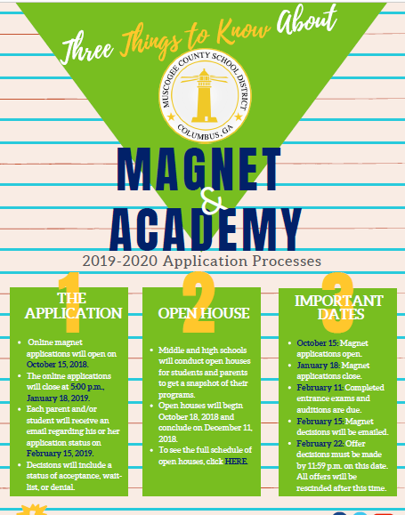
- FINAL CHANCE!!! MAGNET APPLICATION DEADLINE JANUARY 18TH.

- Parents have you been checking Infinite Campus Parent Portal? The portal gives a real time update of grades and attendance for your child(ren). You should be seeing grades in this upcoming week from each teacher on your child(ren) schedule. ECMA Teachers are expected to update grades weekly and for your convenience this program can be downloaded to any Smart Device to review your child(ren) academic progress. Stay Connected! Make sure you have your portal access. Contact: Ms. Daphne Jenkins, Parenting Liaison 706.565.3026 or Jenkins.Daphne.C@muscogee.k12.ga.us
- Students will receive their second 9-weeks report card on Tuesday. I am sure that some of you are asking, how can I help my child at home to improve their grades in their content class(es)? The answer is to review with the current content with them at home and preview the upcoming standards. I have provided interactive links below to each content areas pacing guide to allow you to do just that for your child(ren).
  - ELA: https://www.georgiastandards.org/Georgia-Standards/Documents/ELA-Standards-Grades-6-8.pdf
  - MATH: https://www.georgiastandards.org/Georgia-Standards/Documents/Grade-6-8-Mathematics-Standards.pdf
  - ALGEBRA: https://www.georgiastandards.org/Georgia-Standards/Documents/High-School-Mathematics-Standards.pdf
  - SCIENCE 6: https://www.muscogee.k12.ga.us/Documents/TeachingandLearning/Pre-Kindergarten/Grades6-12Secondary/Science_Pacing_Guide_SIXTH_FINAL.docx
  - SCIENCE 7: https://www.muscogee.k12.ga.us/Documents/TeachingandLearning/Pre-Kindergarten/Grades6-12Secondary/Science_Pacing_Guide_SEVENTH_2015-16.docx
  - SCIENCE 8: https://www.muscogee.k12.ga.us/Documents/TeachingandLearning/Pre-Kindergarten/Grades6-12Secondary/Science_Pacing_Guide_EIGHTH.docx
  - HS PHYSICAL SC: https://www.muscogee.k12.ga.us/Documents/TeachingandLearning/Pre-Kindergarten/Grades6-12Secondary/Pacing_Guide_Physical_Science_FINAL.docx
  - SOCIAL STUDIES: https://www.georgiastandards.org/Georgia-Standards/Documents/Social-Studies-6-8-Georgia-Standards.pdf
- MCSD Robotics Competition will be held at Richards MS on March 9th. The goal of this competition is to ultimately prepare elementary, middle, and high school MCSD students for the challenges that come with operating robots in various space and extreme environments. However, while most robotics competitions include a fixed set of competition parameters in which all teams are judged on the same task (i.e. completing an obstacle course, moving items around a box), our competition allows each team the freedom to showcase their robotics and coding skills by developing and bringing with them the challenge AND the solution. ECMA have their 1st team ever competing in this tournament. Please plan to come out and support the team as they make history.
- How does saving money for college tuition sound to you? Are you interested in your child taking college courses while in high school? Would you like to have more information about these opportunities? Please plan to attend one of these meetings!
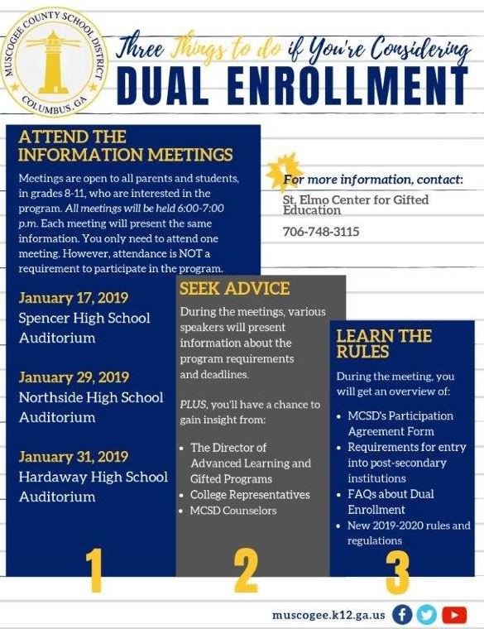
- STUDENT SPOTLIGHT: For the 1st time in history the JLC program will participate with the annual MCSD JROTC military ball. Queen Cadet Dramani Johnson and her escort Cadet Zykevion McCoy will be the representatives for the ECMA JLC program, please join me in congratulating these two young people. The ball is January 26th at St. Luke Ministries.
- SAVE THE DATE: Academic Saturday Academy next Saturday, January 8am – 12pm.
- ATTENTION! ATTENTION! If you have a child with allergies that requires the use of an EpiPen please call the following number for a FREE pen: 1.877.30A.UVIQ.
- If you have a student graduating 2019 – 2021 and would like for them to be considered for a summer internship with TSYS review the flyer below for details.
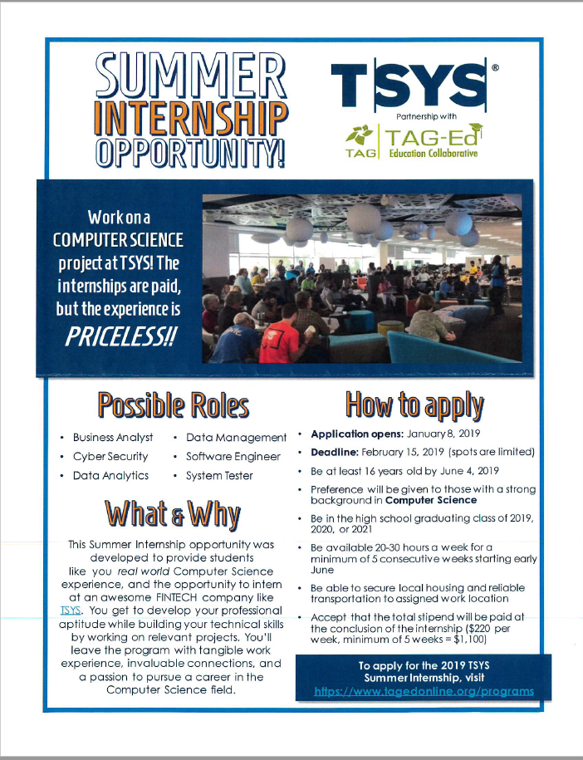
- See Mrs. Cooper to place your pre-order for the ECMA yearbook. $10 for soft cover and $15 for hardcover
STAY CONNECTED @ecmaknights _________________________________________________________________________________________________

