EAST COLUMBUS MAGNET ACADEMY

KNIGHT NOTES: November 5 - 9, 2018

A LOOK AT THE WEEK AHEAD:
MONDAY, NOVEMBER 5th
- College Prep Workshop Rainey-McClullers School of the Arts (see flier below)
- ECMA Debate Team Room 809, 4:00 – 5:15pm, Sponsor Ms. K. Arnold
- Boys’ Basketball conditioning, 4:15 – 6pm, Coach Dye. You must have a current physical on file.
- Girls’ Basketball conditioning, 4:15 – 6pm, Coach Lumpkin. You must have a current physical on file.
- Dazzling Knights Dance Team Practice 4:00 – 6:00 pm, Sponsor Mrs. Brandy Wells-Adams
TUESDAY, NOVEMBER 6th
- Advance Band Practice 4-5pm, Sponsor Mr. Ryan Cutliff
- Boys’ Basketball conditioning, 4:15 – 6pm, Coach Dye. You must have a current physical on file.
- Girls’ Basketball conditioning, 4:15 – 6pm, Coach Lumpkin. You must have a current physical on file.
- Cheerleading Practice 4:05 – 6:00pm, Sponsor Ms. Traveika Hunter
- Dazzling Knights Dance Team Practice 4:00 – 6:00pm, Sponsor Mrs. Brandy Wells-Adams
WEDNESDAY, NOVEMBER 7th
- Boys’ Basketball conditioning, 4:15 – 6pm, Coach Dye. You must have a current physical on file.
- Girls’ Basketball conditioning, 4:15 – 6pm, Coach Lumpkin. You must have a current physical on file.
- Dazzling Knights Dance Team Practice 4:00 – 6:00pm, Sponsor Mrs. Brandy Wells-Adams
THURSDAY, NOVEMBER 8th
- ECMA JLC program join the MCSD JROTC with the MPEC Flag Ceremony at the MC PEC 8:30am.
- ECMA JLC uniform inspection.
- ECMA Debate Team Room 809, 4:00 – 5:15pm, Sponsor Ms. K. Arnold
- Advance Band Practice 4-5pm, Sponsor Mr. Ryan Cutliff
- Orchestra After School Tutorial w/Ms. Hunnewell (4:00 – 5:00pm)
- Boys’ Basketball conditioning, 4:15 – 6pm, Coach Dye. You must have a current physical on file.
- Girls’ Basketball conditioning, 4:15 – 6pm, Coach Lumpkin. You must have a current physical on file.
- Cheerleading Practice 4:05 – 6:00pm, Sponsor Ms. Traveika Hunter
- Dazzling Knights Dance Team Practice 4:00 – 6:00pm, Sponsor Mrs. Brandy Wells-Adams
FRIDAY, NOVEMBER 9th
- Boys’ Basketball conditioning, 4:15 – 6pm, Coach Dye. You must have a current physical on file.
- Girls’ Basketball conditioning, 4:15 – 6pm, Coach Lumpkin. You must have a current physical on file
SATURDAY, NOVEMBER 10th
- Academic Saturday Academy, 8:00am – 12:00pm, Point of Contact Dr. Janet Goodwin, (706)565-3026 or goodwin.janet.m@muscogee.k12.ga.us
________________________________________________________________________________
2018 - 2019 ECMA BUILDING EXPECTATION
- Student Drop Off: 8am There is no adult supervision prior to 8am or after 4:30pm and liability is on you the parent not the school. Parents, please do not drop off your student before this time as it is an EXTREME SAFTEY concern. All students are to report to the gym and should be dropped off on the side closest to the gym NOT THE MAIN LOOP. Student Pick Up: 3:55 – 4:30pm. Students will not have supervision after 4:30pm unless previously coordinated with a teacher, coach or sponsor. I thank you in advance for working together on these request and not forcing the school administration to take alternative measures to ensure that drop off and pick up times are adhered to daily.
- Students will lock up their book bags, cell phones, ear buds and any electronic devices in their locker before reporting to their 1st period class.
- Please help us with ensuring that your child is following the Dress Code expectations which will be enforced daily.
________________________________________________________________________________
VOLUNTEER OPPORTUNITIES AND PTO NEWS

- At ECMA there are many ways for parents to get involved. Concession stand support for home games, ECMA Knight Store, after school traffic flow for car riders and walkers.
- PTO sponsored workshop on Darkness to Light’s Stewards of Children. This workshop is designed to educate parents in our community and help end children sexual abuse. Please contact Ms. Daphne Jenkins or Mrs. Jennifer Melvin to sign up for this workshop.
________________________________________________________________________________
ECMA NEWS YOU CAN USE
- Join us in welcoming two additional staff members to the ECMA community. Dr. Mary Watlington, Title I Part-Time Behavior Intervention Specialist. Dr. Watlington is a retired MCSD counselor with a wealth of knowledge and strategies that will be used to support our sixth grade population. Additionally, Mr. Timothy Marino has been hired to replace Mrs. Hiers as the sixth through eighth Art teacher. You should have received a letter from Mr. Marino that he sent home with your child regarding expectations and ways to support classroom instruction.
- ATTENTION! ATTENTION!
  - Saturday Academic Academy will be held on select Saturdays for the remainder of the school year for those students who would like to receive additional help in ELA and Math. Students will receive personalized instruction in small groups through prescribed lessons supported by computer learning programs. The dates and times for the academy are 8:00 am until 12 noon on November 10th and 17th and December 1st, 8th and 15th. There is no transportation provided for Saturday Academic Academy so students must be dropped off by 8:00 and picked up at 12. If you are interested in your child participating in the program please contact Dr. Goodwin at (706)565-3026 or goodwin.janet.m@muscogee.k12.ga.us to receive more information.
- College and Career Ready Performance Index (CCRPI) Overview of the five components that determine a district’s or school’s CCRPI score. Provided below is a link to a wonderful video that clearly explains what the scores mean: https://www.youtube.com/watch?v=wjFO0AKwvis&feature=youtu.be ECMA has increased our CCRPI score from 53.1points to 62.9points. Additionally, you can see we have seen gains in all areas except Math; however, with the adjustments we have made in teaching positions and the addition of a Title I Math Intervention Specialist we are aggressively working on improving this content area score.

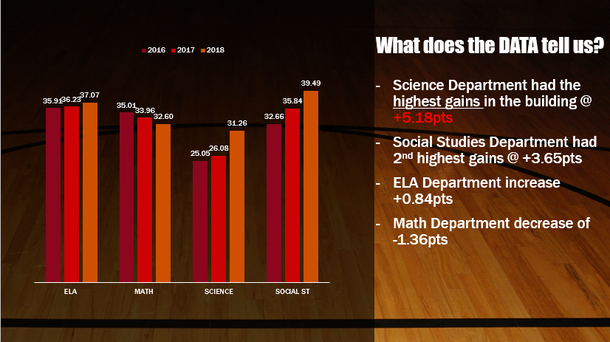
- See Mrs. Cooper to place your pre-order for the ECMA yearbook. $10 for soft cover and $15 for hardcover
- JLC will have inspection on November 29th please ensure that your child has their JLC uniform in compliance.
- The Magnet application process has begun. Eighth grade parents please stay on top of the deadlines and testing dates to ensure that your child can be strongly considered as a viable applicant in the High School Magnet programs. Additionally, if you have a rising fifth grader or a student currently at ECMA that you would like to be considered for our magnet program the magnet exam dates are as follows: Sat. Dec 1, Dec 15, Jan 12, Tues. Jan 15 TIME: TBA
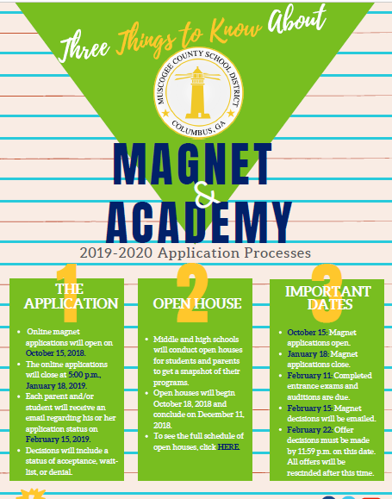
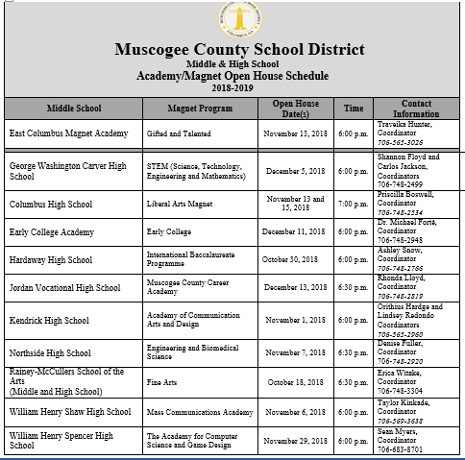
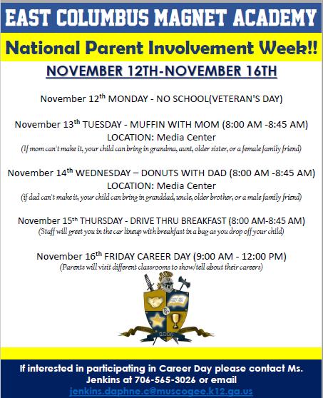
_________________________________________________________________________________________________
STAY CONNECTED @ecmaknights _________________________________________________________________________________________________

