EAST COLUMBUS MAGNET ACADEMY

KNIGHT NOTES: October 29 - November 2, 2018

A LOOK AT THE WEEK AHEAD:
MONDAY, OCTOBER 29th
- RED RIBBON & ANTI-BULLYING CAMPAIGN THEME: “ECMA standing against Drugs” EVERYONE IS ENCOURAGED TO WEAR RED
- ECMA Debate Team Room 809, 4:00 – 5:15pm, Sponsor Ms. K. Arnold
- Football Game 5:15pm ECMA vs VMMS @ St. Anne Pacelli Catholic School, Coach Andre’ Dye
- Girls’ Basketball Conditioning (Must have physical), 4:00 – 6:00pm, Coach Sharon Lumpkin
- Dazzling Knights Dance Team Practice 4:00 – 6:00 pm, Sponsor Mrs. Brandy Wells-Adams
TUESDAY, OCTOBER 30th
- RED RIBBON & ANTI-BULLYING CAMPAIGN THEME: “Give Drugs & Bullying the Boot” EVERYONE IS ENCOURAGED TO WEAR YOUR FAVORITE BOOTS
- Advance Band Practice 4-5pm, Sponsor Mr. Ryan Cutliff
- Football Practice 4:15 – 6:00pm, Coach Andre’ Dye
- Cheerleading Practice 4:05 – 6:00pm, Sponsor Ms. Traveika Hunter
- Girls’ Basketball Conditioning (Must have physical), 4:00 – 6:00pm, Coach Sharon Lumpkin
- Dazzling Knights Dance Team Practice 4:00 – 6:00pm, Sponsor Mrs. Brandy Wells-Adams
- PTO/Local School Council Meeting, ECMA Cafeteria at 6PM
WEDNESDAY, OCTOBER 31st
- RED RIBBON & ANTI-BULLYING CAMPAIGN THEME: “ECMA Standing against Bullying” EVERYONE IS ENCOURAGED TO WEAR ORANGE
- Girls’ Basketball Conditioning (Must have physical), 4:00 – 6:00pm, Coach Sharon Lumpkin
- Dazzling Knights Dance Team Practice 4:00 – 6:00pm, Sponsor Mrs. Brandy Wells-Adams
THURSDAY, NOVEMBER 1ST
- RED RIBBON & ANTI-BULLYING CAMPAIGN THEME: “Socking it to Drugs & Bullying” EVERYONE IS ENCOURAGED TO WEAR CRAZY SOCKS
- MCSD Academic Bowl Competition at Shaw High School, Sponsor Mrs. Elizabeth Smith
- ECMA Debate Team Room 809, 4:00 – 5:15pm, Sponsor Ms. K. Arnold
- Advance Band Practice 4-5pm, Sponsor Mr. Ryan Cutliff
- Orchestra After School Tutorial w/Ms. Hunnewell (4:00 – 5:00pm)
- MS Swimming Try-Outs at 5:30pm (See additional details below.)
- Football Practice 4:15 – 6:00pm, Coach Andre’ Dye
- Cheerleading Practice 4:05 – 6:00pm, Sponsor Ms. Traveika Hunter
- Girls’ Basketball Conditioning (Must have physical), 4:00 – 6:00pm, Coach Sharon Lumpkin
- Dazzling Knights Dance Team Practice 4:00 – 6:00pm, Sponsor Mrs. Brandy Wells-Adams
FRIDAY, NOVEMBER 2ND
- RED RIBBON & ANTI-BULLYING CAMPAIGN THEME: “Teaming up against Drugs & Bullies” EVERYONE IS ENCOURAGED TO WEAR YOUR FAVORITE SPORTS TEAM GEAR
- Football Practice 4:15 – 6:00pm, Coach Andre’ Dye
- Girls’ Basketball Conditioning (Must have physical), 4:00 – 6:00pm, Coach Sharon Lumpkin
________________________________________________________________________________
2018 - 2019 ECMA BUILDING EXPECTATION
- Student Drop Off: 8am There is no adult supervision prior to 8am or after 4:30pm and liability is on you the parent not the school. Parents, please do not drop off your student before this time as it is an EXTREME SAFTEY concern. All students are to report to the gym and should be dropped off on the side closest to the gym NOT THE MAIN LOOP. Student Pick Up: 3:55 – 4:30pm. Students will not have supervision after 4:30pm unless previously coordinated with a teacher, coach or sponsor. I thank you in advance for working together on these request and not forcing the school administration to take alternative measures to ensure that drop off and pick up times are adhered to daily.
- Students will lock up their book bags, cell phones, ear buds and any electronic devices in their locker before reporting to their 1st period class.
- Please help us with ensuring that your child is following the Dress Code expectations which will be enforced daily.
________________________________________________________________________________
VOLUNTEER OPPORTUNITIES

- At ECMA there are many ways for parents to get involved. Concession stand support for home games, ECMA Knight Store, after school traffic flow for car riders and walkers.
________________________________________________________________________________
ECMA NEWS YOU CAN USE
- MARK YOUR CALENDARS: The MCSD JROTC Department has requested that the ECMA JLC program join their JROTC with the MPEC Flag Ceremony on Thursday, 08 NOV 2018 at 8:30am. Parents this is an honor to be asked and we hope you are able to support these young people represent ECMA in grand fashion.
- See Mrs. Cooper to place your pre-order for the ECMA yearbook. $10 for soft cover and $15 for hardcover
- Boys’ Basketball conditioning will begin November 5th (4:15 – 6pm) contact Coach Dye for details. You must have a current physical on file.
- JLC will have inspection on November 8th and 29th please ensure that your child has their JLC uniform in compliance.
- Dinner Table Conversation with your scholar:
  - 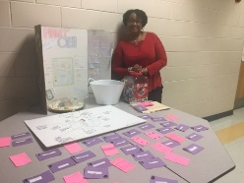 If you missed our Annual Math, Science and Technology Night you missed out on two hours of parent/student competition games, food, candy and HOMEMADE ICE CREAM! One featured game was created by Terron David a 7th grade ECMA student, “The Cell City.”
  - 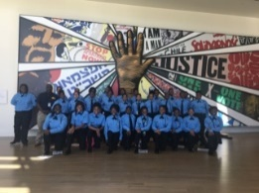 Ask your JLC student about their trip to the Civil Rights Museum in Atlanta this week with 1SGT Wilson and chaperones.
  - 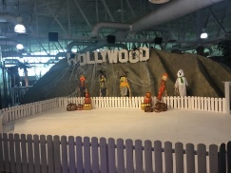 Ask your child about the Academic Walk of Fame Pep Rally and Field Trip. Students that made the Honor Roll and Principal’s List were honored in front of the entire student body and their parents. Encourage your child to join these students next nine weeks. ECMA is the ONLY middle school in the district to honor students in this fashion each nine weeks.
- Technology Adventures at ECMA in concert with our PIE partners we will participate in the Hour of Code on December 9th. If you are interested in learning along with your child or volunteering for this experience that is a global initiative to spark interest in programming. Please email Ms. Jenkins and Mr. Rathert.
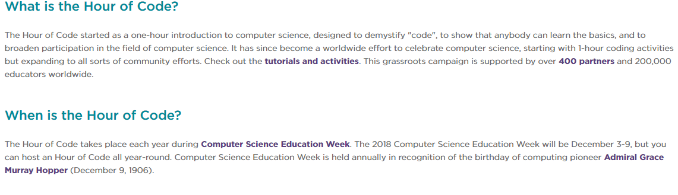
- The Magnet application process has begun. Eighth grade parents please stay on top of the deadlines and testing dates to ensure that your child can be strongly considered as a viable applicant in the High School Magnet programs. Additionally, if you have a rising fifth grader or a student currently at ECMA that you would like to be considered for our magnet program the magnet exam dates are as follows: Sat. Dec 1, Dec 15, Jan 12, Tues. Jan 15 TIME: TBA
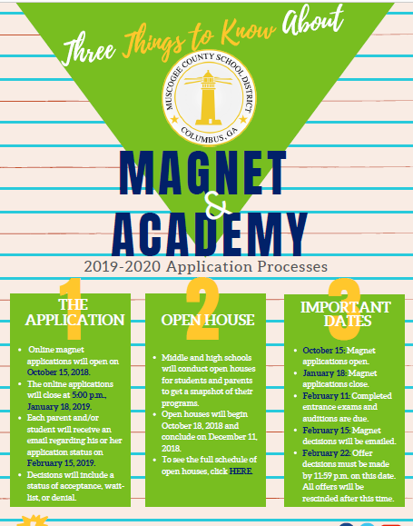
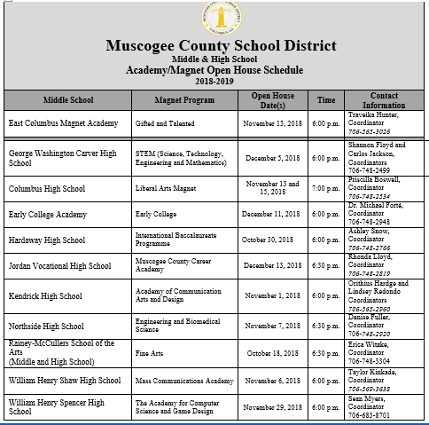
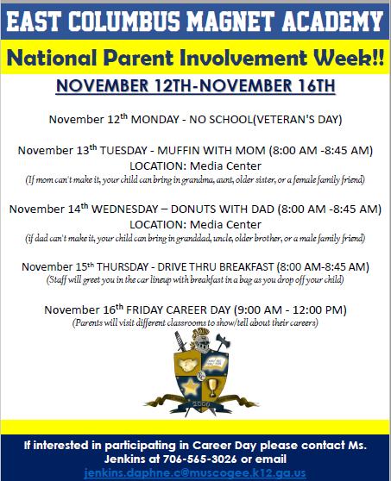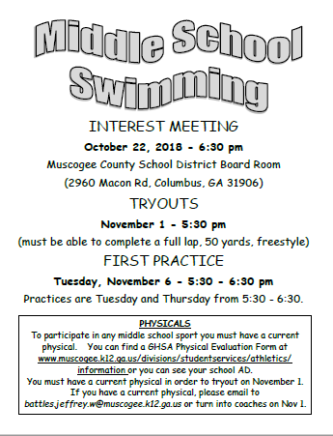
_________________________________________________________________________________________________
STAY CONNECTED @ecmaknights _________________________________________________________________________________________________

