EAST COLUMBUS MAGNET ACADEMY

**KNIGHT NOTES: October 22 - 26, 2018**

**A LOOK AT THE WEEK AHEAD:**

**MONDAY, OCTOBER 22nd**

* **ECMA Debate Team Room 809, 4:00 – 5:15pm, Sponsor Ms. K. Arnold**
* **Sport Pictures: Football, Cross Country, Volleyball and Cheerleading**
* **Football Practice 4:15 – 6:00pm, Coach Andre’ Dye**
* **Girls’ Basketball Conditioning (Must have physical), 4:00 – 6:00pm, Coach Sharon Lumpkin**
* **Dazzling Knights Dance Team Practice 4:00 – 6:00 pm, Sponsor Mrs. Brandy Wells-Adams**
* **MS Swimming Interest Meeting 6:30 MC PEC Board Room (2960 Macon Rd) additional details in flyer below**

**TUESDAY, OCTOBER 23rd**

* **Advance Band Practice 4-5pm, Sponsor Mr. Ryan Cutliff**
* **Volleyball All Star Game 6:30 PM @ Northside High School**
* **Football Practice 4:15 – 6:00pm, Coach Andre’ Dye**
* **Cheerleading Practice 4:05 – 6:00pm, Sponsor Ms. Traveika Hunter**
* **Girls’ Basketball Conditioning (Must have physical), 4:00 – 6:00pm, Coach Sharon Lumpkin**
* **Dazzling Knights Dance Team Practice 4:00 – 6:00pm, Sponsor Mrs. Brandy Wells-Adams**

**WEDNESDAY, OCTOBER 24TH**

* **Football Game 5:15pm @ Harris County MS, Coach Andre’ Dye**
* **Girls’ Basketball Conditioning (Must have physical), 4:00 – 6:00pm, Coach Sharon Lumpkin**
* **Dazzling Knights Dance Team Practice 4:00 – 6:00pm, Sponsor Mrs. Brandy Wells-Adams**

**THURSDAY, OCTOBER 25TH**

* **ECMA Debate Team Room 809, 4:00 – 5:15pm, Sponsor Ms. K. Arnold**
* **Advance Band Practice 4-5pm, Sponsor Mr. Ryan Cutliff**
* **Orchestra After School Tutorial w/Ms. Hunnewell (4:00 – 5:00pm)**
* **Football Practice 4:15 – 6:00pm, Coach Andre’ Dye**
* **Cheerleading Practice 4:05 – 6:00pm, Sponsor Ms. Traveika Hunter**
* **Girls’ Basketball Conditioning (Must have physical), 4:00 – 6:00pm, Coach Sharon Lumpkin**
* **Dazzling Knights Dance Team Practice 4:00 – 6:00pm, Sponsor Mrs. Brandy Wells-Adams**

**FRIDAY, OCTOBER 26TH**

* **Academic Walk of Fame at 9:30am honoring the Principal’s List and Honor Roll recipients in the ECMA Gym. Field trip to Hollywood Connections for the honored students directly after the program.**
* **Annual Math, Science and Technology Night at ECMA 6:00 – 8:00pm. Come out to enjoy games, food and treats with the ECMA Teachers and Partners in Education.**
* **Football Practice 4:15 – 6:00pm, Coach Andre’ Dye**
* **Girls’ Basketball Conditioning (Must have physical), 4:00 – 6:00pm, Coach Sharon Lumpkin**

**________________________________________________________________________________**

**2018 - 2019 ECMA BUILDING EXPECTATION**

* **Student Drop Off: 8am There is no adult supervision prior to 8am or after 4:30pm and liability is on you the parent not the school. Parents, please do not drop off your student before this time as it is an EXTREME SAFTEY concern. All students are to report to the gym and should be dropped off on the side closest to the gym NOT THE MAIN LOOP. Student Pick Up: 3:55 – 4:30pm. Students will not have supervision after 4:30pm unless previously coordinated with a teacher, coach or sponsor. I thank you in advance for working together on these request and not forcing the school administration to take alternative measures to ensure that drop off and pick up times are adhered to daily.**
* **Students will lock up their book bags, cell phones, ear buds and any electronic devices in their locker before reporting to their 1st period class.**
* **Please help us with ensuring that your child is following the Dress Code expectations which will be enforced daily.**

**________________________________________________________________________________**

**VOLUNTEER OPPORTUNITIES**

* **At ECMA there are many ways for parents to get involved. Concession stand support for home games, ECMA Knight Store, after school traffic flow for car riders and walkers.**

**________________________________________________________________________________**

**ECMA NEWS YOU CAN USE**

* **MARK YOUR CALENDARS: PTO/Local School Council Meeting, ECMA Cafeteria October 30th at 6PM**
*  **Technology Adventures at ECMA in concert with our PIE partners we will participate in the Hour of Code on December 9th. If you are interested in learning along with your child or volunteering for this experience that is a global initiative to spark interest in programming. Please email Ms. Jenkins and Mr. Rathert.**

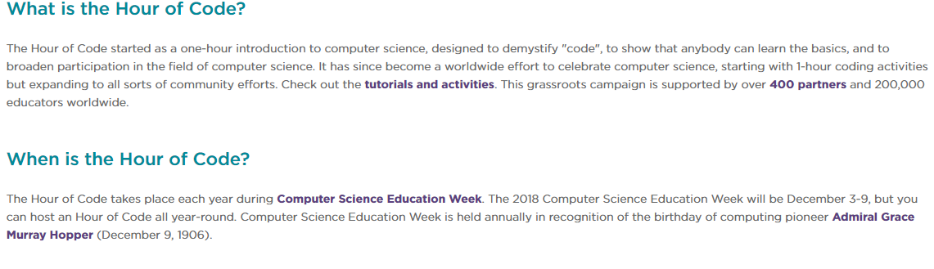

* **The Magnet application process has begun. Eighth grade parents please stay on top of the deadlines and testing dates to ensure that your child can be strongly considered as a viable applicant in the High School Magnet programs. Additionally, if you have a rising fifth grader or a student currently at ECMA that you would like to be considered for our magnet program the magnet exam dates are as follows: Sat. Dec 1, Dec 15, Jan 12, Tues. Jan 15 TIME: TBA**

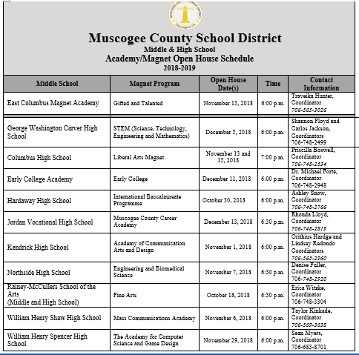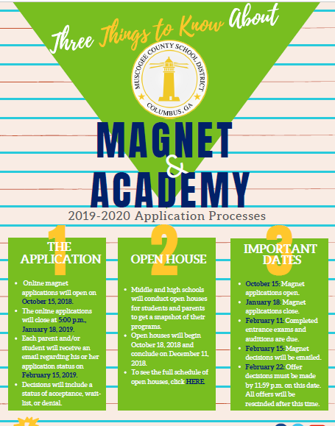

* **See Mrs. Cooper to place your pre-order for the ECMA yearbook.  $10 for soft cover and $15 for hardcover**
* **Students received their first report cards on Thursday. I am sure that some of you are asking, how can I help my child at home to improve their grades in their content class(es)? The answer is to review with the current content with them at home and preview the upcoming standards. We are in the 2nd Nine Week, I have provided interactive links below to each content areas pacing guide to allow you to do just that for your child(ren).**
  + **ELA:** [**https://www.georgiastandards.org/Georgia-Standards/Documents/ELA-Standards-Grades-6-8.pdf**](https://www.georgiastandards.org/Georgia-Standards/Documents/ELA-Standards-Grades-6-8.pdf)
  + **MATH:** [**https://www.georgiastandards.org/Georgia-Standards/Documents/Grade-6-8-Mathematics-Standards.pdf**](https://www.georgiastandards.org/Georgia-Standards/Documents/Grade-6-8-Mathematics-Standards.pdf)
  + **ALGEBRA:** [**https://www.georgiastandards.org/Georgia-Standards/Documents/High-School-Mathematics-Standards.pdf**](https://www.georgiastandards.org/Georgia-Standards/Documents/High-School-Mathematics-Standards.pdf)
  + **SCIENCE 6:** [**https://www.muscogee.k12.ga.us/Documents/TeachingandLearning/Pre-Kindergarten/Grades6-12Secondary/Science_Pacing_Guide_SIXTH_FINAL.docx**](https://www.muscogee.k12.ga.us/Documents/TeachingandLearning/Pre-Kindergarten/Grades6-12Secondary/Science_Pacing_Guide_SIXTH_FINAL.docx)
  + **SCIENCE 7:** [**https://www.muscogee.k12.ga.us/Documents/TeachingandLearning/Pre-Kindergarten/Grades6-12Secondary/Science_Pacing_Guide_SEVENTH_2015-16.docx**](https://www.muscogee.k12.ga.us/Documents/TeachingandLearning/Pre-Kindergarten/Grades6-12Secondary/Science_Pacing_Guide_SEVENTH_2015-16.docx)
  + **SCIENCE 8:** [**https://www.muscogee.k12.ga.us/Documents/TeachingandLearning/Pre-Kindergarten/Grades6-12Secondary/Science_Pacing_Guide_EIGHTH.docx**](https://www.muscogee.k12.ga.us/Documents/TeachingandLearning/Pre-Kindergarten/Grades6-12Secondary/Science_Pacing_Guide_EIGHTH.docx)
  + **HS PHYSICAL SC:** [**https://www.muscogee.k12.ga.us/Documents/TeachingandLearning/Pre-Kindergarten/Grades6-12Secondary/Pacing_Guide_Physical_Science_FINAL.docx**](https://www.muscogee.k12.ga.us/Documents/TeachingandLearning/Pre-Kindergarten/Grades6-12Secondary/Pacing_Guide_Physical_Science_FINAL.docx)
  + **SOCIAL STUDIES:** [**https://www.georgiastandards.org/Georgia-Standards/Documents/Social-Studies-6-8-Georgia-Standards.pdf**](https://www.georgiastandards.org/Georgia-Standards/Documents/Social-Studies-6-8-Georgia-Standards.pdf)
* **ATTENTION! ATTENTION! FREE AT HOME TUTORING…See the flyer below.**

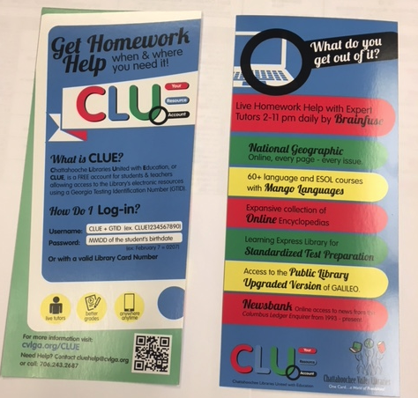

* **Dinner Table Conversation with your scholar:** 
  + 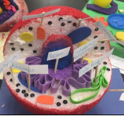 **Ask your 7th grade student about cell structure and function. Mrs. Y. Arnold’s student completed one of three options to display their understanding (1) Cell Analogies Collage, (2) 3-D Model of a plant or Animal Cell and (3) Design and Create a T-Shirt with a Picture of  a Cell.**
  + 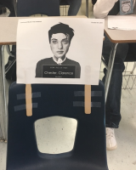 **Ask your 8th grade student about the “Mock Murder Trial” they conducted in Ms. Savage’s ILT class to provide a visual reference of the purpose behind an augmentative essay.**
* **Do you know your child’s Lexile level? Are they using Achieve3000 at home? It is critical that your child perform on GRADE LEVEL to meet their potential academically and their lexile level is an integral piece to the equation. Be sure to talk with your child about their goal of passing 3 Achieve3000 articles a week. If you have any questions about Lexile levels or Achieve3000, feel free to contact our literacy coach, Christy Grigsby at** [**grigsby.christy.n@muscogee.k12.ga.us**](mailto:grigsby.christy.n@muscogee.k12.ga.us).

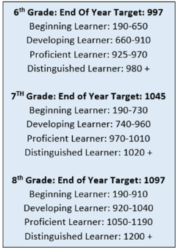

THIS IS THE GOAL!

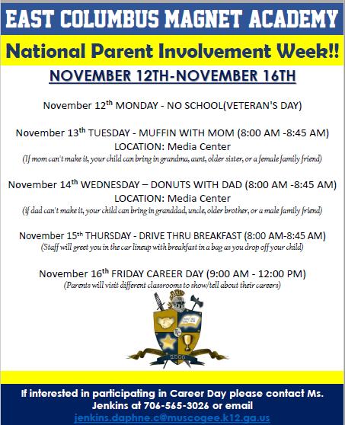 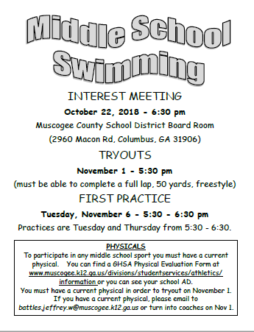 

**_________________________________________________________________________________________________**

**STAY CONNECTED @ecmaknights** **_________________________________________________________________________________________________**