EAST COLUMBUS MAGNET ACADEMY

KNIGHT NOTES: October 15 - 19, 2018

A LOOK AT THE WEEK AHEAD:
MONDAY, OCTOBER 15TH
- ECMA Debate Team Room 809, 4:00 – 5:15pm, Sponsor Ms. K. Arnold
- Volleyball Playoff Games – Round One @ Fort MS, Coach Michael Armstrong
  - Game 1 - #4 vs. #5 – 5:00 PM
  - Game 2 - #3 vs. #6 – 6:30 PM
- Cross Country Practice 4:15 – 5:15pm, Coach Arlys Clayborn
- Football Practice 4:15 – 6:00pm, Coach Andre’ Dye
- Dazzling Knights Dance Team Practice 4:00 – 6:00pm, Sponsor Mrs. Brandy Wells-Adams
TUESDAY, OCTOBER 16^{H}
- Advance Band Practice 4-5pm, Sponsor Ryan Cutliff
- Cross Country Championship Girls 6:00pm and Boys 6:30pm @ Kinnett Stadium, Coach Arlys Clayborn
- Football Practice 4:15 – 6:00pm, Coach Andre’ Dye
- Cheerleading Practice 4:05 – 6:00pm, Sponsor Ms. Traveika Hunter
- Volleyball Practice 4:15 – 6:30pm, Coach Michael Armstrong
- Dazzling Knights Dance Team Practice 4:00 – 6:00pm, Sponsor Mrs. Brandy Wells-Adams
WEDNESDAY, OCTOBER 17TH
- Football Game 5:15pm @ Fort MS, Coach Andre’ Dye
- Dazzling Knights Dance Team Practice 4:00 – 6:00pm, Sponsor Mrs. Brandy Wells-Adams
THURSDAY, OCTOBER 18TH
- 1ST NINE WEEKS REPORT CARDS will be distributed to students
- ECMA Debate Team Room 809, 4:00 – 5:15pm, Sponsor Ms. K. Arnold
- Advance Band Practice 4-5pm, Sponsor Ryan Cutliff
- Orchestra After School Tutorial w/Ms. Hunnewell (4:00 – 5:00pm)
- Volleyball Semifinals/Finals @ Columbus High School, Coach Michael Armstrong
  - Game 3 - #2 vs Winner Game 2 – 5:30 PM
  - Game 4 - #1 vs Winner Game 1 – 5:30 PM
  - Finals – Winner G3 vs. G4 – 7:00 PM
- Football Practice 4:15 – 6:00pm, Coach Andre’ Dye
- Cheerleading Practice 4:05 – 6:00pm, Sponsor Ms. Traveika Hunter
- Dazzling Knights Dance Team Practice 4:00 – 6:00pm, Sponsor Mrs. Brandy Wells-Adams
FRIDAY, OCTOBER 19TH
- Football Practice 4:15 – 6:00pm, Coach Andre’ Dye
________________________________________________________________________________
2018 - 2019 ECMA BUILDING EXPECTATION
- Student Drop Off: 8am There is no adult supervision prior to 8am or after 4:30pm and liability is on you the parent not the school. Parents, please do not drop off your student before this time as it is an EXTREME SAFTEY concern. All students are to report to the gym and should be dropped off on the side closest to the gym NOT THE MAIN LOOP. Student Pick Up: 3:55 – 4:30pm. Students will not have supervision after 4:30pm unless previously coordinated with a teacher, coach or sponsor. I thank you in advance for working together on these request and not forcing the school administration to take alternative measures to ensure that drop off and pick up times are adhered to daily.
- Students will lock up their book bags, cell phones, ear buds and any electronic devices in their locker before reporting to their 1st period class.
- Please help us with ensuring that your child is following the Dress Code expectations which will be enforced daily.
________________________________________________________________________________
VOLUNTEER OPPORTUNITIES

- At ECMA there are many ways for parents to get involved. Concession stand support for home games, ECMA Knight Store, after school traffic flow for car riders and walkers.
________________________________________________________________________________
ECMA NEWS YOU CAN USE
- Mark your calendars: Volleyball All Star Game – Tuesday, October 23 – 6:30 PM @ Northside High School
- The Magnet application process has begun. Eighth grade parents please stay on top of the deadlines and testing dates to ensure that your child can be strongly considered as a viable applicant in the High School Magnet programs. Additionally, if you have a rising fifth grader or a student currently at ECMA that you would like to be considered for our magnet program the magnet exam dates are as follows: Sat. Dec 1, Dec 15, Jan 12, Tues. Jan 15 TIME: TBA
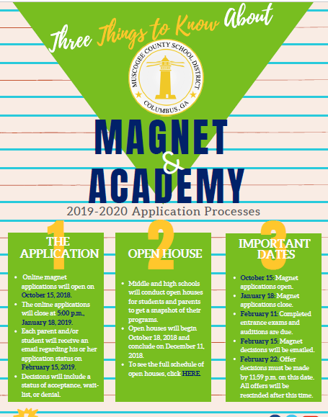
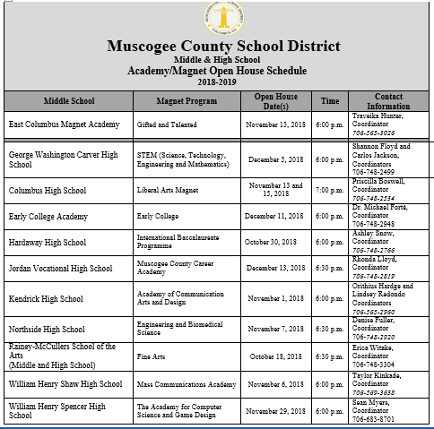
- Walk of Fame October 26th at 9:30am honoring the Principal’s List and Honor Roll recipients in the ECMA Gym. Field trip to Hollywood Connections for the honored students directly after the program.
- Mark your calendars: Annual Math, Science and Technology Night at ECMA October 26th 6:00 – 8:00pm. Come out to enjoy games, food and treats with the ECMA Teachers and Partners in Education.
- See Mrs. Cooper to place your pre-order for the ECMA yearbook. $10 for soft cover and $15 for hardcover
- Parents, do you want real-time feedback on your child’s academic progress? Have you obtained your Infinite Campus Parent Portal Access? If you have answered ‘Yes’ and ‘No’ to these essential questions, please visit the ECMA main office during normal business hours with your GA driver’s license or GA ID to obtain your IC Parent Portal Access information. For your convenience the App can be loaded on any smart device and set up to receive attendance and grade updates. Stay connected don’t wait until it is too late to support your child in their academic progress.
- MARK OUR CALENDARS: National Parent Involvement Week November 12 – 16, 2018. Please contact Ms. Daphne Jenkins, Parenting Liaison to be included as a Career Day presenter on Thursday, November 15th. This year we would love to fill our school with parents as the Career Day presenters so please consider offering your time to encourage the next generation of professionals.
_________________________________________________________________________________________________
STAY CONNECTED @ecmaknights _________________________________________________________________________________________________

