EAST COLUMBUS MAGNET ACADEMY

KNIGHT NOTES: October 1 - 5, 2018

A LOOK AT THE WEEK AHEAD:
MONDAY, OCTOBER 1ST
- Magnet Students: Social Studies Fair Info going home, Sponsor Mrs. Dell King
- Soup Bowl Writer’s Workshop Homework: Final Draft due and submitted to Canvas typed ( Double-Space12 inch Times New Roman Font)
- ECMA Debate Team Room 809, 4:00 – 5:15pm, Sponsor Ms. K. Arnold
- Volleyball Match Double Header ECMA vs ACMS and RMS @ Baker MS 6:00pm, Coach Michael Armstrong
- Football Practice 4:15 – 6:00pm, Coach Andre’ Dye
- Dazzling Knights Dance Team Practice 4:00 – 6:00pm, Sponsor Mrs. Brandy Wells-Adams
- Cross Country Practice 4:15 – 5:15pm, Coach Arlys Clayborn
TUESDAY, OCTOBER 2ND
- Advance Band Practice 4-5pm, Sponsor Ryan Cutliff
- Football Practice 4:15 – 6:00pm, Coach Andre’ Dye
- Cheerleading Practice 4:05 – 6:00pm, Sponsor Ms. Traveika Hunter
- Volleyball Practice 4:15 – 6:30pm, Coach Michael Armstrong
- Cross Country Practice 4:15 – 5:15pm, Coach Arlys Clayborn
- Dazzling Knights Dance Team Practice 4:00 – 6:00pm, Sponsor Mrs. Brandy Wells-Adams
WEDNESDAY, OCTOBER 3RD
- Football Game ECMA vs Richards @ Richards 5:00pm, Coach Andre’ Dye
- Dazzling Knights Dance Team Practice 4:00 – 6:00pm, Sponsor Mrs. Brandy Wells-Adams
- Cross Country Practice 4:15 – 5:15pm, Coach Arlys Clayborn
- Volleyball Practice 4:15 – 6:30pm, Coach Michael Armstrong
THURSDAY, OCTOBER 4TH
- ECMA Debate Team Room 809, 4:00 – 5:15pm, Sponsor Ms. K. Arnold
- Advance Band Practice 4-5pm, Sponsor Ryan Cutliff
- Orchestra After School Tutorial w/Ms. Hunnewell (4:00 – 5:00pm)
- Volleyball Match ECMA vs FSLMA @ HOME 5:00pm, Coach Michael Armstrong
- Football Practice 4:15 – 6:00pm, Coach Andre’ Dye
- Cheerleading Practice 4:05 – 6:00pm, Sponsor Ms. Traveika Hunter
- Dazzling Knights Dance Team Practice 4:00 – 6:00pm, Sponsor Mrs. Brandy Wells-Adams
- Cross Country Practice 4:15 – 5:15pm, Coach Arlys Clayborn
FRIDAY, OCTOBER 5TH
- Fall Picture Make-Ups
- Football Practice 4:15 – 6:00pm, Coach Andre’ Dye
- Dazzling Knights Dance Team Practice 4:00 – 6:00pm, Sponsor Mrs. Brandy Wells-Adams
- Cross Country Practice 4:15 – 5:15pm, Coach Arlys Clayborn
- Volleyball Practice 4:15 – 6:30pm, Coach Michael Armstrong
________________________________________________________________________________
2018 - 2019 ECMA BUILDING EXPECTATION
- Student Drop Off: 8am There is no adult supervision prior to 8am or after 4:30pm and liability is on you the parent not the school. Parents, please do not drop off your student before this time as it is an EXTREME SAFTEY concern. All students are to report to the gym and should be dropped off on the side closest to the gym NOT THE MAIN LOOP. Student Pick Up: 3:55 – 4:30pm. Students will not have supervision after 4:30pm unless previously coordinated with a teacher, coach or sponsor. I thank you in advance for working together on these request and not forcing the school administration to take alternative measures to ensure that drop off and pick up times are adhered to daily.
- Students will lock up their book bags, cell phones, ear buds and any electronic devices in their locker before reporting to their 1st period class.
- Please help us with ensuring that your child is following the Dress Code expectations which will be enforced daily.
________________________________________________________________________________
VOLUNTEER OPPORTUNITIES

- At ECMA there are many ways for parents to get involved. Concession stand support for home games, ECMA Knight Store, after school traffic flow for car riders and walkers. Congratulations to our newest PTO Officers:
President - Mrs. Jennifer Melvin Vice President - Ms. Garbania Barron
Treasurer - Mrs.Katrina Miller Secretary - Mrs. Alicia Davis
Parliamentarian - Mrs. Ingid Edwards
________________________________________________________________________________
ECMA NEWS YOU CAN USE
- ATTENTION! ATTENTION! MONDAY, OCTOBER 8TH NO SCHOOL FOR STUDENTS. The main office will be closed on October 8th during the hours of 1:30PM – 4:00PM for professional development off campus. All business calls and emails will be addressed on TUESDAY, OCTOBER 9TH. THANK YOU FOR YOUR UNDERSTANDING AS WE GROW TOGETHER AS A TEAM!
- See Mrs. Cooper to place your pre-order for the ECMA yearbook. $10 for soft cover and $15 for hardcover
- More exciting news from the Learning Commons formally known as the Media Center! ECMA will soon be the owner of two BreakoutEDU boxes. If you have never heard of BreakoutEDU, think of it as an escape room for the classroom based on educational clues. There are pre-made games for almost every subject area plus you can make your own should you choose. A link to a video is available below so you can review this exciting addition to the ECMA community of learning compliments of our Media Specialist, Mrs. Brookins.
  - What is BreakoutEDU? https://www.youtube.com/watch?v=_dO_TrIvF5k
- ECMA Magnet application process is now open until January 18, 2019 for the 2019-2020 school year. Magnet exam dates are as follows: Sat. Dec 1, Dec 15, Jan 12, Tues. Jan 15 TIME: TBA
- Parents, do you want real-time feedback on your child’s academic progress? Have you obtained your Infinite Campus Parent Portal Access? If you have answered ‘Yes’ and ‘No’ to these essential questions, please visit the ECMA main office during normal business hours with your GA driver’s license or GA ID to obtain your IC Parent Portal Access information. For your convenience the App can be loaded on any smart device and set up to receive attendance and grade updates. Stay connected don’t wait until it is too late to support your child in their academic progress.
- MARK OUR CALENDARS: National Parent Involvement Week November 12 – 16, 2018. Please contact Ms. Daphne Jenkins, Parenting Liaison to be included as a Career Day presenter on Thursday, November 15th. This year we would love to fill our school with parents as the Career Day presenters so please consider offering your time to encourage the next generation of professionals.
- HOMECOMING WEEK is October 8-12, 2018. ECMA Football Field Dedication in memory of Dr. John “Pepper” Spurlock, Jr. for his years of service to the ECMA community and dedication to the athletic program. Presentation will occur during half-time of the game. Sales for the official Homecoming t-shirt are September 24-September 28, 2018. Money will be collected during 3rd period and ILT only.
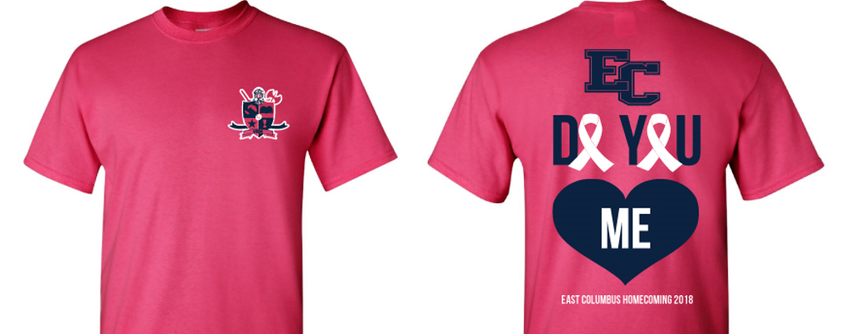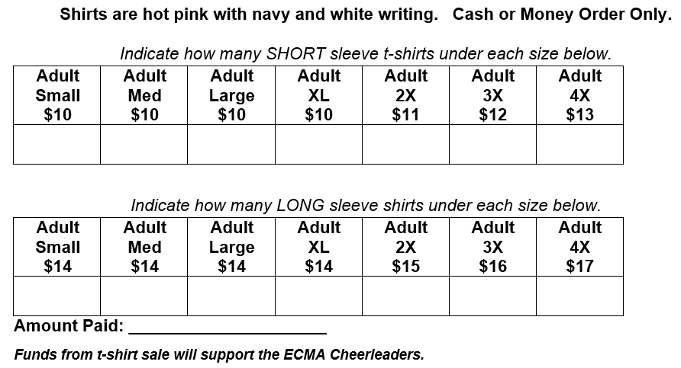
- The Junior Marshal's and Student Council are asking each of your students to support our "Green Team" Shoe Recycling Project! We are collecting shoes to support the Keep Columbus Beautiful Commission 2018 Shoe Recycling Campaign. We have asked that each student donate at least one pair of gently worn shoes (men, women, boys or girls shoes) to support our "Green Team" efforts. The shoes will be given to third world developing countries for people that need them. Final day of collection is Friday, October 12, 2018.
_________________________________________________________________________________________________
STAY CONNECTED @ecmaknights _________________________________________________________________________________________________

