EAST COLUMBUS MAGNET ACADEMY

KNIGHT NOTES: SEPTEMBER 24 - 28, 2018

A LOOK AT THE WEEK AHEAD:
MONDAY, SEPTEMBER 24th
- ECMA Debate Team Room 809, 4:00 – 5:15pm, Sponsor Ms. K. Arnold
- Volleyball Match Double Header ECMA vs DCMS and BRMS @ DCMS 5:00pm, Coach Michael Armstrong
- Football Practice 4:15 – 6:00pm, Coach Andre’ Dye
- Dazzling Knights Dance Team Practice 4:00 – 6:00pm, Sponsor Mrs. Brandy Wells-Adams
- Cross Country Practice 4:15 – 5:15pm, Coach Arlys Clayborn
TUESDAY, SEPTEMBER 25TH
- Cross Country Meet, Kinnett Stadium @ 6:45pm, Coach Arlys Clayborn
- Football Practice 4:15 – 6:00pm, Coach Andre’ Dye
- Cheerleading Practice 4:05 – 6:00pm, Sponsor Ms. Traveika Hunter
- Volleyball Practice 4:15 – 6:30pm, Coach Michael Armstrong
- Dazzling Knights Dance Team Practice 4:00 – 6:00pm, Sponsor Mrs. Brandy Wells-Adams
WEDNESDAY, SEPTEMBER 26TH
- Football Game ECMA vs Arnold @ HOME 5:00pm, Coach Andre’ Dye
- Dazzling Knights Dance Team Practice 4:00 – 6:00pm, Sponsor Mrs. Brandy Wells-Adams
- Cross Country Practice 4:15 – 5:15pm, Coach Arlys Clayborn
- Volleyball Practice 4:15 – 6:30pm, Coach Michael Armstrong
THURSDAY, SEPTEMBER 27TH
- ECMA Debate Team Room 809, 4:00 – 5:15pm, Sponsor Ms. K. Arnold
- Orchestra After School Tutorial w/Ms. Hunnewell (4:00 – 5:00pm)
- Volleyball Match Double Header ECMA vs BMS & VMMS @ BMS 5:00pm, Coach Michael Armstrong
- Football Practice 4:15 – 6:00pm, Coach Andre’ Dye
- Cheerleading Practice 4:05 – 6:00pm, Sponsor Ms. Traveika Hunter
- Dazzling Knights Dance Team Practice 4:00 – 6:00pm, Sponsor Mrs. Brandy Wells-Adams
- Cross Country Practice 4:15 – 5:15pm, Coach Arlys Clayborn
FRIDAY, SEPTEMBER 28TH
- MILLION FATHER MARCH - Dad’s bring their child to school & kick-off of the ‘Real Dad’ volunteer organization
- Football Practice 4:15 – 6:00pm, Coach Andre’ Dye
- Dazzling Knights Dance Team Practice 4:00 – 6:00pm, Sponsor Mrs. Brandy Wells-Adams
- Cross Country Practice 4:15 – 5:15pm, Coach Arlys Clayborn
- Volleyball Practice 4:15 – 6:30pm, Coach Michael Armstrong
________________________________________________________________________________
2018 - 2019 ECMA BUILDING EXPECTATION
- Student Drop Off: 8am Student Pick Up: 3:55 – 4:30pm.
- Students will lock up their book bags, cell phones, ear buds and any electronic devices in their locker before reporting to their 1st period class.
- Please help us with ensuring that your child is following the Dress Code expectations which will be enforced daily.
________________________________________________________________________________

VOLUNTEER OPPORTUNITIES

- At ECMA there are many ways for parents to get involved. Concession stand support for home games, ECMA Knight Store, after school traffic flow for car riders and walkers. Congratulations to our newest PTO Officers:
President - Mrs. Jennifer Melvin Vice President - Ms. Garbania Barron
Treasurer - Mrs.Katrina Miller Secretary - Mrs. Alicia Davis
Parliamentarian - Mrs. Ingid Edwards
________________________________________________________________________________
ECMA NEWS YOU CAN USE
- Do you have one hour to spare this week? Are you interested in becoming a better writer or do you want tips on how to support your child through the writing process? Join the ELA department for a ‘BOWL OF SOUP’ writing workshop.
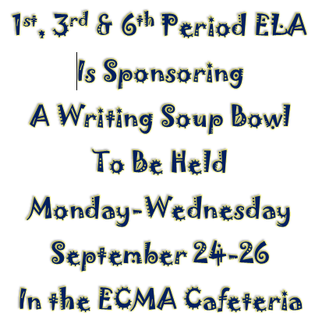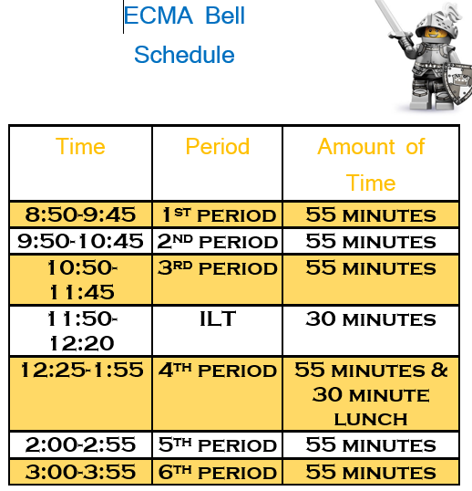

Classes these periods will remain in class but will SKYPE into other classroom for the workshop.
LEARNING OUTCOMES FOR EACH DAY
Monday, September 24, 2018
- Argument and Claim
- Reasons
- Evidence
- Log information on Trace an Argument Organizer
Tuesday, September 25, 2018
- Evidence
- Counterclaims
- Log information on Trace an Argument Organizer
Wednesday, September 26, 2018
- Counterclaims
- Opposing Claims
- Completed Trace an Argument Organizer
- Homework: Write a rough draft
Thursday, September 27, 2018
- In Class: Rough Draft & Peer Read, Conference with Teacher, Make necessary changes
Friday, September 28, 2018
- In Class: Rough Draft & Peer Read, Conference with Teacher, Make necessary changes
- Homework: Final Draft due Monday, October 1, 2018 submitted to Canvas typed ( Double-Space12 inch Times New Roman Font)
- ECMA Magnet application process is now open until January 18, 2019 for the 2019-2020 school year. Magnet exam dates are as follows: Sat. Dec 1, Dec 15, Jan 12, Tues. Jan 15 TIME: TBA
- Parents, do you want real-time feedback on your child’s academic progress? Have you obtained your Infinite Campus Parent Portal Access? If you have answered ‘Yes’ and ‘No’ to these essential questions, please visit the ECMA main office during normal business hours with your GA driver’s license or GA ID to obtain your IC Parent Portal Access information. For your convenience the App can be loaded on any smart device and set up to receive attendance and grade updates. Stay connected don’t wait until it is too late to support your child in their academic progress.
- MARK OUR CALENDARS: National Parent Involvement Week November 12 – 16, 2018. Please contact Ms. Daphne Jenkins, Parenting Liaison to be included as a Career Day presenter on Thursday, November 15th. This year we would love to fill our school with parents as the Career Day presenters so please consider offering your time to encourage the next generation of professionals.
- HOMECOMING WEEK is October 8-12, 2018. ECMA Football Field Dedication in memory of Dr. John “Pepper” Spurlock, Jr. for his years of service to the ECMA community and dedication to the athletic program. Presentation will occur during half-time of the game. Sales for the official Homecoming t-shirt are September 24-September 28, 2018. Money will be collected during 3rd period and ILT only.
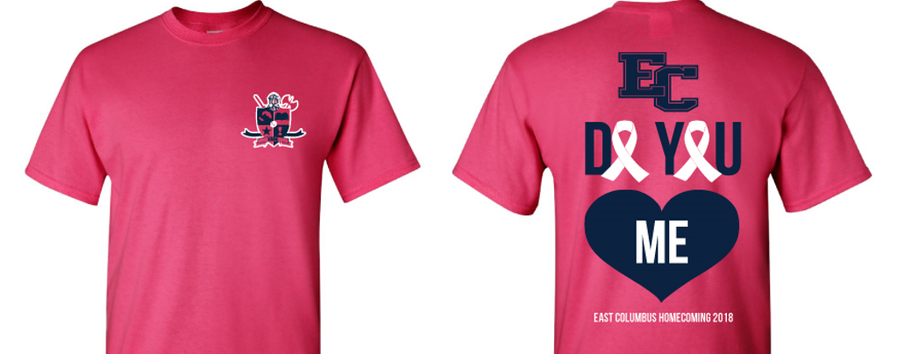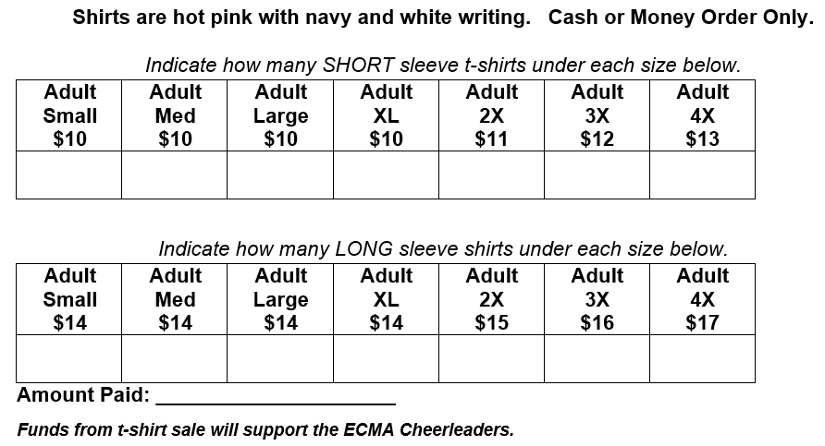

- The Junior Marshal's and Student Council are asking each of your students to support our "Green Team" Shoe Recycling Project! We are collecting shoes to support the Keep Columbus Beautiful Commission 2018 Shoe Recycling Campaign. We have asked that each student donate at least one pair of gently worn shoes (men, women, boys or girls shoes) to support our "Green Team" efforts. The shoes will be given to third world developing countries for people that need them. We will begin collecting shoes now, our final day of collection is Friday, October 12, 2018.
_________________________________________________________________________________________________
STAY CONNECTED @ecmaknights _________________________________________________________________________________________________

