EAST COLUMBUS MAGNET ACADEMY

KNIGHT NOTES: AUGUST 27 - 31, 2018

A LOOK AT THE WEEK AHEAD:
MONDAY, AUGUST 27TH
- Football Conditioning 4:15 – 6:00pm
- Dazzling Knights Dance Team Practice 4:00 – 6:00pm, Sponsor Mrs. Brandy Wells-Adams
- Volleyball TRY-OUT 1st cut posted Tuesday morning, Coach Michael Armstrong

TUESDAY, AUGUST 28TH
- PTO/LOCAL SCHOOL COUNCIL MEETING 5:30 – 6:30 ECMA CAFETERIA
- Football Conditioning 4:15 – 6:00pm
- Dazzling Knights Dance Team Practice 4:00 – 6:00pm, Sponsor Mrs. Brandy Wells-Adams
- Cross Country TRY-OUT (Volleyball and Football team members ONLY) 4:15 - 5:15pm, Coach Ms. Arlys Clayborn
- Volleyball TRY-OUT Final cut posted Wednesday morning, Coach Michael Armstrong

WEDNESDAY, AUGUST 29TH
- Football Conditioning 4:15 – 6:00pm
- Cheerleading Practice 4:05 – 6:00pm, Sponsor Ms. Traveika Hunter
- Dazzling Knights Dance Team Practice 4:00 – 6:00pm, Sponsor Mrs. Brandy Wells-Adams
- Cross Country Practice 4:15 – 5:15pm, Coach Ms. Arlys Clayborn
- Volleyball Practice 4:30 – 6:00pm, Coach Michael Armstrong (Parent meeting immediately after practice)

THURSDAY, AUGUST 30TH
- ACADEMIC BOWL TEAM INTEREST MEETING, RM 701 at 4:15 – 5:00pm, Sponsor Mrs. Elizabeth Smith
- Cheerleading Practice 4:05 – 6:00pm, Sponsor Ms. Traveika Hunter
- Football Conditioning 4:15 – 6:00pm
- Dazzling Knights Dance Team Practice 4:00 – 6:00pm, Sponsor Mrs. Brandy Wells-Adams
- Cross Country Practice 4:15 – 5:15pm, Coach Ms. Arlys Clayborn
- Volleyball Practice 4:30 – 6:00pm, Coach Michael Armstrong

FRIDAY, AUGUST 31ST
- Picture Day in the media center. Order forms will go home Tuesday, September 4th.
- Cheerleading payment due (Family member shirt), Sponsor Ms. Traveika Hunter
- Football Conditioning 4:15 – 6:00pm
- Dazzling Knights Dance Team Practice 4:00 – 6:00pm, Sponsor Mrs. Brandy Wells-Adams
- Cross Country Practice 4:15 – 5:15pm, Coach Ms. Arlys Clayborn
________________________________________________________________________________
2018 -2019 MCSD Student Handbook & Code of Conduct
Students received a copy of their handbook on August 9th. Please review the policies provided in the handbook and for your convenience this link is to the handbook: https://muscogee.k12.ga.us/Documents/StudentServices/StudentDiscipline/18-19%20Student%20Handbook%20and%20Code%20of%20Conduct.pdf
________________________________________________________________________________
VOLUNTEER OPPORTUNITIES
At ECMA there are many ways for parents to get involved! Most of these opportunities come from PTO! Please join us at the first meeting is August 28, 2018 5:30pm.

2018 -2019 ECMA BUILDING EXPECTATION
Student Drop Off: 8am Student Pick Up: 3:55 – 4:30pm.
Students will lock up their book bags, cell phones, ear buds and any electronic devices in their locker before reporting to their 1st period class.
Dress Code will be enforced daily please refer to the ECMA Handbook.
________________________________________________________________________________
ECMA NEWS YOU CAN USE
- Request for schedule changes will be finalized on Monday, August 27th. Mrs. McClary has been reviewing request, contacting parents, and changing schedules all week. She has attempted to honor all request; however, the master schedule constraints dictate any moves. Parents if you do not receive a call and your child’s schedule has not been revised then, those constraints would not allow for a change of schedule.

- JLC parents please be advised that your child(ren) will start wearing uniforms every 2nd and 4th Thursdays of each month beginning September 13th. Please contact 1ST SGT Wilson to address any questions or concerns.

- Did you know that parents can check out a laptop for a week in the Parenting room with Ms. Jenkins? For more details please contact Ms. Jenkins, Parent Liaison 706.565.3026 or Jenkins.Daphne.C@muscogee.k12.ga.us

- TECHNOLOGY IS THE FUTURE: Every student that attends ECMA has access to ACHIEVE3000, IXL AND USATEST PREP. Teachers use this software to individualize student learning, enrichment and for homework assignments. MCSD as a whole has committed to using Achieve3000 to increase lexile scores, improve reading and writing. Through Title I funds ECMA students have access to IXL software which helps our students excel in mathematics and serves as an at home tutor when your student is struggling. Lastly, the science and social studies department utilizes USA Test Prep to enhance their instruction, as well as, support student academic growth. See below to login and explore….

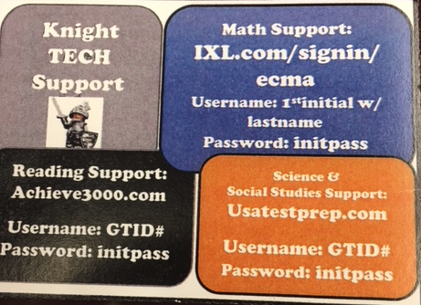

- Parents have you noticed that your students have been given a Student ID? Do you wonder how it is used? One use is PBIS! PBIS (Positive Behavior Interventions and Supports) is a framework that maximizes the selection and use of evidence-based prevention and intervention practices along a multi-tiered continuum that supports the academic, social, emotional, and behavioral competence of all students.
  - Academic Support: Academic Walk of Fame each 9wks after report cards students that make the Honor Roll and Principal’s List are honored in front of their peers and parents in the gym. The format is designed behind an athletic pep rally. Students are taken off campus after the celebration for 2-3hours to enjoy time at Hollywood Connections skating, playing video games, laser tag and lunch off campus.
  - Behavioral Support: The PBIS Reward App is used to scan the Student ID badge to recognize students’ on-task behavior in the classroom and in the non-academic areas. The student must be wearing their ID to receive points so please encourage your child to be in compliance. Every two weeks the ECMA Knight store will open to allow the students to use points earned to purchase snacks, school supplies, engaging games and electronic devices. If you would like to donate to the store or volunteer please contact Dr. Goodwin, PBIS Coach.
  - Social/Emotional Support: Students have weekly themed lessons that support character development and provide strategies to help your child successfully navigate through middle school. Students that are struggling to maintain will be monitored by the PBIS Team for a potential MTSS referral.

- ATTENTION! ATTENTION! FREE AT HOME TUTORING…See the flyer below.
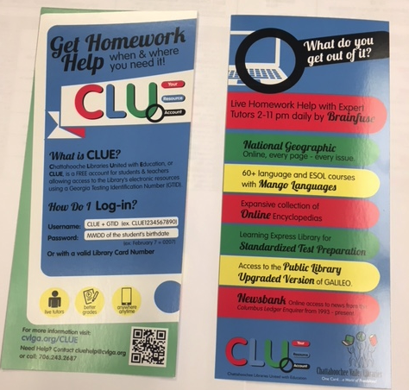
WEBSITE AND HELP INFORMATION
DATES/TIMES
Start here to set up an account
BREAKFAST AND LUNCH
Students at ECMA enjoy free breakfast and lunch daily.
Breakfast Time: 8:20 – 8:45
Lunch Time: 12:25 – 1:55
________________________________________________________________________________STAY CONNECTED @ecmaknights

