Building Partnerships
- Parents are invited to attend monthly parent workshops and activities sponsored at the school.
- Parents are invited to volunteer, participate and observe at the school and in their child’s classroom
- Parents are invited to visit the Parent Resource Room/Area to checkout materials to use with their child at home.

What is a School-Parent Compact?
A School-Compact for Achievement is an agreement that parents, students and teachers develop together. It explains how parents and teachers will work together to make sure all our students reach grade-level standards.
Communication about
Student Learning

Dorothy I. Height Elementary School
is committed to frequent two-way communication with families about children’s learning. Some of the ways you can expect us to reach you are:
- Weekly homework folders/Agenda Books
- Monthly “check-in note” and phone calls
- Updates on the school’s website
- Grade level meetings on understanding student progress
- Parent-teacher conferences in the Fall and Spring.
- Husky News Monthly

Dorothy I. Height Elementary
Mr. Lamont Sheffield, Principal
Mrs. Meredith Adams, Assistant Principal
1458 Benning Dr.
Columbus, GA 31903
706-683-8871
http://schools.muscogee.k12.ga.us/sites/dorothyheight

Effective School-Parent Compacts:
- Link to goals of the School Improvement Plan
- Focus on student learning skills
- Describe how teachers will help students develop those skills using high-quality instruction
- Share strategies parents can use at home
- Explain how teachers and parents will communicate about student progress
- Describe opportunities for parents to volunteer, observe and participate in the classroom

How is the School-Parent Compact Developed?
The parents, students, and staff at Dorothy I. Height Elementary developed this School-Parent Compact for Achievement. Teachers suggested home learning strategies, parents added ideas to make them more specific, and students told us what would help them learn. Meetings are held each year to review the School-Parent Compact and make changes based on student needs.
Parents are welcome to contribute comments/suggestions at any time.
If you would like to volunteer, participate, and /or observe in the classroom please contact Mrs. Carmen Hurston-White at (706) 683-8871.

Family Services Coordinator at (706) 683-8833.

Dorothy I Height Elementary
School-Parent Compact for
Student Achievement
2018-2019
Revised: August 15, 2018
Our Goals for Student Achievement

District Mission
- Our mission is to inspire and equip all students to achieve unlimited potential.
District Goals
- The Muscogee County School District will create an environment that focuses on tier 1 instruction while targeting individual student needs, leadership development, and customer service.
School’s SMART Goals
- By May 2019, 100% of K-5 teachers will be trained on the balanced literacy framework with 90% successful teacher implementation as measured by observational data.

- By May 2019, 100% of teachers will be trained in six (6) out of ten (10) Tier 1 critical elements of PBIS with a 90% implementation rate as measured by the Benchmarks of Quality (BoQ) and Tiered Fidelity Inventory (TFI) Tier I crosswalk.

Our Students:
Our Students:

Our Students:
Students are encouraged to participate in the educational process. A successful student takes ownership of his/her learning and sets high educational goals.
- Set goals to succeed in school and reach for the stars in reading and math.
- Set goals to read each night for 30 minutes.
- Set goals to practice math facts each night at home to improve speed and accuracy with multiplication and division facts.
- Maintain positive behavior to accomplish academic goals.
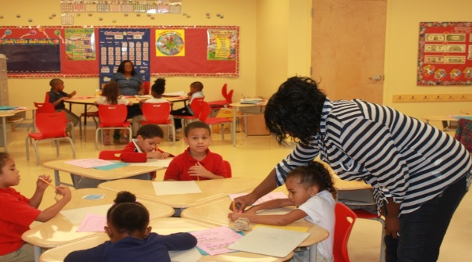

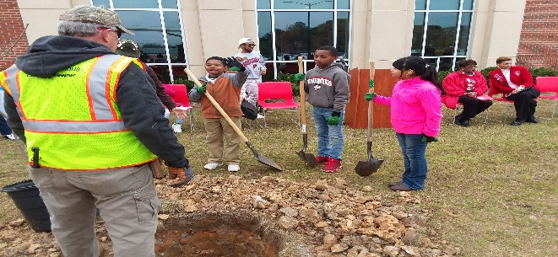
Our Parents:
Parents are expected to participate in the education of their children. Without the cooperation and partnership between parents and school staff, we cannot effectively help a student reach his or her full potential. The major role of parents is to continually show their child that they are interested and supportive of how their child is performing in school.
- Parents will practice math facts with their child each night.
- Listen to their child read a story 3 times a week and ask questions about the story as they read.
- Help our children to see the importance of how good behavior helps to improve academic achievement.
- Practice math facts and work on math strategies each week to help their child improve on mathematics.
- Attend Reading and Math night with their child to learn new ways to support their child in reading and math.

Our Teachers:
Teachers are expected to work with students and their families to support students’ success in reading and math. Some of our key connections with families will be:

- Keep parents up to date on student progress in class. Communicate successes and struggles, and maintain an open line of communication.
Make sure all students receive help and intervention as soon as a need is identified.

- Establish open lines of communication with parents and keep parents informed on student’s progress.
- Send home learning materials in reading and math for students to practice at home.

